**Splintered**

# Contents

Table of Contents

Contents 1

Analysis 4

The Problem 4

Proposal 4

Adding Complexity 5

Computational Thinking 5

Problem Recognition 5

Abstraction 6

Decomposition 6

Divide and Conquer 6

Stakeholders 6

Identifying the stakeholders 6

How will stakeholders make use of the problem? 7

Making the game suitable for different users 7

Questionnaire 8

Questions 8

Results 11

Research 16

Hitman Series 16

Dishonoured 18

Hotline Miami 19

Features 20

Essential features 20

Important Features 21

Bonus features 21

Limitations 22

Requirements 23

Hardware 23

Software 23

Success Criteria 24

Justification 24

Design 24

Decomposition 26

Explanation and Justification 26

Level Design 26

Player 27

User interface 27

Enemies 28

Progression 28

Audio 28

Classes 29

Class diagrams 29

Classes explanation and Justification 32

Player Class 32

Enemy Class 33

Level Class 34

Objects Class 35

Crate Class 35

Other data structures 36

Variable ideas: 36

screen, clock, background, resolution 36

rect 36

pos 37

image 37

size and speed 37

mouse_coords, playermouse_x, playermouse_y 37

kill_count, deathcount 37

timer, internal_timer 37

Pseudocode 38

Player Class 38

Enemy Class 44

Level Class 46

Object Class 49

Menu Class 50

Instantiation 51

Game loop 52

Testing 53

Methods/Functions 54

Development 57

Formatting and Naming conventions 57

Setting up the program 58

Stage 1 58

Setting up the game 59

Adding the player 61

Adding the camera 68

Adding the objects 71

Adding the enemies 79

Stage 2 91

Creating a menu screen 91

Organising the level 93

Creating a game over screen 111

Animations 116

Stage 3 122

Player attacking 122

Adding music 128

Adding the ending 130

Bonus Features 133

Final code 134

Evaluation 150

Survey feedback 150

Final post-development test 152

Player 152

Enemy 155

Level 156

Object 157

Menu 158

Wall 158

Points 158

Has this met success criteria? 159

Success Criteria 159

Addressing unmet criteria 161

Usability features 162

Improving Usability 162

Maintenance 163

Conclusion 163

References 163

# Analysis

## The Problem

### Proposal

I plan on designing a 2d, top-down, stealth video game which involves a protagonist who moves through increasingly difficult levels whilst avoiding enemy detection. The player must use objects in their surroundings to hide and other smaller objects e.g., bottles which can be thrown to distract enemies. The aim of the game is to reach the end and take down the crime syndicate boss. I will code the game in python and use pygame to create a simplistic yet engaging display.

The game will follow a noir style theme and the stealth aspects take inspiration from other popular games within the genre such as Assassins Creed, Dishonoured and Hitman. Enemies are scattered throughout levels and use vision zones to detect players within a given range. If the player is within the detection zone of an enemy for a set period of time, then the player will receive a game over. Player is able to ‘takedown’ (eliminate) enemies when stood behind them which removes the enemies from the levels.

### Adding Complexity

* A large amount of complexity will come from the choice to use pygame which lacks built in features such as Camera or Collision functions which I will need to create myself.
* The program will be object oriented allowing objects to be removed when offscreen which will save resources and majorly increase program efficiency, this is because python is not built for efficiency.
* Enemy vision will need to be programmed to form a specific area which will need to be calculated. The area of the vision will change when interacting with the environment and will need to be recalculated for each frame and then cast.
* A lot of complexity will come from mathematic equational algorithms which, for example, would need to calculate distances between either entities or objects using trigonometry.
* For vision cones to interact with objects I will need to implement a form of raycasting, so that enemies cannot see through objects or the environment. The program would calculate if the player and enemy have an established line of sight and check if there is as set distance between them. An algorithm would be made to cast the rays, check for line of sight, check for distance and calculate whether the player is within the range.
* A form of pathfinding algorithm may potentially need to be implemented to allow enemies to move toward thrown objects. I could achieve this by using a tile system and having an algorithm that checks for empty tiles such as using A* algorithm or Dijkstra’s.
* Extra features I may add are: Throwable items, enemy pathfinding, different enemy types; however, I will add these depending on how possible they will be during the given timeframe.
* More complexity will arise from the large data structures used to hold enemies or objects and how these data structures will be manipulated.

## Computational Thinking

### Problem Recognition

As I plan on creating a game, typical problems arise such as time management and feasibility, features will be considered based on whether or not they will be realistically possible within the time I have to complete the project.

One problem of the development of the game will be that I will need to write algorithms for the physics of the game e.g., collisions as python doesn’t have premade physics functions. Other algorithms such as distance calculations will need to be implemented to find the distance between entities.

Another problem will be the enemy AI which may interact weirdly with the environment and the player character. If I choose to let the enemies roam without a constant path, then a pathfinding algorithm may need to be implemented.

### Abstraction

The most significant form of abstraction will be the graphics; choosing to use 2d graphics will allow the game to run much smoother and more feasible to create and animate. As python is not as efficient as other languages, a lot of abstraction will be based around code efficiency. If code is not optimised then there may be issues with low framerates, slow input response times and a generally worsened user experience.

Objects and enemies must be removed once out of sight of the player to improve code efficiency, I will achieve this by using object-oriented programming. Levels will be relatively simplistic at first, comprising of enemies, objects and the player with a lack of decoration.

A lot of abstraction will also take place so that the project is completable within the time, such as choosing not to include multiplayer capabilities as it is not a necessary part to my game and would be difficult to implement.

### Decomposition

The game can be split into many sub-procedures, the first split being the front-end (what the user sees) and the back-end.

The front-end will focus on how the game looks and sounds to the player, so for example it would need to focus on making sure everything looks to scale and natural, the game is simple enough to understand and maybe has accessibility options to allow for players with visual or acoustic impairments.

The back-end will focus on the algorithms and physics of the game, detecting input, displaying the images and shapes to the screen and calculating numbers necessary for the program. Splitting the problem down into smaller sub-problems makes them easier to manage and allocate my time to. It will help me in creating these sub-procedures and will also help in showcasing the logic behind my code.

### Divide and Conquer

Divide and conquer is similar to the decomposition section in that the problem is broken down into smaller sub-sections to make it more manageable. I will apply this to the development of my game by getting certain sections complete which won’t need much altering afterwards, e.g., sprites, objects and movement so that I can focus on the more complex parts such as the collision physics.

## Stakeholders

### Identifying the stakeholders

The stakeholders of my game would ideally be individuals who spend time playing video games, and in particular are familiar with the stealth genre of video games. To find my stakeholders I would select people from my family and friends who play video games so that they can playtest my game and suggest features which they, as a user, would want to see implemented. I may also select certain family members who have little to no experience with playing video games so that I can gauge how accessible the game is for beginners or people with visual impairments.

### How will stakeholders make use of the problem?

Elderly people may play the game to keep their brains active as the complex levels will require a degree of thought when aiming to complete them. It would be interesting to see if there is a disparity in responses between my elderly stakeholders who lack gaming experience and my other, younger stakeholders who are more familiar with the industry and know what to expect.

My younger audience may play the game for enjoyment, many describe video games as a form of escapism. I want the game to allow people to load up my game and play it to their hearts content, not needing to think about school or stress.

A lot of games people play simply to just pass the time as they have nothing better to do, they may play games in the little free time they have as they require little energy for how fun they can be. Others may only play video games and sink hours and hours of their life into game which they may forget about by next month. It will be difficult to appease all of these groups of people when making my game, but I will take them all into consideration when making decisions about the direction and features of the project.

### Making the game suitable for different users

The game will be relatively simple in its controls and concepts, the difficulty will stem from the level design, requiring players to think of a solution to the level. The ideas listed below I would only add if I considered them feasible or possible within the timeframe.

Typically within the gaming industry, professional players are the ones who are likely to spend the most money on their games as they will invest more time into them. For players who have spent a lot of time with video games and are skilled in gaming, a speedrun-style mode could be implemented to allow skilled players to race for the fastest time in order to give them an incentive to keep playing. A sort of save system for high scores could be implemented and saved locally onto the computer to allow players to beat their own scores.

However, as gaming is a growing industry, more and more people are being introduced into video games who aren’t too familiar with other video games. For less skilled players maybe a lives system or more forgiving enemies could be implemented to allow them to enjoy the game while getting to grips with the controls and physics. Could even add some sort of teaching or tutorial within the game to teach players how to play without them needing to read a boring text wall of instructions.

For players with visual impairments, I could implement a high contrast setting to allow players to better see important sections of the game. I could also add settings to allow for larger text for it to be easier to read.

## Questionnaire

### Questions

To gain information and insight on what users wish to see in a stealth game, I designed a survey comprised of 11 questions. I aim to understand what people are looking for in my game and other suggestions which they may have so that I can properly tailor the experience to my audience.

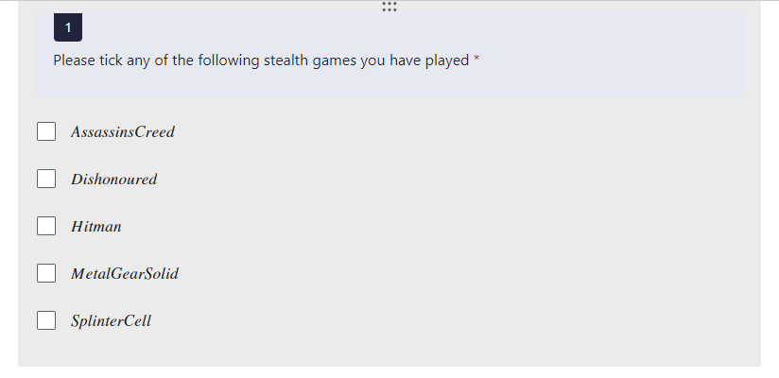The questions gauge how familiar my audience is to stealth based video games and what aspects they would like to see.

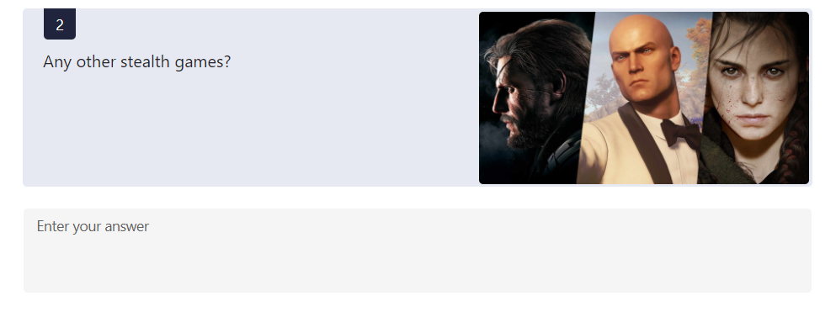

This first question is designed to find which kind of games the audience is familiar with, I chose these 5 games as examples as they are some of the most famous and highest grossing within the stealth genre. This would allow me to gauge what games are popular with my intended audience and thus research these games to gain inspiration.

The second question was a continuation from the first question and was an open question allowing for more freedom in the user input.

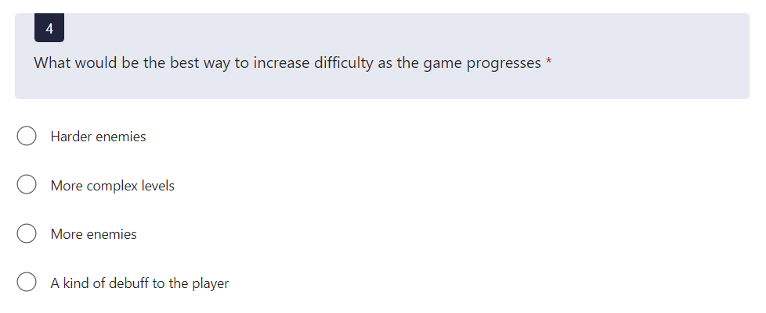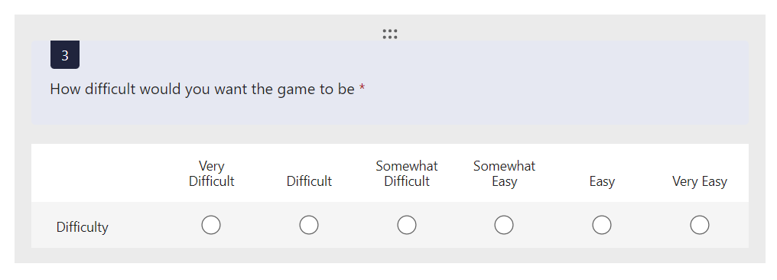I chose this question because I wanted to see what kind of difficulty that my audience is looking for. Some games have become wildly famous (or infamous) for their difficulty e.g., Dark Souls, and other games have been renowned for their easy, casual nature. I used a 1-6 Likert scale to discourage users from selecting a neutral option.

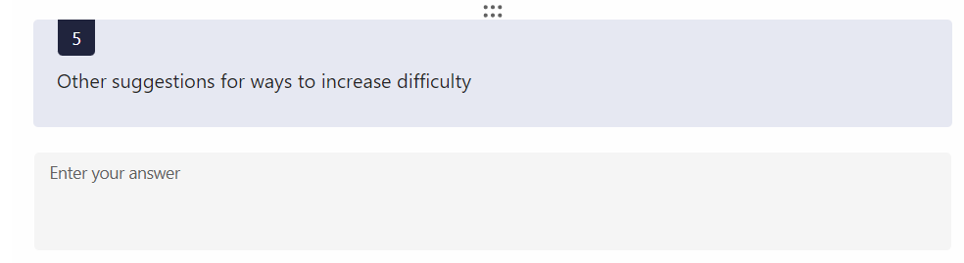I used this question to learn how my users would want the game to become more challenging as it continues. Some difficulty features can seem tedious to players, increasing amounts of enemies is simple form a development point but is typically uninteresting to the player and may seem lazy. On the other hand, making levels more complex would take more work but would provide a more unique experience.

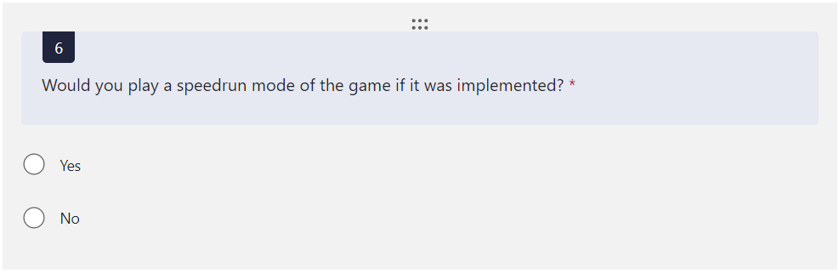Question 5 is a continuation of question 4 and allows users to suggest any of their own ideas.

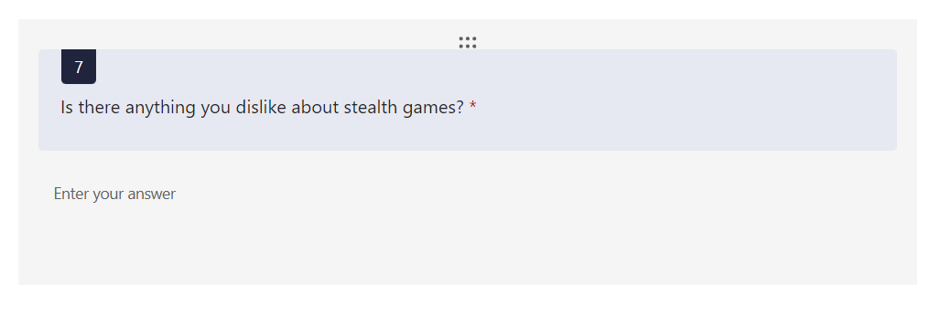I used this question to see how users may feel about the concept of a speedrun mode. I initially wanted to use this idea of the speedrun mode as an incentive to keep skilled players playing and potentially competing for times.

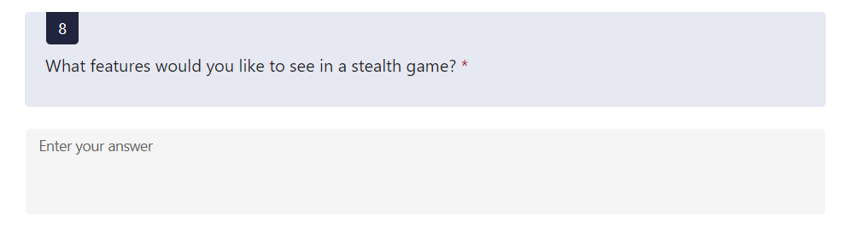This question is very open, and I included it to get a rough idea of what to avoid when designing the game and implementing features. Naturally, everybody has their own likes and dislikes, so I intend to take the responses with a grain of salt when reviewing them.

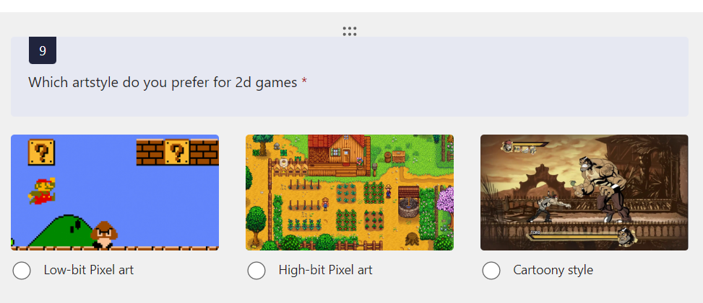Similarly, to the previous question, I wanted to see what the audience generally wanted to see from the project; this would give ideas for more features and let me consider if they would be feasible or not for the game.

As I might be using premade assets for the art in my game, the art style is really just a preference choice. I wanted to see whether my audience favoured simplicity or more detailed style choices for the game art.

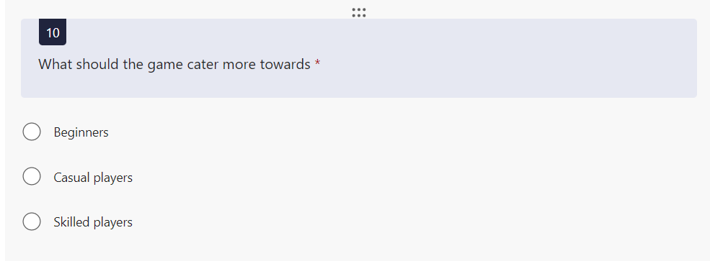Beginners, casuals and pros always seek different things within games. To cater to beginners, I may have simplistic controls, a tutorial or some kind of guidance which teaches the player. For casuals who are more familiar with video games, the players may be told the controls but have the rest of the game left to be figured out. For skilled players I may need to add new features entirely.

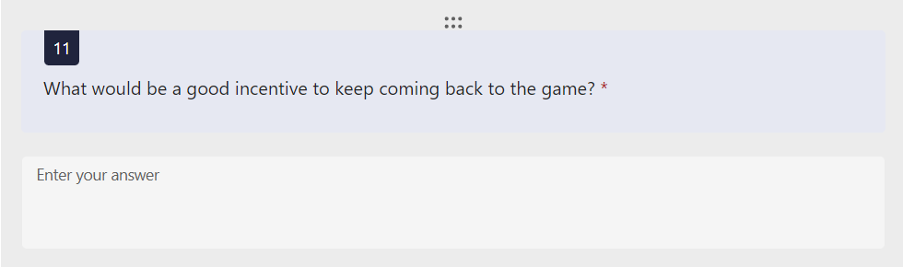

For the final question, I ask for suggestions on how to keep player retention. As my game will lack much (if any) multiplayer interaction, players may see little reason to continue playing after completing the game. The players know what they want which is why I included many open questions within the questionnaire. Many studios have been praised for how they listen to their players and use their feedback to improve on what they might have missed/be unaware of, which seems obvious, people like having their voices heard. This is what I aimed to achieve when creating this questionnaire.

### Results

Hitman takes a majority win, being the most commonly played stealth game of the ones I chose to list. From this I may choose to research hitman as a solution and take some features and apply them to my game. Assassin’s creed is the second highest played game of the list, however in recent years the game series has strayed further from stealth into more of an open world RPG style. If I chose to research Assassins creed, I would research some of the older games in the franchise which made it popular in the first place. 11/13 people have played at least one of the games, shows that stealth games are popular within my selected 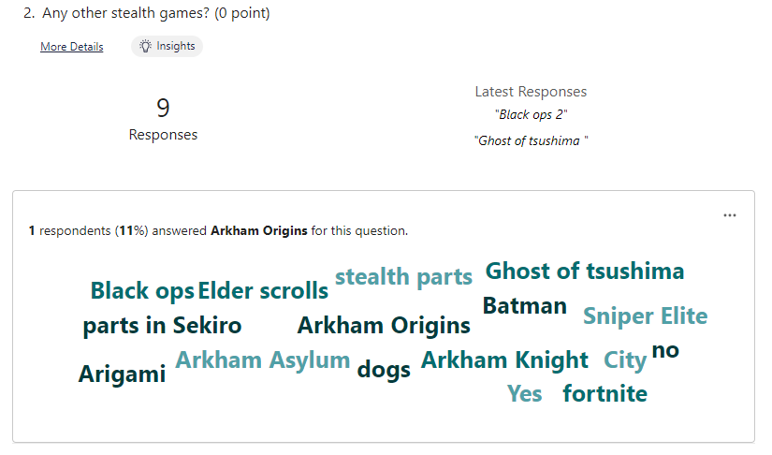audience.

What I learned from this question is that many of my stakeholders have played games which aren’t dedicated stealth games but instead have stealth sections. Games like Call of duty wouldn’t typically be known as stealth games but have levels of the campaign based around sneaking. Elder scrolls gives the player the ability to play with a stealthy approach, but also allows them to play however they want.

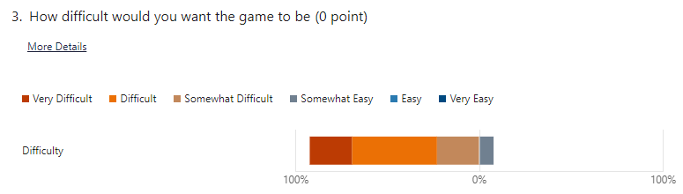The response to this question was heavily swayed towards a difficult game; this isn’t too surprising considering a lot of my audience spend a lot of time playing games and are quite skilled. In my opinion (And seemingly my stakeholders’ opinion), difficulty is a tool which can be used to enhance player experience. Games like dark souls which are insanely hard, have amassed a cult following as many people enjoy the brutal difficulty that it presents. The game will most likely have a fixed difficulty rather than a selectable difficulty.

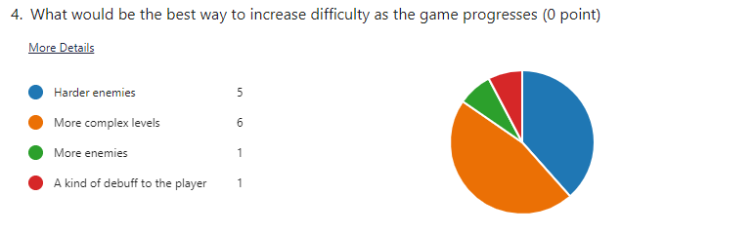Using more complex levels to progress difficulty is how I planned on approaching the design of the game. ‘Harder enemies’ was a popular choice and would be easy to implement as it would just require changing a few numbers e.g. detection radius or movement speed. More enemies and player debuffs were unpopular choices as they make the game harder without it being more interesting, they usually just make the game more annoying.

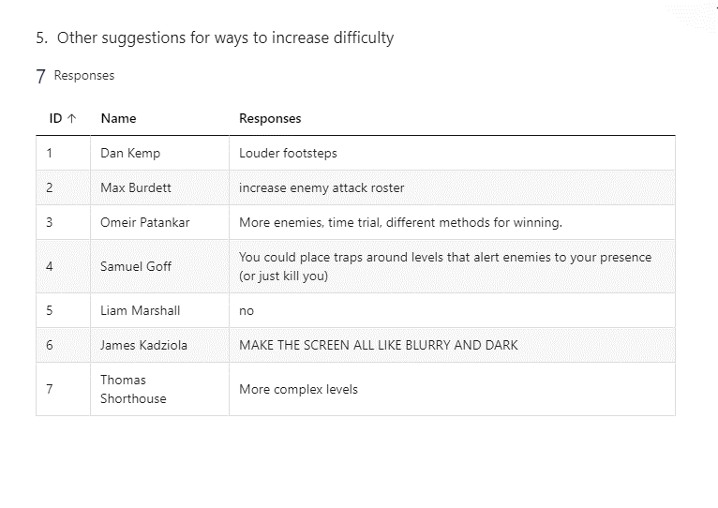Many of these responses were features I had already considered implementing, Omeir’s idea of different methods of winning particularly took my interest. I could have different endings / rewards based on how the player approaches the game which would add another level of depth and give the game more replay value.

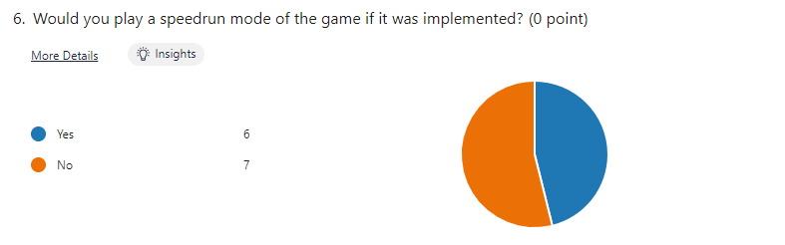

This question had a generally even response from the stakeholders but more importantly showed that people would be interested in this mode if I were to add it.

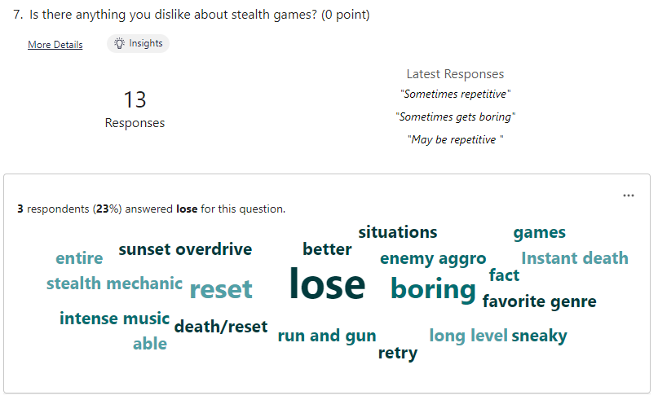

Responses for question 7 were generally around 3 main factors: Boring, repetitive and losing. Many players found losing to be annoying and inconvenient and disliked having to start again when they lost. Others found aspects to be incredibly repetitive and boring such as having to wait for enemies or needing to walk back to where they were after dying. I will take into account all of these suggestions and try to avoid them.

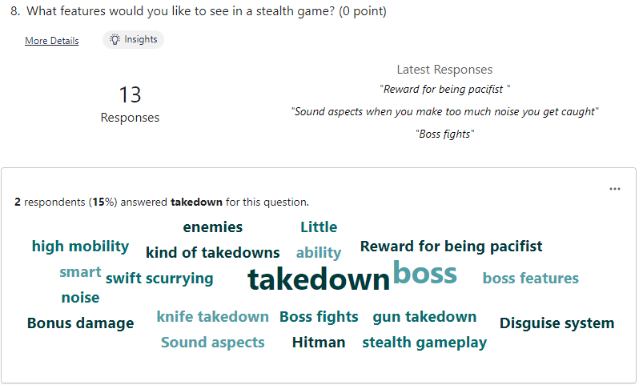

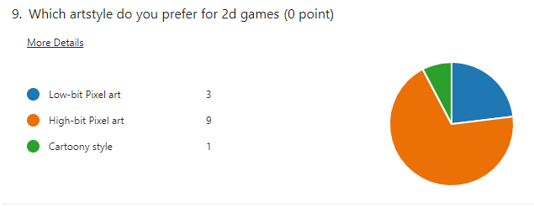A lot of responses wanted the inclusion of takedowns which I plan to add as a way of fighting enemies. While a boss battle may be impressive, I feel as though it may not be possible within the timeframe or really work with the gameplay of the game.

Majority of people chose the high-bit pixel graphics, I was originally going to use a cartoony design however this has influenced me into looking into using a pixel art style for the game graphics.

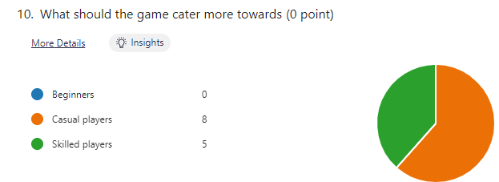Nobody believed that the game should cater more towards beginners. Majority thought it should be catered to casual gameplay, which is how the game would naturally be on the base settings. I would however like to add some features which apply more towards skilled players like a timer and leaderboard.

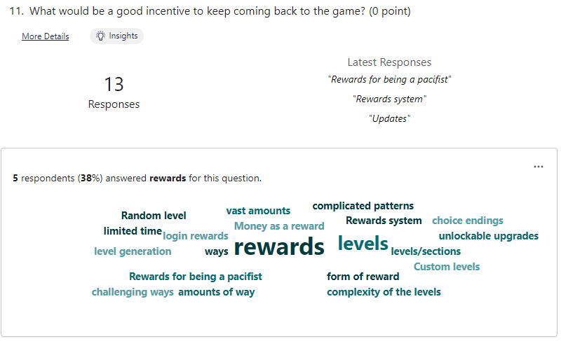

A large proportion of respondents wanted a form or reward system which would give them reason to play the game. These rewards may be cosmetic or have actual in game function like powerups. A rewards system may be something I add if I have the time to implement it.

## Research

The research section will detail all of the research which I have conducted on similar solutions to my problem. Naturally, all of these will be video games which are either from the stealth genre or incorporate some aspects from them. This research will help me find successful solutions to the problems I have found from the results of the questionnaire.

### Hitman Series

*(1,2 & 3)*

#### Overview

Hitman was the most played stealth game which people had played when answering the questionnaire, which is no surprise as it’s a series I’m familiar with and have played myself. The hitman games are synonymous with the genre as the core gameplay revolves around assassinating targets without being detected. Of the hitman series I will be focusing specifically on the most recent iterations of the series, being Hitman 1, 2 and 3 (Developed by IO interactive).

The series follows agent 47, a master assassin trained in stealth, recognised for his signature barcode found on the back of his head. Players enter a large open level with the task of murdering a specified target but are given the freedom to approach this in whatever way they like e.g., poisoning them, pushing them in front of a car or even framing someone else for the murder. This degree of freedom to approach levels however players want to, is what makes the hitman series so popular among the gaming community; this level of freedom is something which I would want to incorporate into my game. I’d like there to be multiple ways of approaching a specific level and allow players to choose how they’d like to solve it. In hitman the player takes on many disguises to sneak past guards and hide within the enemy ranks without being detected. It also features an enormous arsenal of different weapons, ranging from miniguns and explosives to rubber ducks and muffins. Players are given a score at the end of the mission based on how efficient they were but also lose points for collateral damage, taking too long, being seen or leaving any evidence. This score incentivises players to take a stealthy approach and think about their actions rather than just killing everyone and everything.

The hitman games can be played by players of any skill, but I feel as though they are more catered towards skilled players as there is the score count and online leaderboards to compete in.

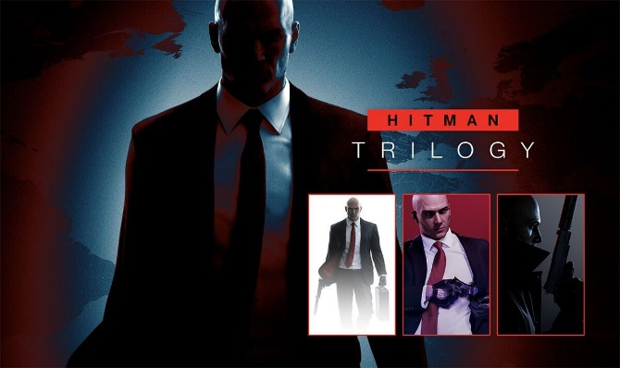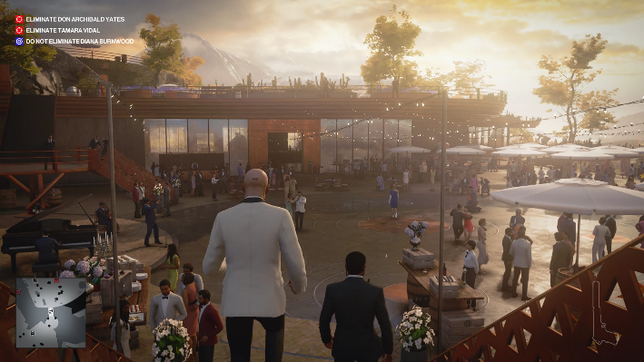

As all 3 games in the series are practically the same in terms of gameplay, physics, concepts, I will talk about them as one game. The only changes between games are the levels which can be played, some new items and a new UI for each game; the actual core of the game stays the same.

#### What I would take for my game

* Multiple approaches to level completion
* A points system – based on speed of level completion, enemies killed and how many attempts It may have taken.
* A leaderboard for high scores – this would be a local leaderboard for only that system but would save scores as a text or csv files they are kept even when the program ends.
* Level selection in the menus – players can choose to play a specific level which they have already completed.

### Dishonored - WikipediaDishonoured

(V. A. Wikipedia 2012)

#### Overview

Dishonoured was played by 2/13 of my stakeholders but I decided to research it due to how widely its praised within the gaming community and its commercial success. Dishonoured takes place in the industrial city of Dunwall in an 1800-1900s style era. The game follows the assassin Corvo who is framed for the murder of the Empress and is tasked with overthrowing the new ruler.

#### Gameplay

The player can choose to either take a stealthy approach to completing levels or instead just fight their way through hordes of enemies and guards. The main character has a knife for stealth takedowns, a crossbow for silent ranged eliminations and a pistol for head on encounters. A unique aspect of dishonoured is the players access to dark magic, these abilities can allow the player to teleport, slow down time, possess enemies, control rats, see enemies through walls or blast enemies with wind. These unique powers give the player a huge level of freedom in how players approach levels as they can kill/neutralise enemies in many different ways. The player can also choose to play passively by only knocking out enemies or avoiding them entirely; the game reacts to this by having less rats as there are 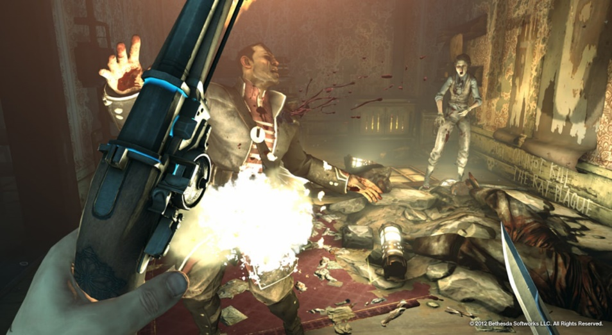dead bodies. I might consider a feature similar to this to make the game harder depending on if the player kills more enemies.

As a Bethesda game, the game has a high focus on worldbuilding with many side characters you can meet wandering the streets. These characters help in making the world feel real and actually lived in but also can provide help to the player in forms of vendors to buy from or just giving the player rewards. These characters can also give out optional side quests e.g., one of your friends at the base asks that you don’t kill their uncle, who is one of the security guards who you will encounter in the next level. This quest forces the player to make the conscious decision not to kill someone they see as an enemy because its ‘the right thing to do.’

#### What I would take for my solution

* Making a conscious decision to kill or spare enemies – e.g., a reward for playing passively or aggressively.
* The game has a dark tone, and the settings typically use a quite muted colour palette which I would probably use in my game to reflect the noire style and aspect.

### Hotline Miami

(V. A. Wikipedia 2012)

#### Overview

Hotline Miami is a top-down shooter game which takes place in a neon-style 1989 Miami and follows a hitman named ‘jacket’, who is tasked with killing everyone at a given location. Hotline Miami is the first of the games I’ve researched which isn’t actually a stealth game however I chose to research this game specifically as it has a lot of features which I found interesting, and I wanted to take influence from games of other genres. When in a level, the player navigates through a series of rooms where they must kill all the enemies or kill some kind of boss and reach the end.

A unique feature of hotline Miami is the fact that the player dies after a singular hit, meaning they need to be skilled to be able to be successful. To account for how often the player dies, the game allows for the levels to be instantly restarted, without the need for punishingly long game over screens or having to restart the game from the very beginning. This keeps a very fast pace for the game which keeps players engaged without putting them through tedious load screens.

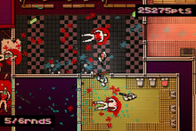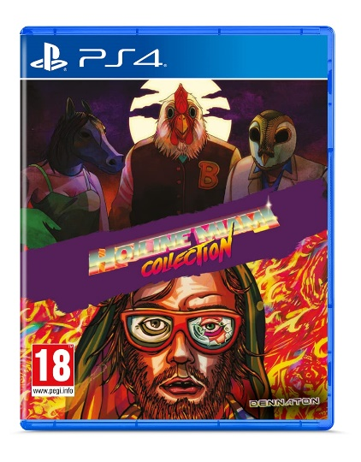The AI enemies within the game have their own complex pathfinding patterns. The player begins each level without a weapon and so the player must rely on finding weapons and using things they find to their advantage.

#### What I would take for my solution

* Top-down style – My game will also feature a top-down view of the character and game and may ear similarity to Hotline Miami.
* Quick restarting levels – id like the player to be able to restart a level after a button press or instantly if they die so that they don’t get an instant game over and have to start from the beginning again. Also makes the game more fast-paced.
* Hotline Miami features a character who dies after one hit, I might adapt this to my game so that you are caught upon detection and don’t have the ability to fight back, would make it realistic as you are heavily outnumbered and can’t take on the enemies head on

## Features

### Essential features

These are features which I think are essential to my game and I will aim to fully complete by the end of the process. They will make up the core gameplay, physics and graphics of the gameplay.

|  |  |
| --- | --- |
| **Feature** | **Explanation and reason** |
| Player movement | The player will be able to move on a 360o axis using the WASD keys. The player will be able to walk through levels, maybe be able to run at higher speeds if holding the shift key. This is necessary for them to be able to progress the game. |
| Enemies and cones of vision | Enemies will walk on predetermined paths and will be scattered throughout levels. Each enemy will have a cone (triangle) of vision which is drawn in an area in front of where they are facing. If the player enters this cone of vision, then they will receive a game over. |
| Objects | There will be objects which the player can hide behind to avoid detection from the enemies. I will need to program enemy cones of vision so that they do not pass through objects.  Objects will have their own hitboxes which the payer cannot pass through. |
| Multiple levels | Upon reaching the end of a level, the player will be transitioned into the next level of the game, which would ideally be harder in difficulty. |
| Enemy takedowns | The player will have the ability to eliminate enemies using a stealth takedown from behind. This will remove enemies from the level to make it easier to move without detection. |
| Main menu | The game will begin by opening onto a main menu screen with the ability to begin the first level. This menu would also facilitate a settings tab and also any other gamemodes which I may potentially add. |
| Collision physics | The game will need to detect when the player is colliding with an object, wall or player and stop them from walking through it. The game would also need to detect if the player is within a cone of vision or if the player is at a level exit and will need to load the next level. |

### Important Features

These are features I would ideally like to add if I have the time to add them. I think they would greatly benefit the game and would want to add them however I don’t consider them essential to consider the game completed.

|  |  |
| --- | --- |
| Throwable items | These items would be found in levels and could be thrown at enemies to knock them out. They could also be thrown to a specific location to create a distraction, some sort of noise prompt which influences the enemies. This would give the player even more freedom to level approach. |
| Other enemy types | Enemy types may have different vision cone sizes or have a different movement speed/style. This would add a higher level of variety to the game, making players have to become familiar with more enemies. |
| Enemy pathfinding | Enemy pathfinding would be needed if I decided to add throwable items so that enemies properly react to the items. I’ve never written any pathfinding before so I’m unsure how difficult it would be to implement |
| Speedrun Mode | A mode which has a built-in timer to time how long it takes players to complete a certain level or to complete the full game in one run. This would incentivise players to replay levels for a faster time and to beat their high score. |
| Tutorial | A tutorial which would teach the player the basic controls and features of the game and how to play. This would help players understand the game and also help with those unfamiliar with video games in general. |

### Bonus features

These are features which I find interesting and would love to add if I have the time. Many of these were suggested by my stakeholders or were features I found particularly interesting about the games which I chose to research. They are ideas which I think would improve my game but are not essential for me to consider it being complete.

|  |  |
| --- | --- |
| Rewards system | This would offer unlockable rewards as incentive for completing specific objectives e.g., beating levels or getting a certain time on levels. These rewards would most likely be cosmetic, maybe a new design for the player or a different menu design. |
| Different approaches – pacifist | The player would be able to complete levels without killing any enemies, either by avoiding detection or maybe using non-lethal takedowns. This would allow players to complete the game without killing any enemies if they choose to, maybe a secret reward or achievement for doing this. |
| Score system | The game would give the player a score for how well they completed the level. This score would be based on the time taken to complete a level, how many enemies were killed and how many attempts it took. This would again give the player an incentive to replay levels for a better score. |
| Accessibility options | These might include a high contrast setting to better see the levels and objectives. Also, the ability to scale the text size so it is easier to see. This would make the game more enjoyable for people who may struggle with bad eyesight and make it move available to people. |
| Moving level parts | This would entail objects which move within the level e.g. crates on a conveyor belt which the player can enter to traverse levels unnoticed. This would add a unique way to complete certain levels and add more atmosphere and depth to the game. |

## Limitations

A major limitation of my solution will be its visual and graphical capacity. The game will be 2d and utilise pixel graphics; while pixel graphics are a preferred art style for many, it is not as technically impressive as 3d, more realistic graphics. This is because I’m creating my game in pygame which is much more suited to 2d games than 3d games. The textures for objects and the environment will be very simple and rudimentary as it is not my priority for getting the game to its completed state.

As the game is single player, its limited by its multiplayer capabilities. Only one person would be able to play at a time which while many do enjoy the more personal experience of single player games, some might be put off by this. The game will also lack online capabilities, so while I may add a leaderboard, the leaderboard will be specific to the local computer rather than being a leaderboard of all players. This is because it would be difficult to give my game online capabilities and it would be for such a minor feature that it wouldn’t be worth the time investment.

The solution is also limited to its platform. The game will only be available on windows so therefore couldn’t be played on games consoles such as Xbox or PlayStation. This is a limitation as a large portion of the gaming market play exclusively on consoles and so would not be able to play the game, therefore missing out on a huge market.

Another limitation is that my code may contain more bugs and cause more errors than that of a game created by a large studio. This is because I won’t have access to as many testers and have to do most of the testing myself which can create problems if I can’t see the code from a different perspective. All the code will be written by myself and so while I should be able to understand it, it may be difficult to understand by other people.

## Requirements

### Hardware

As the game is ran on python, the specifications follow those of python:

* 4GB RAM
* 5GB disk space
* x86 64-bit CPU
* Modern operating system

These are the recommended minimum requirements to properly run python and so should be met in order to run the game as it is intended.

To interact with the UI the player will need a keyboard and mouse as all the controls will be centred around keyboard and mouse controls. Naturally a monitor would also be required to display the graphics of the game. A form of audio output e.g., speakers or headphones would be needed in order for players to hear music and sound effects triggered by the game.

### Software

To play the game, users will need python installed, ideally the latest version. This is because the program will be written in python. Pygame will also need to be installed as it is what I will be using to make the game, display graphics, output audio, check for keystrokes and perform the logic of the game.

Users will require a Windows, Mac or Linux operating system to be able to run python which shouldn’t be an issues as most modern computers use these operating systems. Ideally users will have a modern version of these OS so that the program runs the same as it does for me (the developer).

## Success Criteria

* Player will be able to move through levels using the WASD and arrow keys, having responsive movements.
* Each Level will have enemies with working cones of vision and ability to interact with the player.
* There will be collision physics between objects and the player
* There will be multiple levels for the player to interact with
* Player will be able to kill enemies.
* The game will have a menu and settings screens.
* When a new game is started, I will reset all objects in the game.

### Justification

The player movement is the most integral point to the game as without it the player would not be able to progress, interact with enemies or objects.

Enemies are necessary to the game to provide a challenge to the player. They make it more interesting and I would not consider the game complete without enemies populating the levels.

Multiple levels are important for the game as they will contain different features and designs. With only one level the game may be lacking in content as it would be very short with the player not getting the full intended experience.

The player killing enemies is important as it adds some action to the game. It also adds a degree of skill to time your kills to avoid detection. It’s a mechanic in many games and I think my users would want it to be implemented.

I wouldn’t consider it a complete game without a menu screen as entering a game instantly upon startup feels lazy and unfinished. The menu would also be necessary for players to be able to adjust settings within the game. The menu would be vital to making the game feel polished and complete.

It is important that all the objects and enemies in a level are reset upon starting a new game because otherwise past attempts may affect new attempts e.g. enemies keeping their attributes from the previous game or level.

# Design

## Decomposition

I’m choosing to begin my design by using decomposition to break the problem down to its core elements. This will help with the development of the game as it will tell me what I need to code to make each aspect work. It will also help me keep track of what needs doing and make the whole process more manageable. I will explain and justify the main 6 categories to better explain what I need and plan to do.

## Explanation and Justification

### Level Design

I have broken down the level design into 3 categories: Objects, physics and stylisation.

#### Objects

Each level will be comprised of objects. These may be purely decorative such as plants or tables, or may serve a purpose such as the crates or wastebins which the player is able to hide in/hide behind. These objects will need some kind of collisions physics so that the player cannot just walk straight through them.

#### Physics

Very importantly the game must have accurate boundaries so that the player can’t walk off of screen and break the game. If the player collides with a barrier then they wont be able to move any further.

#### Stylisation

I intend for each level to be unique not only in its design but also in its solution. Levels will be fairly simplistic in their solution but wont be repetitive and will be distinctive from one another.

### Player

Player is comprised of 3 smaller categories being: Movement, sprites, interactions

#### Movement

The player has to be able to move for it to function as a game, as the core gameplay aspect is moving from point A to point B (The start and end of a level). To move, the program will need to detect input from the keyboard (WASD keys) and will need to be able to check for this input at all times, otherwise there will be input delay. There are 2 important variables associated with movement: The speed at which the player moves at, and where on the screen the player is. A ‘speed’ constant will dictate how many pixels the player sprite will move when a movement key is pressed. ‘X’ and ‘Y’ variables will be used to track where things are on the screen, in this case they will keep track of where the player is.

#### Sprites

The sprites will probably be taken from a copyright free source online rather than making them myself as it will save time. Different sprites will be needed for: walking forwards, standing still, getting caught by enemies. As the game is top down I wont need direction based sprites as the sprite will just turn in the direction that the player intends.

#### Interactions

This will be the most difficult part of developing the player as I will need to code how the player will interact with a multitude of situations. Two of these will be interacting with enemies: Killing enemies and being caught by enemies. To kill enemies the player would have to be stood near them and outside of their vision radius, within this singular interaction the enemy would have to be removed and have a death animation, there would need to be some kind of animation for the player, a sound should be played and the kill counter should be updated. Players will also need to be able to interact with the exits to the levels and also interact with objects which they will either be able to hide within or hide behind.

### User interface

The UI section is comprised of 2 sections: The menu and the HUD

#### Menu

The menu will be relatively simple, consisting of a button to start the game, potentially a level selection button and then the settings button. Within the settings the player would be able to customize features such as game volume and the ability to turn off music. Starting a new game would begin the main game loop which would handle most of what is necessary for the game e.g. loading the map, player, enemies, objects and everything else. Level selection would only allow players to play through levels they have already played so that they don’t miss content and cannot skip straight to the end.

#### HUD

The HUD will be relatively simplistic with only the necessary features. The first of which is a number in the top left/right corner which displays which level the player is currently on. This will allow players to better keep track of where they are in the game. Other elements of the HUD may include a timer for levels (toggleable for if the player wants this displayed), and a score counter which updates when the player does something worthy of points e.g. killing an enemy or finishing a level in good time. This lets players easily keep track of there score while playing.

### Enemies

#### Movement

Enemy movement will be simplistic in that all enemies will follow a predetermined path and will follow this same path throughout every playthrough. This will be made possible by just changing the X and Y values of the enemy character.

#### Vision cones

Each enemy will have assigned vision cones which will be a triangle/circular sector shape. These cones will need to be drawn and have their area calculated using θ * r2 * 1/2 (radians). This cone will move with the enemy and drawn directly in front of them. Should the area of the cone collide with the player, the player will be caught resulting in a game over. This game over will trigger a sound effect while showing a game over screen, before redirecting the player to the start menu.

### Progression

#### Level progression

Levels need to be loaded upon reaching them. All the tiles, object, enemies and player will need to be loaded as well. Upon reaching the end of a level, the new level will be loaded with all of its corresponding features and the previous level will be unloaded, a variable keeping track of which levels have been completed will need to be updated.

#### Stats and trackers

Kill counter – This will keep track of how many enemies the player has killed. This will be showed to the player at the end of the game. This may be used for further challenges such as ‘no kill’ challenges. Kills will be taken into account for score

Timer – This will keep track of how long it takes the player to complete a given level. This will be displayed on the top of the screen but can be toggled on/off. Time will be taken into account for score

### Audio

#### Music

There will be a music track for the menus which plays until the player decides to begin the game. Separate music will play within the level, potentially having unique tracks for each level. This will be played using pygame’s built in music playing function.

#### SFX

Many interactions in game will have sound effects e.g., clicking buttons, walking, completing a level etc. These would be played using the pygame.mixer module and would be unique to each action.

## Classes

### Class diagrams

## Classes explanation and Justification

### Player Class

The Player class will obviously create and control the player. Initialisation will set the image for the player, the starting position, determine the rect(Rectangular area) for the player image and set the size and speed. The initialisation is important as it sets up the basics of the player class and declare all of the main variables which will be used in the class.

Other methods will include a movement function for getting keypresses, updating the players directional velocity and then updating the players position. A method for updating the player each frame which will just call all of the other functions which need to be called each frame.

The animations for the player will also take place within the player class. I will achieve the player animations by having a separate list for each animation which contains each image frame of the animation. When the animation is called, the list will be iterated through and the image variable will be updated to the image within the list. When the player is attacking, they will enter a state “attacking” where if they collide with an enemies hitbox, it will kill the enemy and remove them from the sprite group.

There will be a method for detecting collisions, this will first check if the players rect/hitbox is colliding with another object’s hitbox. In the case of objects, the players position will simply be offset as the collision will act as a boundary. In the case of enemy vision cones, the player will die and have to restart the level from the beginning (this process may be instant or If the player is inside the cone for a set period of time). In the case of the actual enemy hitboxes, a function within the enemy class will be called which makes the enemy turn towards and face the player.

Another important method Is the rotation method, this is responsible for making the player sprite look towards the mouse. This will be achieved by taking the mouse co-ordinates and finding the difference between the mouse and the player. To get the angle of rotation the calculation would be arctan(x difference / y difference) as shown by the diagram.

mouse

angle

x_difference

y_difference

### Enemy Class

The enemy class will be similar to the player class in that upon initialisation it will be assigned an image, a position, a rect, and a size and speed. However as the enemies aren’t controlled by the player, the movement method won’t take an input from the users keyboard and mouse. The enemies’ movement will instead follow a preset route where they will move from one coordinate to another, each separate enemy object will have to be passed a separate route depending on which level it is assigned to and where in the level it is based.

The enemy class will also contain all of the code for the vision cones. This will be in a method named vision_cones and will draw the triangle/cone based on the enemy position variable and the enemy angle variable (This will determine the direction the enemy is facing). The vision cones will have a form of collision detection, potentially using the colliderect() function in pygame, to detect when the cone is touching the player hitbox.

As each enemy will have a different route, the route will need to be passed in as a parameter when each enemy object is instantiated. There will be the set routes and to make the enemies walk between these they will slowly update their co-ordinate position until they reach the co-ordinate destination.

Here is an example route which an enemy might have (the number signify co-ordinates):

To achieve this enemy route, there will be a list of tuples which are all of the co-ordinates of the route. E.g. this route would be co-ordinates = [(100,100), (100,200), (200,200), (200,100)]. The enemy would begin at (100,100) and have the ‘destination’ variable assigned to the next item in the list (100,200). The x and y position values will then be incremented each frame until they are both equal to the destination values. The program will then need to recognise that the player has reached the destination with ‘if position == destination’. The destination will then need to change to the next item in the list, It will iterate through this process until I reaches the final item of the list which the program will know when position == co-ordinates[len + 1]. At this point the list index will be set back to the first value so that the enemy can return to its original position.

(200,200)

(100,200)

(200,100)

(100,100)

The enemies destination locations will also need to be updated according to the where the camera has moved. Because everything on screen is being offset by the same amount, the destinations will also need to be offset, otherwise the enemies will keep walking towards their original destinations.

If an enemy contacts a player while they are attacking, the enemy will be removed both from the list of active enemies, and the enemy sprite group. In this sense they enemy will be ‘killed’ and removed from the level.

### Level Class

The level class will be responsible for assigning all of the features of the levels, to each level. These will include: the enemies, the objects e.g. crates, the players starting position, the level walls and boundaries, the entrance and exit of the level and any of the other potential level features which I detailed in the ‘Bonus Features’.

The level class will also be responsible for the games camera, for the camera I will offset the position of all of the sprites on screen each time the player moves, the background will also move. For this I will use the vector variables calculated by the input_detection() method in the player to see how much they have moved and then do the inverse to all of the sprites and the background. There are two ways I can go about the camera:

Option one: The player is locked in place (in the centre of the screen) and all of the objects move around them under any movement. This is simple and effective and gives the illusion the player is moving despite the camera being locked on them. A major downside to this is that it renders the position variable of the player completely useless as they aren’t moving around the screen. That is why there is a second option.

Option two: The player is able to move around within a ‘dead zone’ which is an area in which the camera won’t move but the player can. The camera will move when the player is on the edge of the dead zone giving the illusion that the camera is ‘lagging behind’ the player or more loosely following rather than being locked on. Here is a link to a simple [Video demonstration](https://www.youtube.com/watch?v=ylHXo98G1hM) (Subversions 2010). The benefit to this is that it provides a use for the players position variable which I have already based a large portion of my pseudocode and design around, this is also a more complex camera design as the camera will also now need collision detection for when the player is on the edge of the deadzone.

### Objects Class

The objects class will contain all of the objects such as tables or other decorations which can be found in the levels. These objects wont be interactable and will have a hitbox which wont allow the player to pass through them. These will be purely for decoration so this will be a small class. When instantiated they will take 2 arguments (object_type, position).

I may have the Crate class as a subclass of the objects class and have it inherit the boundaries method and attributes. Or even potentially just merge the two into one singular class

### Crate Class

This crate class will contain the crate objects, these objects will appear throughout the levels and will have: a boundary which stops the player from being able to walk through the crate, a form of detection which allows the player to click on the crate, separate boundaries for all 4 sides of the cube. These will be written in their own methods.

Boundaries method: This will create four separate rects for each side of the cube, when the player touches this side, their position will be offset depending on which side they are touching. I will achieve this using the built in function colliderect() in pygame which detects when two rects are touching. E.g. if the players rect is touching the left rect of a crate then the players position will be offset in the left direction.

The player will be able to interact with the crate just by clicking on it if they are in range. There will be a method to detect this by checking if the mouse I within the rect of the crate and there is a mouse button press. This will need to update the player to a ‘hidden’ status and also hide the player image so that they can’t be detected by the enemy. There will also need to be a method for when the player exits the crate, where the player clicks a location within the crates range and the players location is updated.

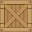`

One way to achieve the collisions would be to have one rect which covers the whole image. The function would check where the player is in relation to the crate e.g. if the players x position is less than the x position of the left of the crate then the players will be offset to the level when it touches the crate. This would also work when approaching a corner of the crate as the player would be in two sections e.g. top and left and so would be offset in both of these directions.

`

Another way to achieve the collisions would be to have four separate rects for each side of the crate. The player would then be offset based on which rect it is touching e.g. if they touch the left rect then they will offset in the x direction. A problem with this approach is the corners, if a player touches a corner, they may be offset in 2 directions, despite only entering from one side which produces an unwanted outcome.

### Other data structures

#### The game loop

The game loop is insanely important as without it none of the classes or functions are actually being called and used. The loop will be a while True loop and as with every pygame game loop it will need to detect if the user clicks the quit button and then close the program otherwise the program will run infinitely. Also within the loop will be where the sprites are drawn to the screen each frame. The update() functions for all of the classes will be called so that all of the classes are actually updated per frame. And most importantly the game loop will include pygame.display.update() as it is essential to actually update the screen with all of the sprites and images.

## Variable ideas:

### screen, clock, background, resolution

These variables will be used to set the screen width and height, frames per second and background image of the game. These variables will be set up and assigned at the beginning of the code during initialisation but wont be used much more throughout the program. The resolution variable which have to fetch the width and height of the monitor it is being ran on. As the game will be fullscreen, I will need to retrieve the monitors local resolution which will be held in the resolution variable.

### rect

The rect variable is responsible for holding the information of the rectangle which makes up the image of the player. A rect value contains four arguments which are (left coordinate, top coordinate, width, height). An easy way to get the rect for the player is to use the pygame function.getrect() which calculates the rect based on the image dimensions. For other rects such as boundaries I may have to hard code the rect values themselves rather than just getting them from an image.

### pos

The pos variable will keep track of the players position by getting the coordinates of the centre of the player image. pos is necessary for moving the player and spawning the player in the correct locations. The position of objects will be the center of the their image and therefore the center of their rect. This is important as the position may typically be the top left of an image.

### image

The image variable will be used to: set the base image for the player, change the size of the player, rotate the player, change the loaded image for animations and potentially for setting the hitbox sizes. Each object will have a image tied to it. This image will be cast to the screen using the draw() function for sprite groups in pygame rather than blitting each individual image which would be much more time consuming and less efficient.

### size and speed

These will define the size at which the image is enlarged/scaled down to and the speed at which the player moves. Both of these variables will be set in a separate settings file which can be easily updated rather than them being assigned values in the main program. Speed will be used to change the velocity which will be used in calculating the moved distance of the player.

### mouse_coords, playermouse_x, playermouse_y

mouse_coords will be used to assign the mouse x and y coordinates to, to get the mouse co-ordinates there is a built in pygame function pygame.mouse.get_pos() which returns 2 integer values ((x,y)). playermouse_x and playermouse_y will be assigned as the difference in X values and difference in Y values between the player and the mouse. To calculate the difference in x and y values between the player and the mouse, I will simply subtract the player position from the mouse position.

### kill_count, deathcount

The kill_count variable will simply keep track of how many enemies the player has killed and will update on kill. A potential issue with this is that if the player kills an enemy and the kill_count updates, but they have to restart the level then I would also have to reset the kill_count so that duplicate kills don’t count. The death_count variable will similarly track how many times the player has died and so will be fairly simple to implement.

### timer, internal_timer

The timer variable will keep track of how long the player has been playing since they begun the first level, I will achieve this by calculating the seconds based on the framerate and how many frames have passed, for this to work however I will need to lock the frames per second at a set number (which will be the clock variable). internal_timer is similar but will instead only time each specific level and will reset at the end of each level. I may save this variable to a text file or some other external file which holds the high score times for each level.

## Pseudocode

This section will be split into sections based on data structures including the classes, methods and loops, all of the code will be written in OCR reference A-Level pseudocode using the guide linked [here](https://www.ocr.org.uk/Images/260952-pseudocode-guide.pdf).

My pseudocode intends to contain all of the essential features which I outlined in my analysis section. It may include some of the less important features that I wanted to add but a majority of the extra features will be added in the development phase when I have a working program and I can iteratively test new features to see how they fit into the game.

### Player Class

For this section (and all of the classes) I will include sections of the code and keep them in chronological order i.e., the order in which they are written in the main code.

class Player

procedure __init__()

self.pos = (resolution.width DIV 2,resolution.height DIV 2)

self.image = set.image(player_base_image.png)

self.base_image = self.image

self.rect = Get.rect(self.image)

self.size = 1

self.speed = 1

self.attack_frames = [frame1.png, frame2.png, frame3.png, frame4.png, frame5.png, frame6.png, frame7.png, frame8.png, frame9.png, frame10.png]

self.attack_animate = False

    endprocedure

Here is where the player class is first initialised and variables are assigned. The procedure __init__() will only be ran once to initialise the class. The prefix ‘self’ signifies that that variable is specific to the class its being used in, in this case the player class. There are a lot of new variables being made here, and I suspect that I will need to add more when I begin development if I need to make changes.

The player is set to the middle of the screen because they wont move around the screen but rather everything else on the screen will move around them.

|  |  |
| --- | --- |
| Variable | Explanation and Justification |
| pos | This variable is a tuple which holds the x and y values (x,y) of the player sprites centre. This variable will be used to update the rect variable as in pygame I can update the pos and use it to set a centre for the rect (which is easier as pos takes 2 arguments compared to the rect which takes 4 arguments) |
| image | This holds the image which is currently being displayed to the screen, this variable will be updated a lot in the program as it will be changed for each animation e.g. the attacking or walking animation. |
| base_image | This variable holds the original image which is assigned to the image variable. This is useful if I ever need to set image = to the original image. |
| rect | Rects (rectangular area) will be used a lot in this program. rects contain 4 arguments (left, top, width, height) but I will update the players rect using rect.center = pos as the pos variable is easier to update. The rects will be used to detect collisions e.g., when the players rectangular area collides with a wall it, the program will detect this and stop the player walking through.  I will also be using rects to draw the player on the screen, this is because I am going to draw the sprites using the pygame sprite functions which requires a image variable and a rect variable. |
| size | This variable will be used when transforming the image for the player, in case it needs to be larger or smaller. This is a constant. |
| speed | This dictates how many pixels the player will move per frame and is used in the move() method, the speed is changed when the player holds CTRL to sneak. |
| attack_frames | This is a list which contains all of the images for the attacking animations, this list will be iterated through each frame to show the animation of the player attacking. |
| attack_animate | This is a Boolean variable which is set to True when the mouse button is pressed, there will be code later to check if this variable is True or False, if its True then the animation will play until it ends. |

    procedure player_rotation()

        self.mouse_coords = mouse.get_pos

        self.x_difference = self.mouse_coords[0] - self.pos[0]

        self.y_difference = self.mouse_coords[1] - self.pos[1]

        self.angle = aTan(x_difference / y_difference)

        self.image = rotate(self.image, self.angle)

        self.rect.centre = self.pos

    endprocedure

This procedure will rotate the players current image to face towards the mouse, I explain how the maths for finding the angle works in my player class section. The first line of code will use a function to get the x and y coordinates of where the mouse is on the screen. The next 2 lines calculate the distance horizontal and vertical distance between the mouse and the player respectively. This is then calculated using arctan(opposite/adjacent) to get an angle of rotation. A rotate or image transformation function will then be used to turn the player towards the mouse.

|  |  |
| --- | --- |
| Variable | Explanation and Justification |
| mouse_coords | This variable holds two values (x,y), these are the x and y coordinates of the mouse, this is simply used to find the difference between the player and the mouse. |
| x_difference , y_difference | This holds the difference in position between the mouse position and the player position. These values are used to calculate the angle of rotation |
| angle | This variable holds the angle of rotation (in degrees) that the player should be rotated clockwise |

procedure user_input()

        self.velocity_x = 0

        self.velocity_y = 0

        keys = get.keypresses()

        //for sneaking and walking slower

        if keys == 'CTRL' then

            self.speed = self.speed MOD 2

        endif

        //for directional player movement, the velocity variables will be updated which will added/subtracted to the player pos when movement is updated

        if keys == 'W' then

            self.velocity_y = -self.speed

        endif

        if keys == 'A' then

            self.velocity_x = -self.speed

        endif

        if keys == 'S' then

            self.velocity_y = self.speed

        endif

        if keys == 'D' then

            self.velocity_x = self.speed

        endif

        self.speed = 1 //resetting speed if it changed when CTRL is held

        if self.velocity_x != 0 and self.velocity_y != 0 then

            self.moving = True

        elseif self.velocity_x != 0 and self.velocity_y != 0 then

            self.velocity_x = self.velocity_x / (square root 2)

            self.velocity_y = self.velocity_y / (square root 2)

        else then

            self.moving = False

        endif

        mouse = get.mouse_presses()

        if mouse == left.press then

            self.attack_animate = True

endif

    endprocedure

This method is made up of 3 separate sections, the first section takes any keypresses from the keyboard using a function (in pygame this is pygame.key.get_pressed() ) and will change the players velocity accordingly e.g., if the key is ‘w’ the velocity will be set to a negative y as they are travelling upwards (the negative y direction). Also if the player is holding the CTRL key then the speed variable will be halved so that the player can move slower if they want to.

The second section checks if the player is moving in 2 directions at once. If they are then the speed variable will be multiplied by √2 as otherwise the player would move faster when walking diagonally and using this calculation offsets the increased speed. It also checks if the player is moving at all and if they are then the moving variable will be set to true.

The third section gets any mouse presses and then checks if the left mouse button has been pressed. If it is pressed then the attack_animate variable is set to true which then has an effect within the update() method later.

|  |  |
| --- | --- |
| Variable | Explanation and Justification |
| Velocity_x, velocity_y | These two variables will dictate how much distance the player should move and also which direction they will move. The variable ‘speed’ is used to update the velocity as speed is always positive and is not a directional value. The velocity is then used in the move() function to offset all of the items on the screen in the opposite direction of the player and the correct distance. |
| keys | This variable holds all of the keypresses from that frame, these are fetched using a function and then the variable is checked for which key specifically is pressed. |
| moving | This is a Boolean value which simply holds ‘True’ if the player is moving and ‘False’ if they aren’t. |
| Attack_animate | This is a Boolean value which is updated depending on whether the player is clicking the left mouse button, when it is true, an if statement within the update function will occur and then the animation for the players attack will play. |

procedure collisions_check()

        for object in objects

            if rect.collide(object) and self.pos[0] > object.pos[0] then

                self.velocity_x = self.speed

            endif

            if rect.collide(object) and pos[0] < object.pos[0] then

                self.velocity_x = -self.speed

            endif

            if rect.collide(object) and pos[1] > object.pos[1] then

                self.velocity_y = self.speed

            endif

            if rect.collide(object) and pos[1] < object.pos[1] then

                self.velocity_y = -self.speed

            endif

This section was added later in pseudocode development. It shows how the level will be updated when the player contacts the area where the exit of level is. This will call the update_level() function rather than calling it each frame which would cause a lot of unnecessary processes -> worse performance

        next object

if rect.collide(object.level_exit) then

level.current_level += 1

level.update_level()

endif

        for enemy in enemies

            if rect.collide(enemy.cone_rect) then

                frames_in_cone -= 1

            else then

                frames_in_cone = 60

            endif

if rect.collide(enemy.rect) and attack_animate == True then

enemies.remove[enemy]

all_sprites.remove[enemy]

endif

        if frames_in_cone <= 0 then

            level.game_over()

        endif

    endprocedure

This method iterates through each object within the list ‘barrier_objects’ which is just a list of all the objects which the player wont be able to walk through. It then checks if the player has collided with the object and where they are in relation to the object. The player will be offset based on which side of the object they are approaching from.

This will also iterate through all of the enemies in the enemy list and check if the player is colliding with the vision cone. If they are touching the cone for 60+ frames then the function game_over() from the level class will be called, resulting in a game over. If the player enters but leaves the cone quick enough then the frame counter will be reset to 60.

In this same for loop, the game checks if the player collides with the enemy directly AND are attacking. If this returns True, the enemy is removed from both the enemies list (handles the object itself and contains all of the attributes and methods) and the all_sprites group (handles the drawing of the enemy). There is no current course of action for if the player collides with the enemy and isn’t attacking.

|  |  |
| --- | --- |
| Variable | Explanation and Justification |
| object | This variable simply exists just to iterate through all of the objects within the sprite group ‘barrier_objects’ |
| frames_in_cone | This variable acts as a counter which counts down for each frame that the player is In the players vision. This allows the player a small window of time to react, the variable will simply reset to 60 when leaving the area of the cone. |

    procedure move()

        // self.pos[0] = self.pos[0] + self.velocity_x

        // self.pos[1] = self.pos[1] + self.velocity_y

        self.general_offset = (-self.velocity_x, -self.velocity_y)

    endprocedure

the // commented sections are from how the pseudocode originally worked before implementing the code for the camera. I have kept this code In because it may be needed if I choose to make a deadzone for the camera which would allow the player to move within a small area before the camera moves.

This method takes the velocity calculations of the collisions_check() and user_input() methods and makes a vector of the x and y velocity. The function pygame.math.vector() allows for 2 values to be taken into a format (x,y) and can be easily manipulated

|  |  |
| --- | --- |
| Variable | Explanation and Justification |
| general_offset | This variable in format (x,y) holds the values for how many pixels all of the objects on screen will be offset when the player moves. The player wont move on the screen but all of the objects will move the opposite direction. This variable is used in the camera() method in the Level class. |

    procedure update()

        self.user_input()

        self.move()

        self.player_rotation()

        if self.attack_animate == True then

            self.frame += 1

            if self.frame > 0 and self.frame < 11 then

                self.image = self.attack_frames[self.frame]

        elif self.frame >= 11 then

            self.attack_animate = False

            self.image = self.base_image

    endprocedure

endclass

This is the final function in the player class and what it mostly does is call all of the methods which need to be ran each frame. The update() method will be called in the game loop so that it occurs on each frame of the game. The second section of this method handles the attacking animation (and any other animations I may add as the code will be very similar), it checks if it should be playing the animation. To play the animation it will iterate through the images each tick, as the images are all stored in a list, the pointer in this list will just be incremented and the image variable set to the current image in the list. Once it has reached the end of the list, the animation ends and the image is set back to the base_image.

Endclass marks the end of the player class

|  |  |
| --- | --- |
| Variable | Explanation and Justification |
| frame | This is a counter which keeps track of which image in the animation list should currently be displayed. Is incremented on each frame rather than using a for/while loop which would break the flow of the game. Is reset to 0 upon reahing the end of the list. |

### Enemy Class

class Enemy

    procedure __init__(self, position, route, level)

        self.pos = position

        self.image = set.image('Enemy_base_image.png')

        self.rect = Get.rect(self.image)

        self.size = 1

        self.speed = 1

        self.route = route

        self.cone_image = set.image('cone.png')

        self.cone_rect = Get.rect(self.cone_image)

self.native_level = level

    endprocedure

This is the start of the enemy class where all of the variables are first initialised. A lot of the variables are similar to the player, with the enemy having a pos, image, rect, size and speed. The enemies however have a route which is passed in as a parameter (type integer) which corresponds to a list in a later method. They also have a separate variable for the cone_image and cone_rect which store the image for the cone and the area measurements respectively.

|  |  |
| --- | --- |
| Variable | Explanation and Justification |
| route | An integer which is passed in as a parameter and corresponds to one of the route lists within the larger 2d array |
| cone_image | Holds the image for the cone of vision, may use different images if there are different varieties of cone sizes |
| Cone_rect | Stores the rect values of the cone (left, top, width, height), will be updated based on the main pos and rect variables of the enemy class |

    procedure move(route)

        for enemy in enemies

            if self.route == 1 then

                route_destinations = [(100,100), (100,200), (200,200), (200,100)]

            elseif self.route == 2 then

                route_destinations = [(300,300), (400,400), (500,500), (400,400)]

            endif

            for I in route_destinations

                if self.pos == route_destinations[-1] then

                    self.destination = rouute_destinations[0]

                elif self.pos == route_destinations[I] then

                    self.destination = route_destinations[i+1]

                endif

            next I

            if self.pos[0] != self.destination[0] then

                if self.pos[0] > self.destination[0] then

                    self.pos[0] = self.pos[0] + 1

                elseif self.pos[0] < self.destination[0] then

                    self.pos[0] = self.pos[0] - 1

                endif

            endif

            if self.pos[1] != self.destination[1] then

                if self.pos[1] > self.destination[1] then

                    self.pos[1] = self.pos[1] + 1

                elseif self.pos[1] < self.destination[1] then

                    self.pos[1] = self.pos[1] - 1

                endif

            endif

        next enemy

    endprocedure

In this procedure each enemy is assigned a list which contains multiple co-ordinates, the route assigned is based on what is passed into the route parameter. This list is then iterate through to check if the enemy is currently at any of the locations. If it is at one of the locations its destination variable is updated which is the coordinate which it will move towards. Its x and y position are updated until they are = to that of the destination variable. If the current location of the player is the final item in the list then the destination will be set to the first item in the list.

When there are more routes I may put all of the lists into a larger 2d array and use that to store the original lists.

|  |  |
| --- | --- |
| Variable | Explanation and Justification |
| Route_destinations | A list which holds multiple x,y coordinates which are the points that the enemy will walk towards. These separate lists may all become part of a 2d array later in development |
| Destination | The coordinate which the enemy will walk towards, in the form (x,y) and is updated each time the enemy reaches the destination. The destination will need to be updated based on what the offset is for the camera. |

    procedure rotation()

        for enemy in enemies

            self.x_difference = self.destination[0] - self.pos[0]

            self.y_difference = self.destination[1] - self.pos[1]

            self.angle = atan2(self.x_difference , self.y_difference)

            self.image = rotate(self.image, self.angle)

        next enemy

    endprocedure

This is the same logic for as the player rotation method but instead of facing towards the mouse location, the enemy will face towards the destination coordinate. See the player rotation method for a more in-depth explanation. Again, a function will be used to rotate the image by the angle variable.

    procedure draw_cone()

        for enemy in enemies

            self.cone_rect.center = self.pos

            screen.draw(self.cone_image, self.cone_rect)

        next enemy

    endprocedure

This procedure updates the position of the cone on the screen by setting the center of the rect to that of the enemy position. This can be done directly in pygame using a built in function but the same effect could be achieved like this:

self.cone_rect = ((self.pos[0] - width/2), (self.pos[1] - height/2), width, height)

The cone is then drawn to the screen using the rect to know where it should be drawn

    procedure update()

        self.move()

        self.rotation()

        self.draw_cone()

endprocedure

endclass

This is simply a method to call all of the method which need to be ran on each frame. This is where the enemy class ends.

### Level Class

class Level

    procedure __init__(self)

        self.current_level = 0

        level_backgrounds = [background_image0.png, background_image1.png, background_image2.png]

        self.offset = (0,0)

        background = level_backgrounds[current_level]

        self.floor_rect = image.get_rect(background)

        self.end_screen = image.set('gameover.png')

    endprocedure

This is where the level class is initialised, and the variables are set up. The current level of the game is 0 (level 1 is 0, level 2 is 1 etc.). There is a list of all the background images for the game. A variable is made for the position vector by which every object in the game will be offset when the player moves. A rect Is made for the background image so that it can be moved and translated. A variable is set up to hold the image for the game over screen.

|  |  |
| --- | --- |
| Variable | Explanation and Justification |
| Current_level | Holds an integer (starting 0) which represents which level the player is currently in. |
| Level_backgrounds | A list which holds all the images for the backgrounds of each level. This list will not change or be updated at any point within the game. |
| offset | This variable holds the amount of x and y pixels by which each object on screen will be offset when the player moves, this is necessary for the camera to function |
| Floor_rect | Simply holds the rectangular area of the background image in the form (left, top, width, height)pixels. |
| End_screen | A variable which holds the image for the ‘game over’ screen. This will be shown when the player is caught by an enemy. |

    procedure update_level()

        background = level_backgrounds[self.current_level]

        for object in objects

            if object.native_level != self.current_level then

                objects.remove[object]

            endif

        next object

        for enemy in enemies

            if enemy.native_level != self.current_level then

                enemies.remove[enemy]

            endif

        next enemy

        for object in object_library

            if object.native_level == self.current_level then

                objects.append[object]

            endif

        next object

        for enemy in enemy_library

            if enemy.native_level == self.current_level then

                enemies.append[object]

            endif

        next object

    endprocedure

This method is responsible for updating the level upon a player entering a new level. First it sets the new background to be that of the current_level. Then it removes all of the objects and enemies which don’t belong to that set level, it finds these by checking if their native_level variable matches the current_level variable. If they don’t belong to that level then the objects and enemies lists are updated. There are four main lists here: objects, object_library, enemes, enemy_library. The lists ‘objects’ and ‘enemies’ represent all of the objects and enemies which are in the current level that the player is in, this is different to the ’object_library’ and ‘enemy_library’ lists which hold all of the enemies and all of the objects for the whole game. After removing all of the items which don’t belong to the level, the objects and enemies lists are appended with all of the items which do belong to the current level.

|  |  |
| --- | --- |
| Variable | Explanation and Justification |
| Objects | This list is responsible for storing all of the objects which are native to the current level. This list is updated when the level changes by the update_level() method. I am using lists to store all of the objects created by the classes so that I can iterate through them to update each object individually |
| Enemies | Similair to the ‘objects list’, this list is responsible for storing all of the enemies which are native to the current level. This list is updated when the level changes by the update_level() method. |
| Object_library | This list holds all of the objects in the game in one list. The purpose of this list is so that the objects list can be appended with items from this list if it needs them. |
| Enemy_library | This list holds all of the enemies in the game in one list. The purpose of this list is so that the enemies list can be appended with items from this list if it needs them. |

    procedure game_over()

        alive = False

        screen.draw('game_over.png')

    endprocedure

This is a very simple method which simply updates the alive variable to false and draws the game over image to the screen. I may in the future add buttons to this screen but that is an extra feature and I would implement it if I had time. The alive variable when set to false will mean that all of the update() methods will stop being called in the game loop and the game over screen will continue showing until the player closes the game.

|  |  |
| --- | --- |
| Variable | Explanation and Justification |
| alive | This variable holds a Boolean depending on whether the player is alive or not. The functions in the game loop are only called when alive == True so that the methods aren’t being called and updated when the game is over |

    procedure camera()

        self.floor_rect = floor_rect + player.general_offset

        screen.draw(background, self.floor_rect)

        for sprite in all_sprites

            offset_pos = (0,0)

            offset_pos = sprite.rect.center + player.general_offset

            sprite.pos = offset_pos

            sprite.rect.center = sprite.pos

        next sprite

    endprocedure()

endclass

This method is responsible for offsetting all of the objects on screen and updating their position. This method is called in the game loop each frame. The floor_rect is updated using the player.general_offest (taken from the player class) which moves it the opposite direction of where the player is moving. The background with its new position is then drawn to the screen. The method then iterates through each sprite in the allsprites group, then calculates the position that the sprite will be moved to.

This is also the end of the level class

|  |  |
| --- | --- |
| Variable | Explanation and Justification |
| Offset_pos | This holds the position which each sprite on screen will be moved to. It acts as a placeholder variable and exists more to demonstrate the logic of the pseudocode I’ve written so it may be removed in the development phase. |

### Object Class

class Object

    procedure __init__(self, position, type, level)

        self.native_level = level

        self.pos = (position)

        if type = crate then

            self.image = set.image('crate.png')

        endif

        if type = horizontal_wall then

            self.image = set.image('horizontal_wall.png')

        endif

        if type = vertical_wall then

            self.image = set.image('vertical_wall.png')

        endif

        if type = level_exit then

            self.image = set.image('level_exit.png')

        endif

        self.rect = get.rect(self.image)

    endprocedure

endclass

This is the only method in the object class. It gets its position and which level it belongs to passed in as parameters when the class is instantiated. The type parameter determines which image file is set to the image variable. The rectangular area is then found from the image file.

All of the collisions with the player are handled within the player class so there is no need for a method here.

One of the potential features from analysis was being able to interact with crates and hide inside them which I may still add if I have time. To achieve this I would get the coordinates of the mouse and if they are within the range of the crates rect area AND a mouse press is detected then a player.hidden variable would be set to true and hide the player image, and make it so that they cant be caught. This is only if I have the time to add this feature

|  |  |
| --- | --- |
| Variable | Explanation and Justification |
| Native_level | An integer which represents which level the object belongs to e.g. 0 represents level 0. This allows for objects to be loaded upon reaching a certain level so that different levels can have different layouts |
| type | A parameter passed into the object class as a string. Determines what image is used for the new object being made, this image will also determine the area of the object |

### Menu Class

class Menu

    procedure __init__(self)

        self.bg_image = set.image("menu_bg.png")

        self.button = set.image("button.png")

        self.button_rect = get_rect(self.button)

    endprocedure

This is where the menu class is initialised. I actually decided to add this class very late in design which is why I didn’t explain and justify it in my classes section. I will do so here. The menu designed here is a simple background image with a button that Is centered in the middle of the screen. When the button is clicked, the main game will be able to run. If I have time I will make it so the button changes colour when hovering over it. The reason for a menu is that it makes the game appear more polished rather than dropping the player straight into the game.

|  |  |
| --- | --- |
| Variable | Explanation and Justification |
| Bg_image | Holds the image for the menu background |
| button | Holds the image for the button which is displayed above the menu background |
| Button_rect | Holds the measurements for the rectangular area of the button image |

procedure button

        self.mouse_coords = mouse.get_pos()

        mouse = get.mouse_presses()

        if mouse == pressed AND self.button_rect.left <= self.mouse_coords[0] <= self.button_rect.right AND self.button_rect.top <= self.mouse_coords[1] <= self.button_rect.bottom then

            start_game = True

        endif

    endprocedure

endclass

This method checks if the mouse is over the button and if the mouse is clicked. It checks this by checking if the mouse x coordinate is between the left and right coordinate of the button and if the mouse y coordinate is between the top and bottom coordinates of the button.

When the button is pressed, the variable start_game Is simply set to true and then the rest of the game loop can then run as normal. This is the end of the menu class.

|  |  |
| --- | --- |
| Variable | Explanation and Justification |
| Start_game | A Boolean variable that is set to false at the start of the program. When this variable is true, the majority of the game loop will run so this acts as a switch between the games menu and the actual main body of the game. |

### Instantiation

player = class.Player()

menu = class.Menu()

enemy_library = []

enemy_library.append(Enemy((100,100), 1, 0))

enemy_library.append(Enemy((300,300), 2, 0))

enemy_library.append(Enemy((100,100), 2, 1))

enemy_library.append(Enemy((300,300), 2, 1))

object_library = []

object_library.append(Object((500,500), crate, 0))

object_library.append(Object((700,700), horizontal_wall, 0))

object_library.append(Object((700,400), vertical_wall, 0))

object_library.append(Object((900,400), vertical_wall, 0))

object_library.append(Object((1000,200), level_exit, 0))

object_library.append(Object((140,200), crate, 1))

object_library.append(Object((700,700), horizontal_wall, 1))

object_library.append(Object((700,400), vertical_wall, 1))

object_library.append(Object((900,400), vertical_wall, 1))

object_library.append(Object((1000,200), level_exit, 1))

enemies = []

objects = []

level.update_level()

all_sprites = sprite.group()

for enemy in enemy_library

    all_sprites.add(enemy)

next enemy

for object in object_library

    all_sprites.add(object)

next object

Here is where the classes are used to create/instantiate objects. Only one player is made. Both the enemy_library and object_library are lists which contain objects created by the Enemy and Object classes respectively. The enemies and objects lists are then created to hold the objects of the current level and are immediately updated with the level.update_level() method.

A sprite group is then made (in pygame this uses the image and rect variables of the sprite to know where and what to draw to the screen) and all of the enemies and objects are added. However the player is not added as I don’t want it to be updated in the camera function the same as the rest of the sprites.

The positions of the enemies and their routes (and the objects), will probably change in development so the values shown here are more a demonstration of how it would work rather than the final finished locations.

|  |  |
| --- | --- |
| Variable | Explanation and Justification |
| All_sprites | Not a variable but a sprite group, I’m unsure whether this Is specific to pygame or not but if you wanted to achieve this in another language you would just use whatever draw function is native to that language and just pass through the image and position as normal as that’s all I’m really using the sprite groups to do. This sprite group holds all the sprites(excluding the player) and will draw them to the screen using the image and rect variables. |

### Game loop

while True == True

    for event in get.events

        if event == event.quit() then

            quit()

        endif

    next event

    if start_game == True then

        if alive == True then

            screen.draw(background, (0,0))

            all_sprites.draw(screen)

            level.camera()

            player.update()

            enemy.update()

        if alive == False then

            screen.draw('game_over.png')

        endif

    elif start_game == False then

        screen.draw(menu.bg_image, (0,0))

        screen.draw(menu.button, (resolution.width DIV 2, resolution.height DIV 2))

menu.button()

    display.update()

endwhile

This is the game loop which runs until the program is closed. It checks for this by getting events and if that event is the exit button being pressed then the program will close, this Is basically required for any pygame program with a display. Provided that alive == True, all of the classes are updated except the object class which doesn’t have an update function. While the player is dead the game over screen is shown.

The actual gameplay only begins when the button on the menu is clicked which sets start_game = True. When it is False (which it is set to by default) the background for the menu is drawn, the button is drawn in the centre of the screen and the method menu.button() is called to check if the button has been pressed.

Before the end of the loop the display is updated to have all of the changes which have occurred on this tick. This is an essential line of code as without updating the screen it will just be blank.

This marks the end of the pseudocode section, It doesn’t contain every feature that I conceptualised but it does contain all of the essential features which I wrote about and meets all of my success criteria. As I stated at the start of the pseudocode, there will be more added in the development section and the pseudocode will almost definitely have errors with in it so a lot will change.

## Testing

Testing will occur during the development phase of the program. Development will use iterative testing and follow a process of: **Code creation -> Code testing -> Find Errors -> Fix Errors -> Repeat until there are no errors -> Implement new code.** In the section I will outline all of the data and methods I will use to test my program.

The methods spoken about here in testing are the methods which are present within my pseudocode so I will be using the same names for them here.

### Methods/Functions

#### Player

|  |  |  |  |  |
| --- | --- | --- | --- | --- |
| Method | Data | Expected Outcome | Error Outcome | Justification |
| Player_rotation() | Mouse movement | Player sprite rotates to face the mouse | Player doesn’t rotate/ rotates the wrong way | This is to test that the rotation function works at intended. Tests that the mouse location is being fetched. |
| User_input() | Directional Input (‘W’ / ‘A’ / ‘S’ / ‘D’) | Objects and background in the opposite direction of the key being pressed | Objects and background don’t move/ move at wrong speed/ move in wrong direction | Tests that the player moves when the movement keys are pressed. |
| User_input() | Input ‘CTRL’ | Player moves at 0.5x speed so objects move at 0.5x speed | Speed doesn’t change/ too fast or slow/ objects move at different speeds to each other | This is to test that the player slows down as intended. This input data is the key used to slow down. |
| User_input() | Input any keys (excluding WASD, CTRL and mouseleftclick) | Nothing happens | Game responds in any way | This is a test to make sure that the keys which aren’t being used in any part of the program, don’t have an effect on the game. |
| User_input() | Player moving diagonally | Player should move at the same speed as when they move horizontally/ vertically | Player moves too fast | This input is tested as moving diagonally may cause the player to move faster as they are moving in 2 directions at once. |
| User_input() | Mouse click | Player should perform the attacking animation | Doesn’t play animation / plays animation multiple times | This input is tested to check that the mouse input is being detected, and that the animation is playing as intended. No other data should activate this animation. |
| Collisions_check() | Player walks into object | Player should not be able to walk through the object | Player can walk through object / Player gets stuck when contacting with an object | This data is tested to check that the collisions are working with the stationary objects. |
| Collisions_check() | Player walks into the level exit area | New level should be loaded | Stays on the same level | This data is tested to check that the collisions are working with the level exits and that they are loading the new levels. |
| Collisions_check() | Player walks into an enemy vision cone and stays inside for 60 ticks | Game over | Game continues as normal (no game over) | This data is tested to check that the timer for vision cones works and collisions with the cones works. |
| Collisions_check() | Player walks into an enemy vision cone but exits before the 60 tick timer | Game should continue as normal | Game over | This data is tested to check that the timer for vision cones works and collisions with the cones works. |
| Update() | Mouse click -> attack_animate variable is set to true | Plays attacking animation once | Doesn’t play animation | This data is tested to check that the animations for attacking are played when the mouse is clicked. Checks if this function is actually receiving an update when the mouse is clicked |

#### Enemy

|  |  |  |  |  |
| --- | --- | --- | --- | --- |
| Method | Data | Expected Outcome | Error Outcome | Justification |
| Move() | Route destinations | Enemy walks to each coordinate in order | Enemy doesn’t move / goes to wrong coordinate / doesn’t follow the order | This data is not inputted in runtime but is passed as a parameter into the method. Is used to test that the enemies are following the correct route no matter what route is inputted. |
| Rotation() | Run program | Enemy rotates to face its destination | Enemy doesn’t rotate / rotates incorrectly | This input data is just running the program because this method should automatically run this process from start until the game ends. Tests that the enemy is rotating and doing it correctly. |
| Draw_cone() | Run program | Cone is drawn at the correct location | Cone is drawn at wrong location | Tests that the image of the cone is actually being drawn and being drawn at the right location. |

#### Level

|  |  |  |  |  |
| --- | --- | --- | --- | --- |
| Method | Data | Expected Outcome | Error Outcome | Justification |
| Update_level() | Level change (player enters a level exit) | Background changes, new objects loaded, new enemies loaded, old level deloaded | Background doesn’t change / new data isn’t loaded / old data isn’t deloaded | This data is tested to check if the level actually changes upon entering a new level. |
| Game_over() | Game_over == True | Game over screen is loaded, all other processes are stopped | Game over screen isn’t drawn / other processes continue | This data is tested to check if the game over sequence occurs when the variable is set to true. This change would occur in the player class. |
| Camera() | Player moves | All objects on screen move opposite to the directional input | Objects on screen don’t move / move in wrong direction / at inconsistent speed | This test data is chosen as it is the only time in which the objects on screen should move. If they move due to any other data then there is an error. |

#### Object

|  |  |  |  |  |
| --- | --- | --- | --- | --- |
| Method | Data | Expected Outcome | Error Outcome | Justification |
| __init__() | Image passed as parameter | Draws image that is passed into the method. Has rect of that image. | Draws no image, incorrect rect measurements | Testing that any image can be used to make an object and get the area of that object. |
| __init__() | Position passed as a parameter | Image is drawn at the correct location | Draws no image, drawn at wrong position | Testing that images are drawn at the right location of whatever is passed into the method. |

#### Menu

|  |  |  |  |  |
| --- | --- | --- | --- | --- |
| Method | Data | Expected Outcome | Error Outcome | Justification |
| Button() | Button is clicked | Menu is closed -> game is loaded | Menu doesn’t close and game cant begin | This tests that the button detects a click and that it actually loads the game after. |
| Button() | Screen clicked not on button | Menu stays open, game cant begin | Menu is closed -> game is loaded | Tests that only when the mouse is on the button that the button detects a click. |

# Development

I intend to use visual studio code as the IDE for developing my program. This is mostly due to the ease of access to other files and navigating the menus. It has other benefits such as auto indentation or being able to search for certain parts of code. I will avoid using any extensions that do any of the coding for me or make the process easier.

Majority of the code will be commented, so while I will explain and justify the code and the images of code that I add, a lot of explanation will be from the comments themselves.

I wont bother documenting small errors like syntax errors due to spelling mistakes, however I will document any major logic errors or roadblocks I run into which will require a different approach.

Coding and testing will not be separate sections but rather be part of the same section as they will take place at the same time, this allows me to iteratively develop my code and change the issues found in testing.

### Formatting and Naming conventions

For the majority of naming conventions I will be using the snake_case convention as I also stated in the design section at the start of my pseudocode. I find it easiest to read and makes variables more understandable to others who may view the code.

|  |  |
| --- | --- |
| Type | Format |
| Commenting | Comments will be before functions / methods or on the end of lines of code which need commenting |
| Operators | Operators will have whitespace on either side of the operator e.g., 1 + 1 = 2 (rather than (1+1=2) |
| Commas | Commas used in lists or parameters will be followed by a whitespace e.g., 1, 2, 3 |
| Variables | snake_case |
| Functions | snake_case |
| Constants | snake_case |
| File names | PascalCase.fileformat |
| Folders | PascalCase |

### Setting up the program

BEGIN

Import all modules

resolution = get_resolution()

screen = display.set_screen((resolution.width,resolution.height))

background = set.image(background_image.png)

clock = time.clock()         #(Setting the program to run at 60fps)

‘alive’ was added later and so is explained later

alive = True

BEGIN naturally indicates where the program begins. ‘Import all modules’ represents all of the modules I intend to import and use: pygame because I’m making my game with pygame so I need it for a lot of the functions, math module for some of the more complex maths calculations I will need to do such as the trigonometry for player rotation.

There are 4 new variables being setup here: resolution, screen, background and clock.

|  |  |
| --- | --- |
| Variable | Explanation and Justification |
| resolution | This variable is a tuple which holds two values (width of the monitor, height of the monitor). These values will be gained using a function to fetch them from the native monitor. Pygame has a built in function for this, pygame.display.Info() |
| screen | This variable is used to set the screen display, here the dimensions are passed in (using the resolution variable). This screen variable will be used everytime something is drawn to the screen e.g. the player sprite. |
| background | This variable simply holds the image which I am using for the background. This saves me having to write out the file location each time I want to use the image |
| clock | This variable is used to set the framerate or ticks per second of the program. This will be set to 60 FPS at the end of the program. Keeping the FPS at a locked number means that the program should run the same on any computer. |

## Stage 1

This is the first stage of the game, in this stage I plan to add the player, objects and enemies and have a working camera. All of these will be fairly rudimentary and simple in design at this stage. They wont be in the correct places as I plane to organise all of the objects and enemies in the second stage when I begin to actually put the levels together rather than them just be scattered all over the place. This is also where the bare basics of the program will be set up, the game loop will be made and the modules imported. The screen will be created and any other connected files will be set up to be imported into the main program.

The main file will be named main.py and a folder ‘Assets’ will hold multiple folders:

* ‘Player images’
* ‘Level images’
* ‘Enemy images’
* ‘Object images’
* ‘Sounds’

All these folders hold their respective assets. This iteration will follow a process of **Success criteria -> Coding -> Testing.**

### Setting up the game

This will be one of the shortest sections as I’m simply just creating a surface to later display everything onto.

#### Success Criteria

* Import all modules
* Create a display that fits the screen and has a name
* Make it able to be closed by clicking the exit button

#### A computer screen with white text Description automatically generatedCoding + Testing

Here I import pygame and initialise it, the rest of the code is explained in comments.

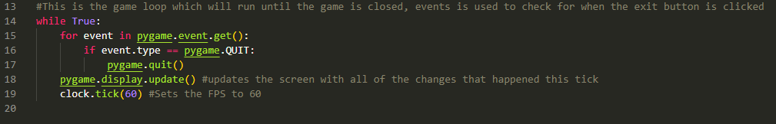This is the game loop which is responsible for the game actually talking place. This code checks if the exit button is pressed and will close the program If so.

**Test 1**

The screen Is drawn but as it is Fullscreen there is no way to exit the program as the exit button cant be accessed. To make it possible to close I will add a key input detection for the escape key to also close the program. I will also set the screen size to be smaller than Fullscreen for testing purposes.

**Changes**

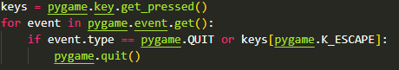Screen is now smaller so that the title can be read, and the exit button can be pressed

The program now gets the keys pressed, it then checks if the escape key is pressed and will close the program if so.

**Test 2**

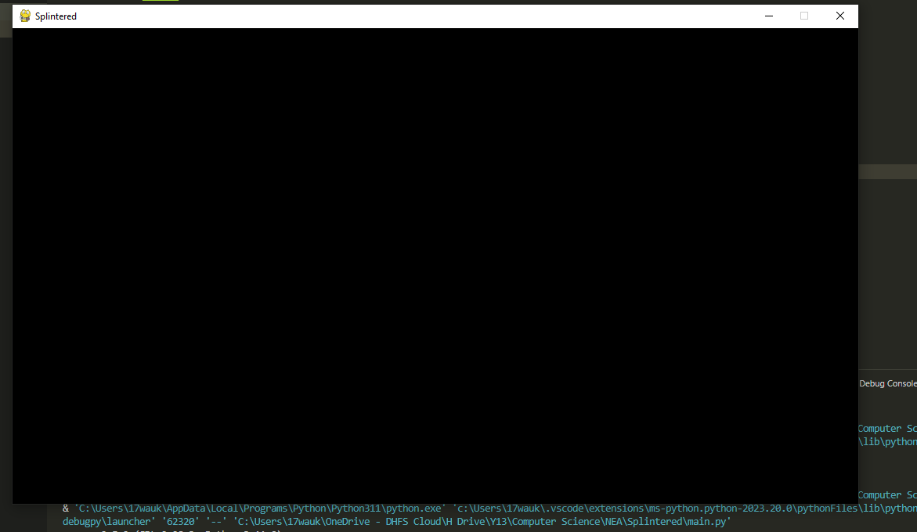

|  |  |  |
| --- | --- | --- |
| Test Data | Outcome | Success |
| Running the program | Produces a black screen, Screen has a name, screen is the correct width and height. | **Yes** |
| Quit button pressed | Closes the screen as intended | **Yes** |
| Esc button pressed | Closes the screen as intended | **Yes** |

### Adding the player

Because there is no camera yet, the player will move around the screen rather than the screen moving around the player. The camera will be the next feature I implement. In this section I also plan on adding a placeholder background for the player to move around on

#### Success Criteria

* Background image
* Player Is drawn to the screen
* Player that can move around the screen
* Player can turn to face the mouse
* Player has an accurate rectangular area

#### Coding + Testing



This is how I set up the image for the background, I made a variable to hold the image file so that I don’t have to reference the image every time its used. Convert_alpha() is used to remove transparent parts which while this specific image has none, I will try to use this function for all images. The rect is then taken from the image and the centre of the rect is set to the centre of the screen(This is for backgrounds which may not be the same size as the screen so they are still centered). The function pygame.transform.rotozoom is used here to scale the image to 1.2x the size as it didn’t quite fit the dimensions of my screen.

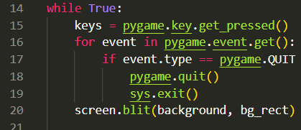Where the image is drawn in the game loop. Result when ran: 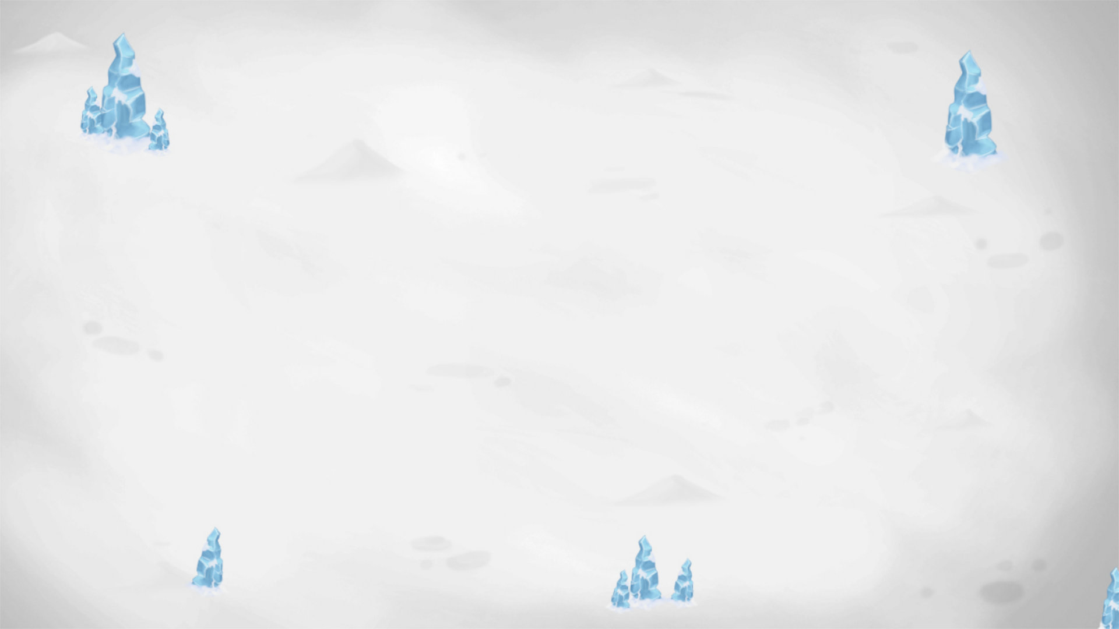

Setting up the player class 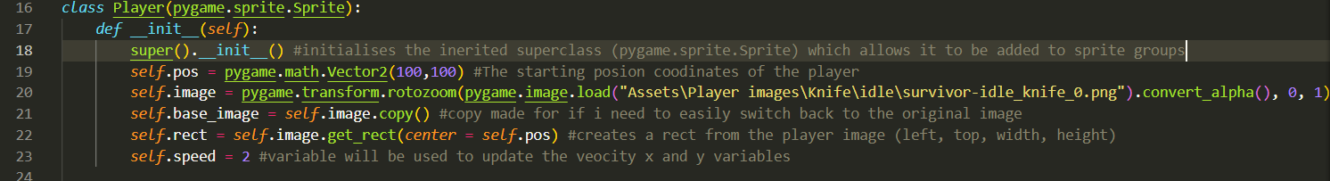

Here is where the class is initialised and the attributes of the player are set up. I don’t test the code at this point as nothing will happen until the player starts being drawn. Convert.alpha() is used again to remove transparent parts of the image.

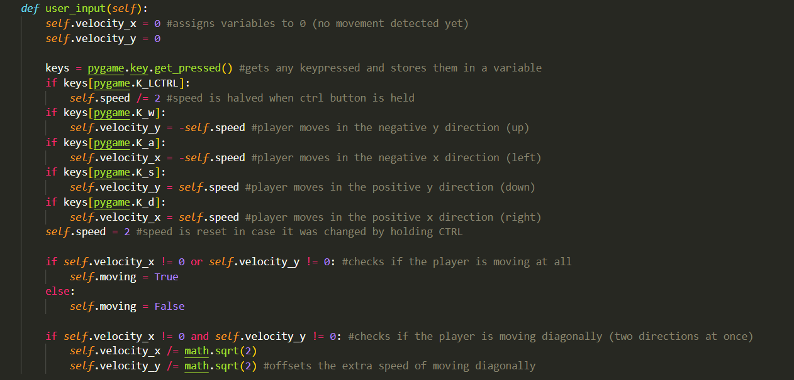

Here is the method for checking the user inputs. It is very similar currently to my pseudocode. The movement at this stage will be different until I add my camera functionality. Inputs are stored in a variable and then are checked for which key is pressed.

Velocity variables are used here rather than just adding to the pos variable. This is so that all of the changes to position can be added together then update the pos variable with all the changes at once instead of updating pos multiple times per tick.

I explain the logic of dividing by square root 2 in the development.

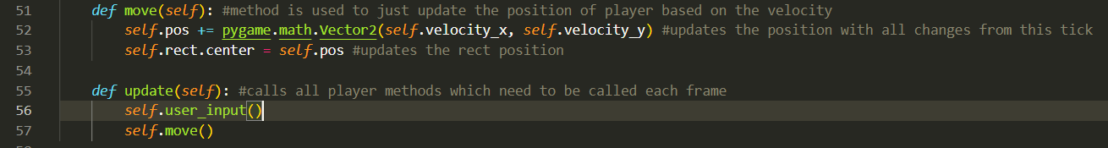

The movement is handled in its own method so as to separate the user_input() and the move() but they could really just be part of the same method. The update() method is used as it can be easily called using the pyame.sprite.Group.update() function which calls the update method in each sprite in the group. 

This is where the player is instantiated, occurs outside of the class but before the game loop as this instantiation should only happen once. Once it is intantiated it is added the all_sprites sprite group. 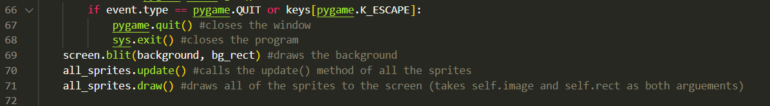This is where in the game loop the sprites are updated and are drawn. I believe at this stage there is enough to test the player.

**Test 1**

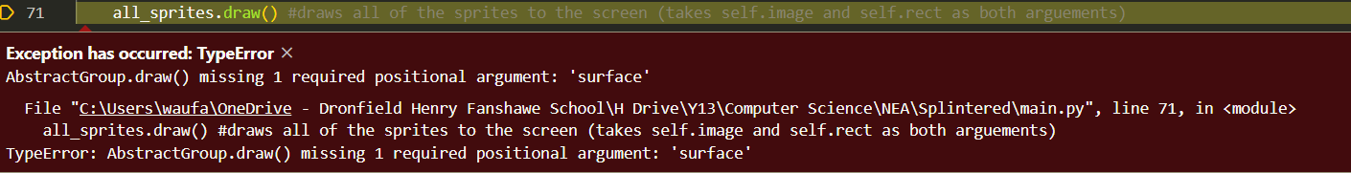**Problem:** Forgot to write which screen to draw the sprites to

**Fix:** 

**Test 2**

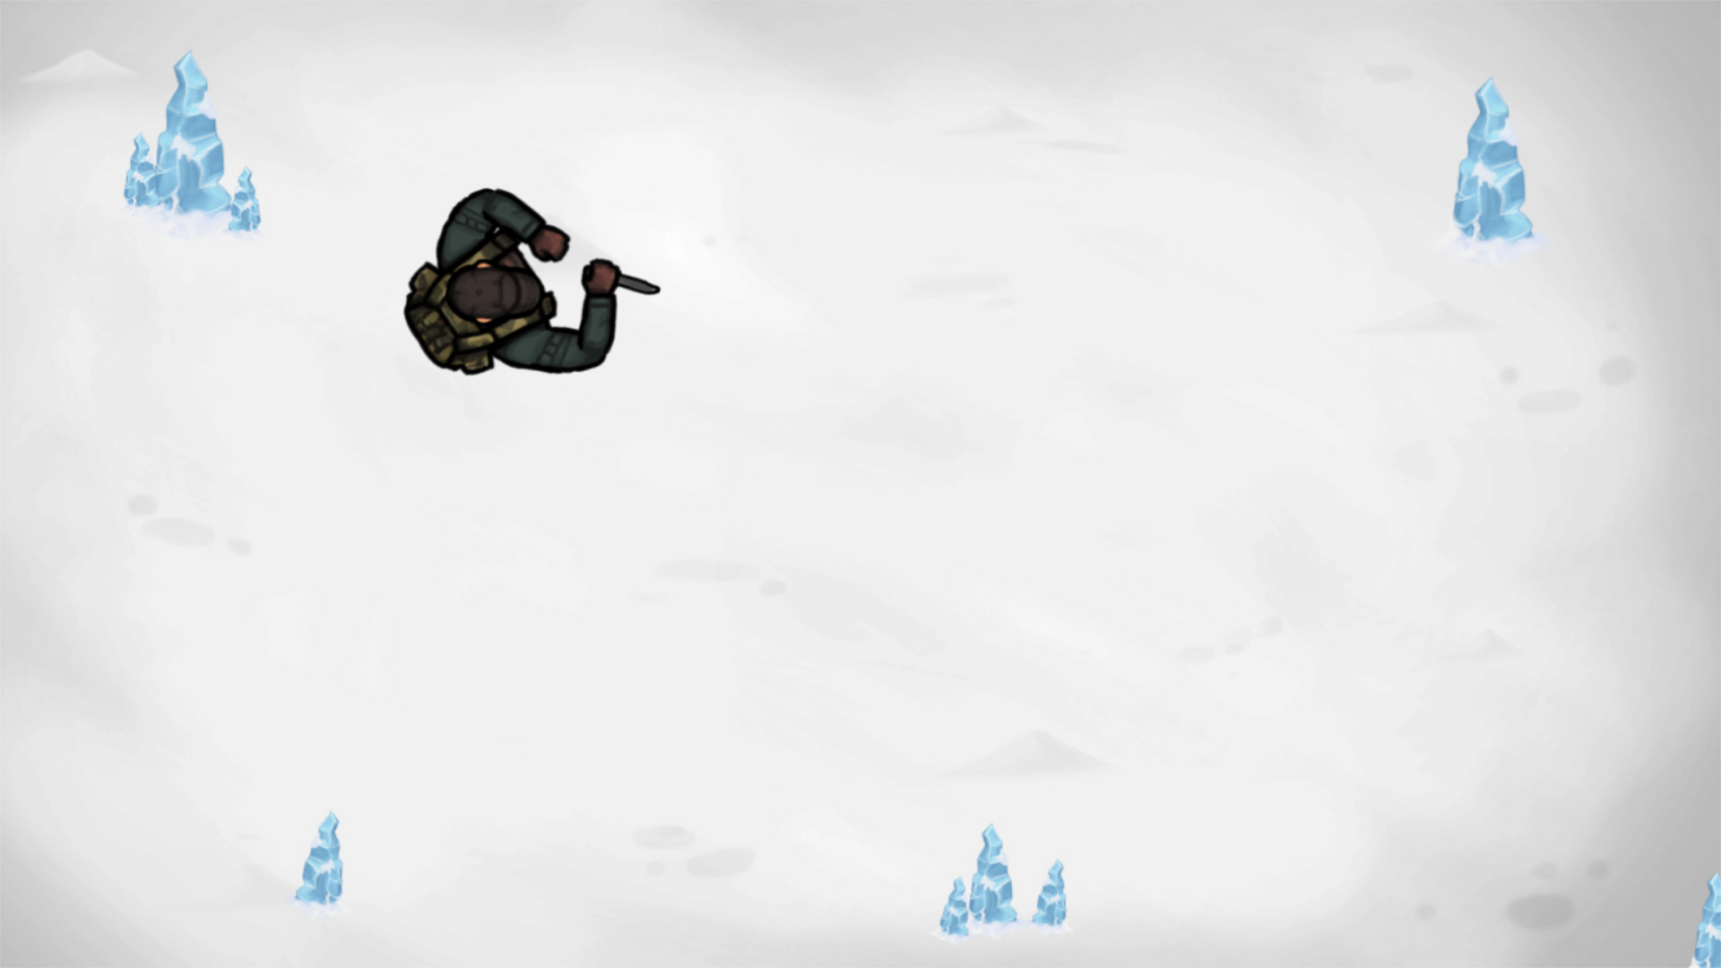

**Successes:**

* Player is drawn to the screen
* Player moves in direction of input
* Player moves slower when ctrl is held

**Problems:**

* Player cant rotate
* Player image too large
* Player moves too slow
* Havent tested the rectangular area

I will first fix the size and speed as these should be a simple fix. I will also draw the rect to test the hitbox of the player

**Fix:**

I decided to creat a module named constantsSettings.py to store the constants which I may need to just easily change. Here is all it stores currently: 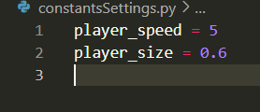

Where these variables are then used: This will reduce the size of the player image using the rotozoom function

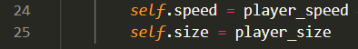

This code will draw the outline of the players rect.

**Test 3**

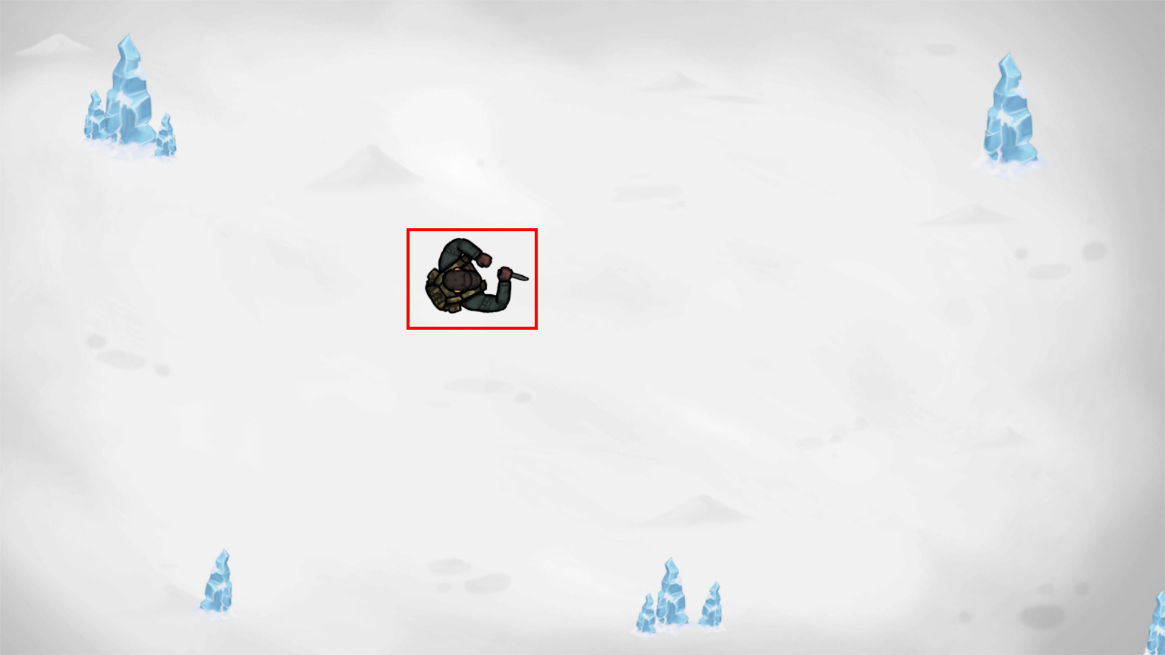

**Successes:**

* Player is a better size (smaller)
* Player moves at a more suitable speed (faster)
* Rect is visible

**Problems**

* Player still cant rotate
* Rect is slightly too large

The rect being slightly too large is a negligible issue currently, my next course of action is to implement the method for rotation.

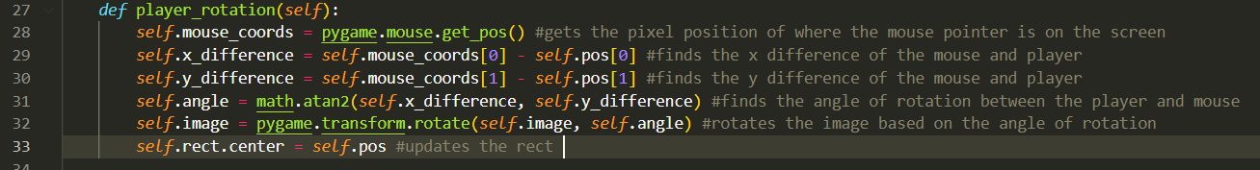This is basically my pseudocode with tweaks to fit the python and pygame syntax. The logic is explained in my pseudocode. The math.atan2() function is used rather than math.atan() because atan2() takes two arguments which it knows the sign of so it can give the correct quadrant of the angle.

While reading the documentation I realised that atan2() returns a radian value whereas transform.rotate() takes an argument of degrees so I made a small change.



**Test 4**

I cant provide screenshots of this test, but the player spins insanely fast and moves off screen without any keys being pressed. The program then cant be closed using the escape key so has to be manually stopped on visual studio code.

To fix this problem, I changed it so that the image variable is set to the base_image variable so that the rotation on the previous tick doesn’t affect the rotation on the current tick. This was causing the player to spin exponentially fast which Im not sure how it caused the image to move but it explained the spinning.

**Test 5**

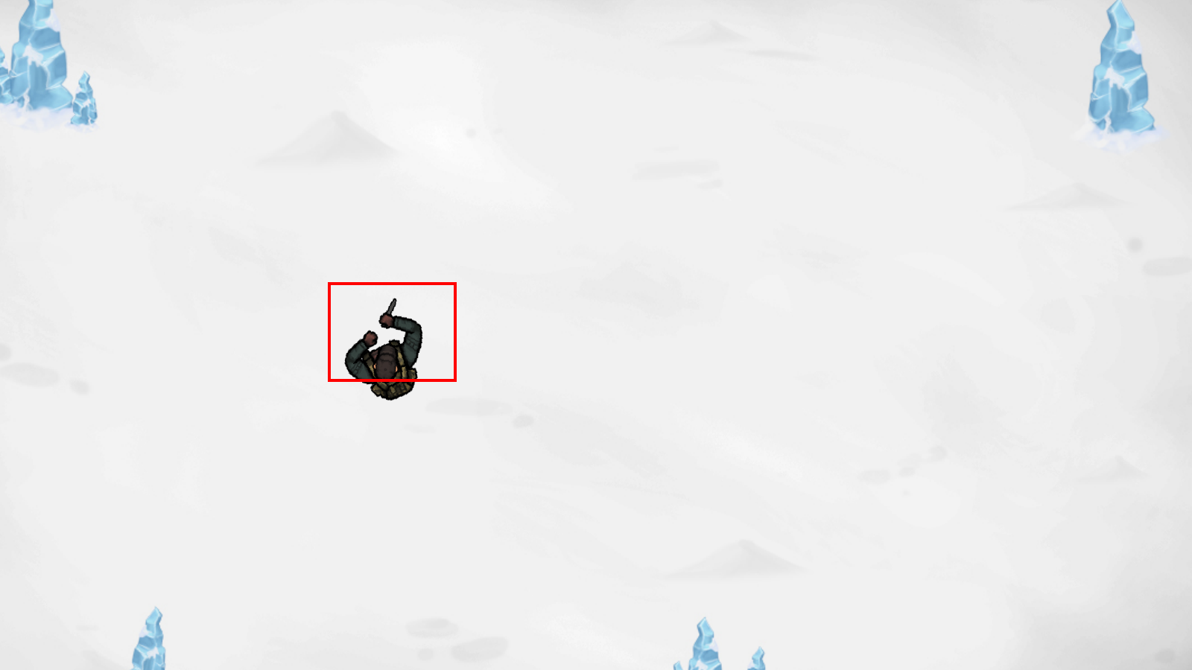

**Successes**

* Player now rotates when the mouse is moved

**Problems**

* Doesn’t look towards the mouse
* Doesn’t rotate around its centre

**Fix**

The first issues that I will fix is that the player doesn’t face towards the mouse. The issue is that the default image of the player is facing right but the angle is calculated from the player image facing upwards (at 0 degrees).

I solved this by just rotating the image by -90 degrees so that it faced upwards.



The next issue to fix is that the rotation doesn’t spin around the centre of the player image.



This updates the position of where the centre of the rotated image is, rather than just where the players position is.

**Test 6**

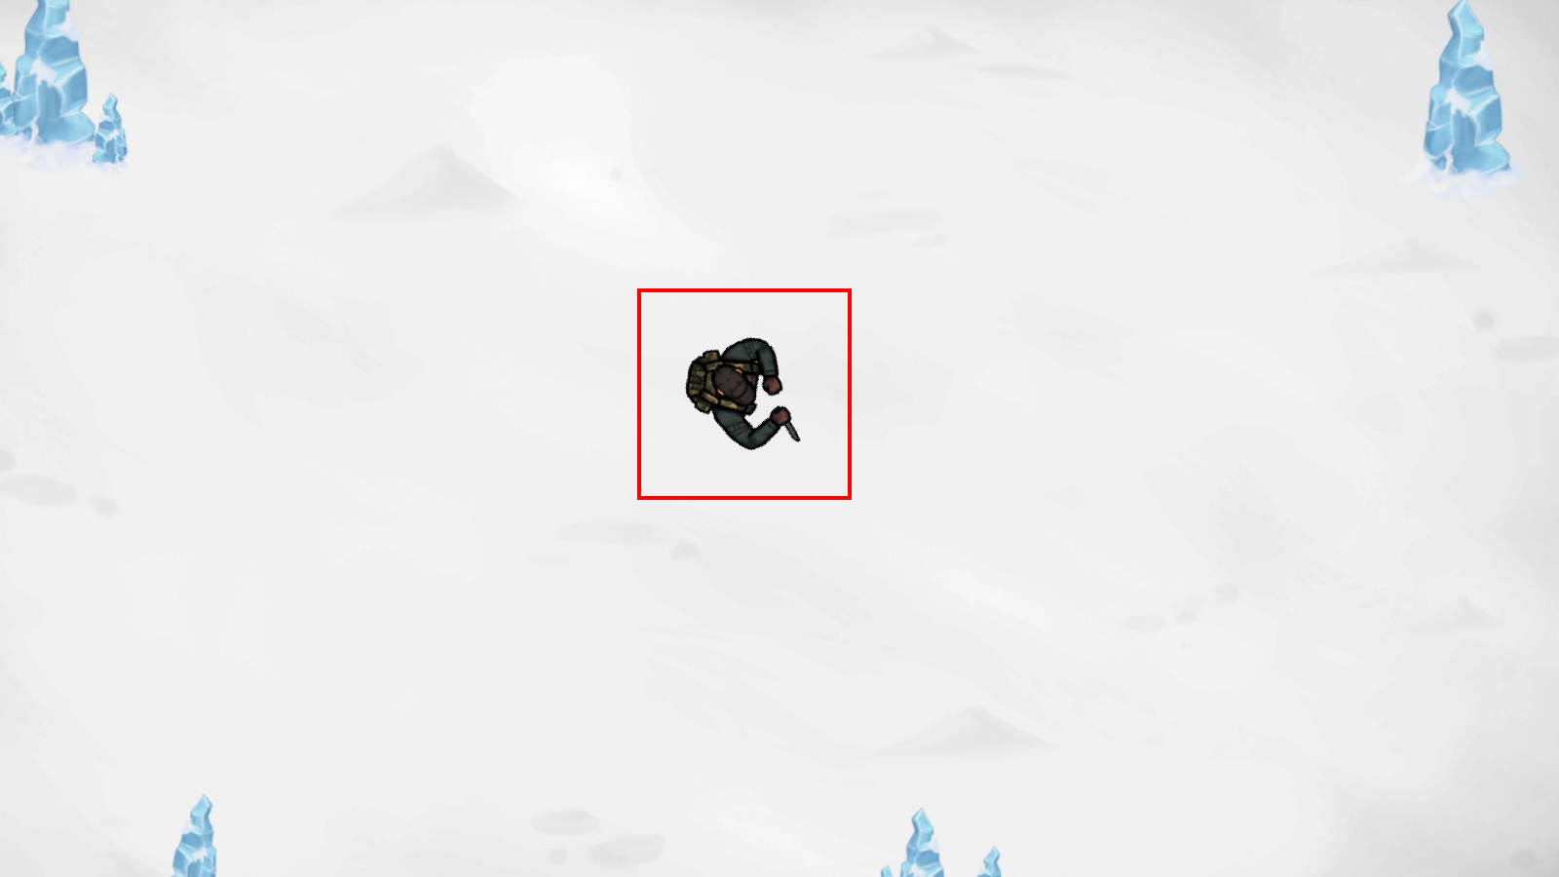

The player now rotates to face the mouse AND around a fixed point, however a byproduct of this is that the rect size changes based on which way the player is facing. To solve this I will create two rects, one which is used to detect close collisions with the player, and one to just know where to draw the player

I will make a rect based on the size of the image, then scale this down based on the scale I’m using for the image (Currently 0.6x). The image size is 289x224 so multiplying the width and heigh by 0.6 = 173.4x134.4. I want to make it a square so what ill do is set the dimensions to be 135x135.



The code in the settings file which is imported to the main.py: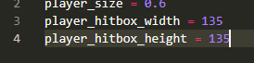 Drawing the new rect so I can test for it

**Test 7**

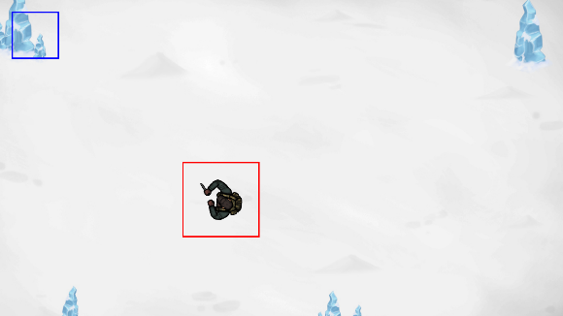The hitbox_rect is drawn (indicate by blue square) but the rect position is not being updated.

Can update this by just updating the center = self.pos variable in the move method.

Here is the fix: 

#### **Final test**

Screenshot of run-time:

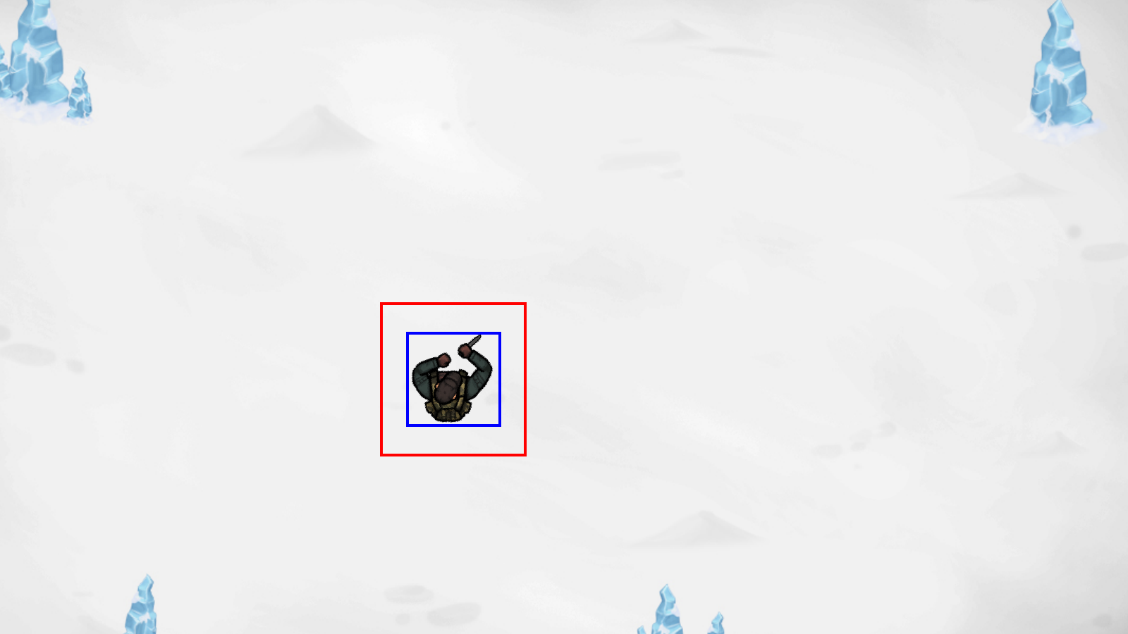

|  |  |  |  |
| --- | --- | --- | --- |
| Test | Expected Output | Actual Output | Success? |
| Run program | Creates a screen, draws player, draws 2 separate rects, draws background | Creates a screen, draws player, draws 2 separate rects, draws background | ✓ |
| W key pressed | Player moves up (pos[1] decreases) | Player moves up (pos[1] decreases) | ✓ |
| A key pressed | Player moves left (pos[0] decreases) | Player moves left (pos[0] decreases) | ✓ |
| S key pressed | Player moves down (pos[1] increases) | Player moves down (pos[1] increases) | ✓ |
| D key pressed | Player moves right (pos[0] increases) | Player moves right (pos[0] increases) | ✓ |
| CTRL key held | Player speed is halved (self.speed // 2) | Player speed is halved (self.speed // 2) | ✓ |
| Mouse pointer in top left of screen | Player looks at the top left of the screen | Player looks at the top left of the screen even when moving around | ✓ |
| Mouse pointer in the centre of the screen | Player looks at the centre of the screen | Player looks at the centre of the screen wherever they are on the screen | ✓ |
| Player moves in any direction | Self.moving == True | Self.moving == True | ✓ |
| Mouse click | Nothing happens | Nothing happens | ✓ |
| Player walks to edge of screen | Player will walk off screen | Player walks off screen | ✓ |

All of the success criteria I had for this section has been successfully met. The mouse click and edge boundaries haven’t yet been implemented so they have no functionality. They will be added later, I am happy to begin implementing the camera now as it will change a lot of how positioning is handled so id rather add it sooner than later.

### Adding the camera

What the camera method will do at this stage is offset the background depending on the players movement while the player stays locked in place.

#### Success Criteria

* Background moves according to player movement
* Player stays locked in place
* Level class containing the camera method

#### Coding + Testing

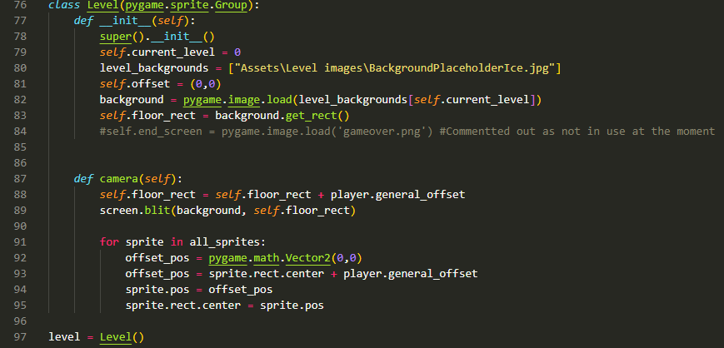  
For implementing this code, I copy and pasted the level class directly from my pseudocode and just edited it to be the correct syntax for python and pygame, the logic remains essentially the same. For making the attribute offset_pos the function pygame.math.vector2() is used to store (x,y) values as they can be easily updated and changed rather than a tuple.

The Camera method here could be cleaned up a bit as I didn’t factor efficiency into my pseudocode. I don’t expect the code to run at this stage but ill run it to find and iron out the errors.

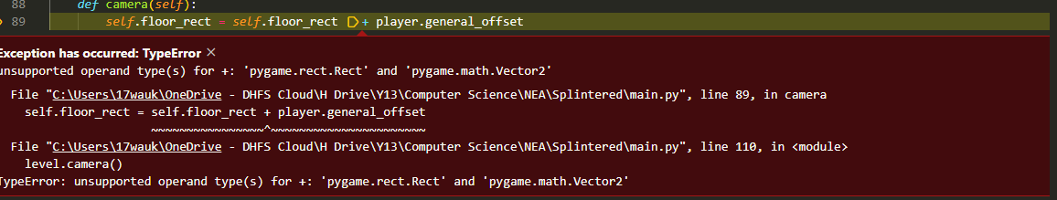This error occurred because the rect takes 4 arguments but the general offset variable only contains 2 integers. To fix this I will just update the centre of the rect, which takes 2 arguments (x coordinate, y coordinate).

Also removed this section of code as the background is being drawn in the camera method now instead of the game loop: 

**Test 1**

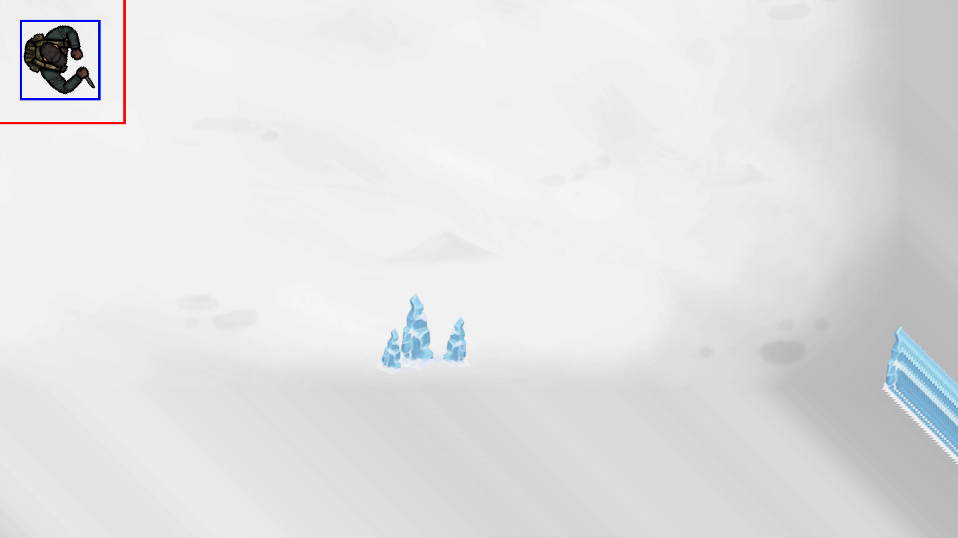

**Successes:**

* Background moves when the direction keys are pressed
* Background moves in the correct direction
* Moves at appropriate speed

**Problems**

* Player is locked in the top right corner of the screen
* Player can move about 4 pixels before it is moved back to its starting position
* When the player leaves the area of the background, images are drawn but not drawn over (as seen in the right hand side of the image). Background isn’t big enough

**Fix 1**

Firstly I will lock the player to the middle of the screen, I will change the starting position to be that of the resolution width and height divided by 2 to find the centre of the screen.

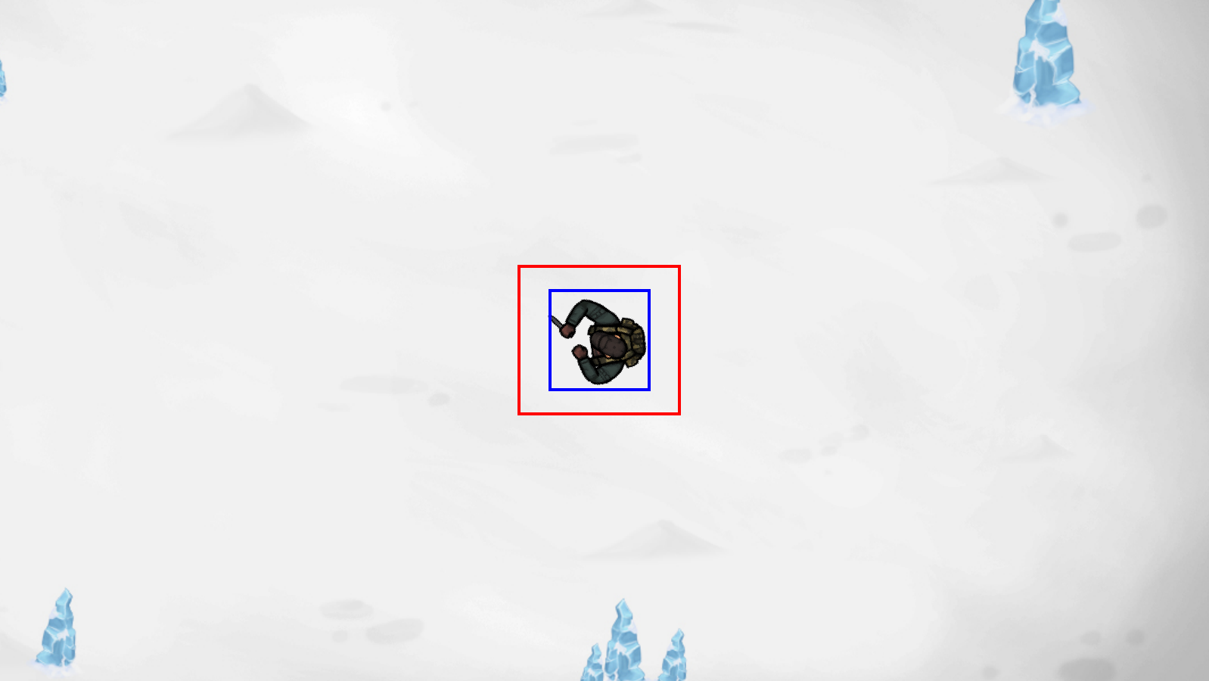

The player is now in the middle of the screen which is what I wanted, however the player still moves a few pixels before returning to the middle of the screen which results in a ‘dead zone’ like effect but I don’t yet want to implement a dead zone so I will fix this.

Ill start by removing my old movement where the player position is updated(I’m commenting it out in case I need it for the dead zone later)

**Test 2**

In this test, when the camera moves so does the player. It creates this weird free camera where the player is being offset the same amount as the background and so is treated like a stationary object. I may use this free camera as a toggleable feature that I add later in development but for now I will just fix it as a bug. I’m assuming that this is happening because the player is being offset within the camera function along with the background.

**Fix**

To fix this I will make another sprite group named offset_sprites. This group will contain all of the sprites which will be offset when the player is moved. They will also be in the all_sprites group. The camera method will then only offset sprites within this new sprite group. Also decided to clean up the code as some of it was basically useless (e.g. offset_pos)

Old method: 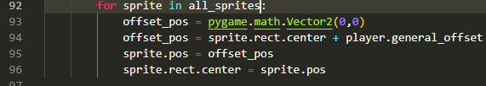

New method:



**Test 3:**

Now the player is locked to the centre of the screen and doesn’t move about the screen which is a success. The only issue now is the background is too small. For now, to fix this I will just fill the screen in black behind it until I get the actual main background for the game.

**Fix**



This draws over the past images of the player when its off screen which solves the weird effect.

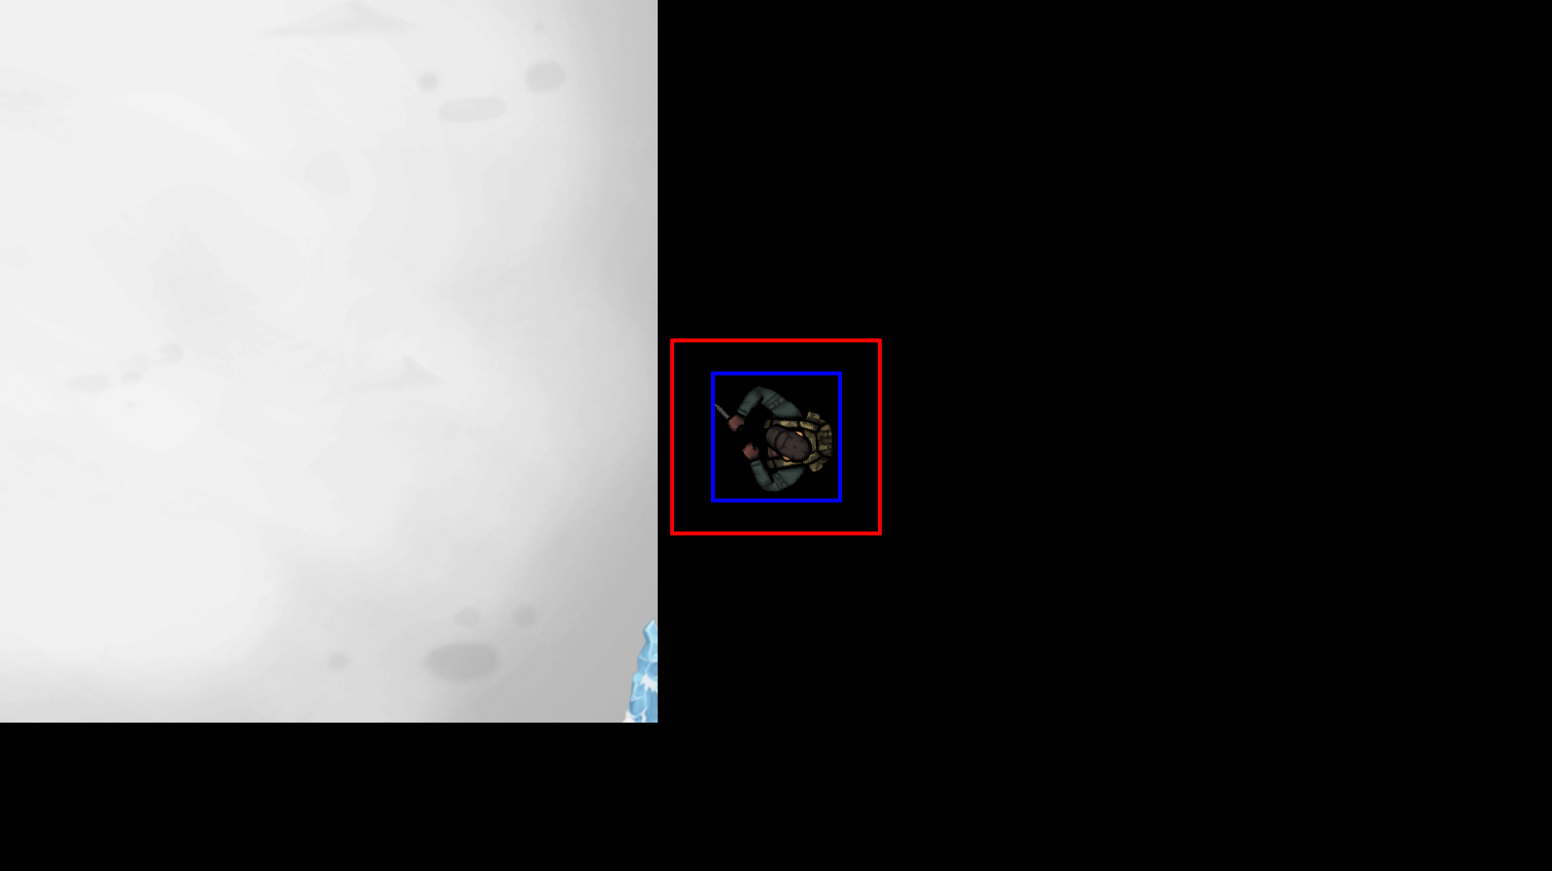

#### **Final test**

|  |  |  |  |
| --- | --- | --- | --- |
| Test | Expected Output | Actual Output | Success? |
| Run program | Program runs | Program runs | ✓ |
| W key pressed | Background moves down | Background moves down | ✓ |
| A key pressed | Background moves right | Background moves right | ✓ |
| S key pressed | Background moves up | Background moves up | ✓ |
| D key pressed | Background moves left | Background moves left | ✓ |
| Any movement key pressed | Player stays in the middle of the screen | Player stays in the middle of the screen | ✓ |
| Shift key held | Player moves slower | Player moves slower | ✓ |
| Player walks off background | Player walks into black void | Player walks into black void | ✓ |

I am satisfied with the camera method at this time and so will now move onto adding the collidable objects. The level class will likely be updated as well in that section.

### Adding the objects

This will likely be a fairly short section as well because I already have all of the pseudocode for the collidable objects and the code is not very long as the object have limited functionality.

#### Success Criteria

* Objects class created
* Objects have an accurate rect area
* Player cant walk through objects
* At least 2 different types of object (passed in as parameters)

#### Coding + Testing

First thing I did was copy paste my pseudocode into my main program and then edit the syntax to match that of python and pygame

Before (pseudocode):

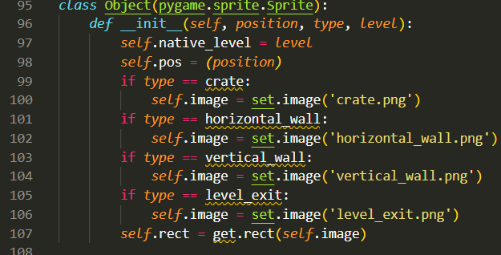

After:

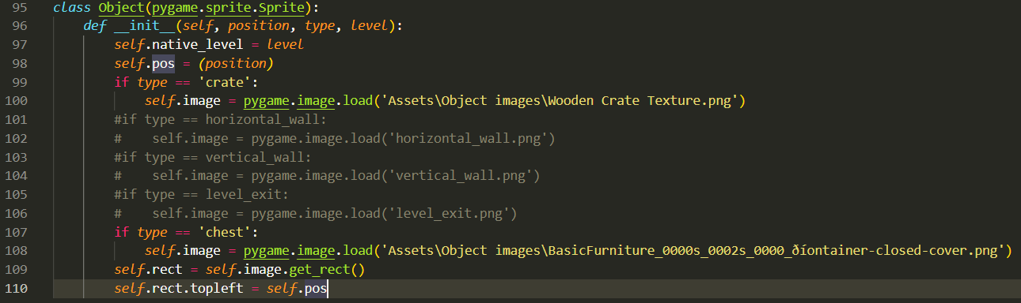I changed the if statements to check for a string, I commented out the 3 objects which I am not implementing yet and I added the correct paths to the image.

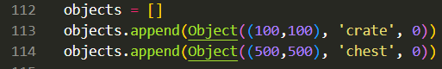

Here is where the objects are instantiated and added to a list. I’m adding them to a list so that I can iterate through the list to check/update each object individually as there will be multiple of them with different attributes.

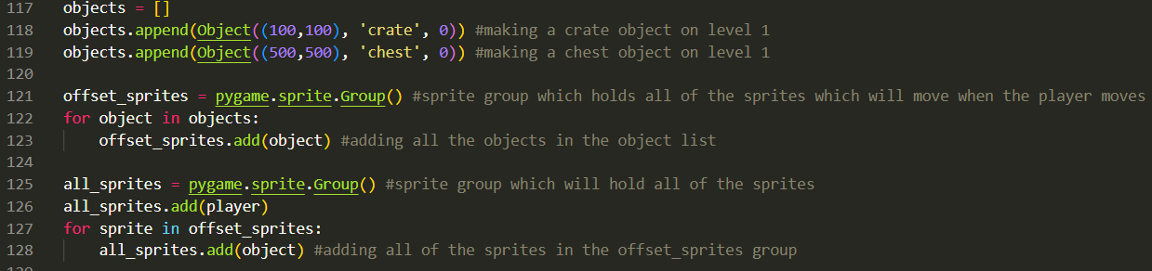The objects in the list are then added to the offset sprites group and then the offset_sprites group is added to the all_sprites group. At this point the object images should be being drawn to the screen and at the correct locations but shouldn’t have any collision physics yet.

**Test 1**

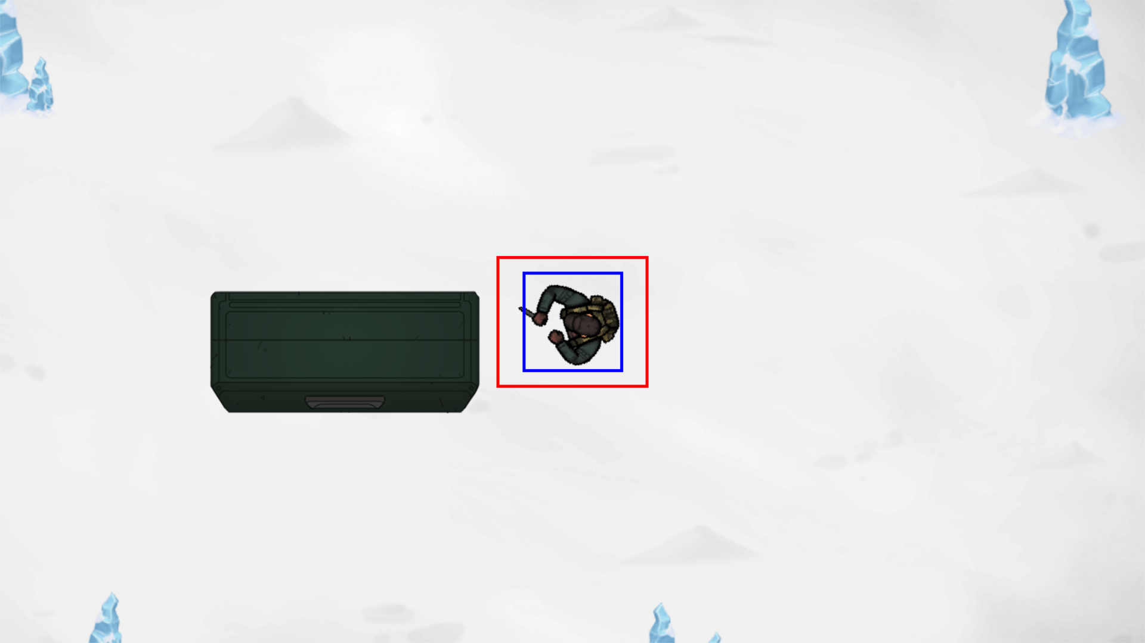

**Successes:**

* Chest is being drawn to the screen

**Problems:**

* Crate is either not being drawn or is behind the chest
* Incorrect position
* Chest needs to be smaller

**Fix**

The first issue I will fix is the position as I don’t think the position variable is being used when drawing the objects. 

Here I am setting the centre of the rect to be that of the position which is passed into the initialisation method.

**Test 2**

While the chest has moved to the correct position, the crate is still not visible for some reason. There is an issue with it being drawn rather than an issue with it being behind the chest.

The issue: 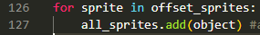

The fix: 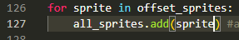

**Test 3**

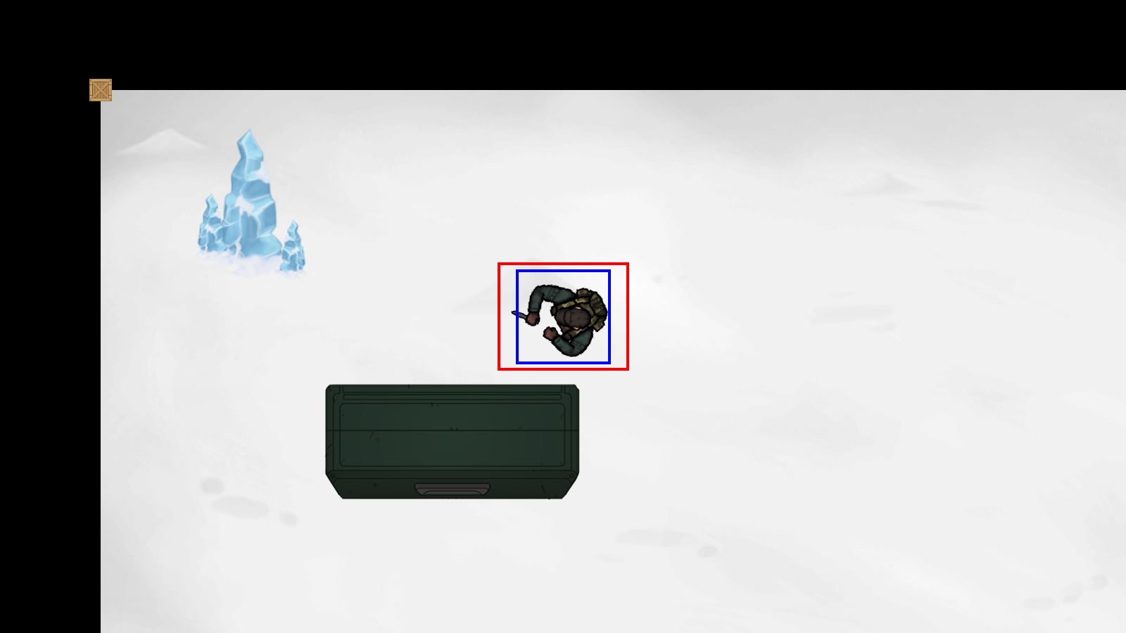

The crate is now being drawn to the screen and at the location passed as a parameter. The crate is far too small and the chest is far too large so I will use pygame.transform.rotozoom() to change the sizes.



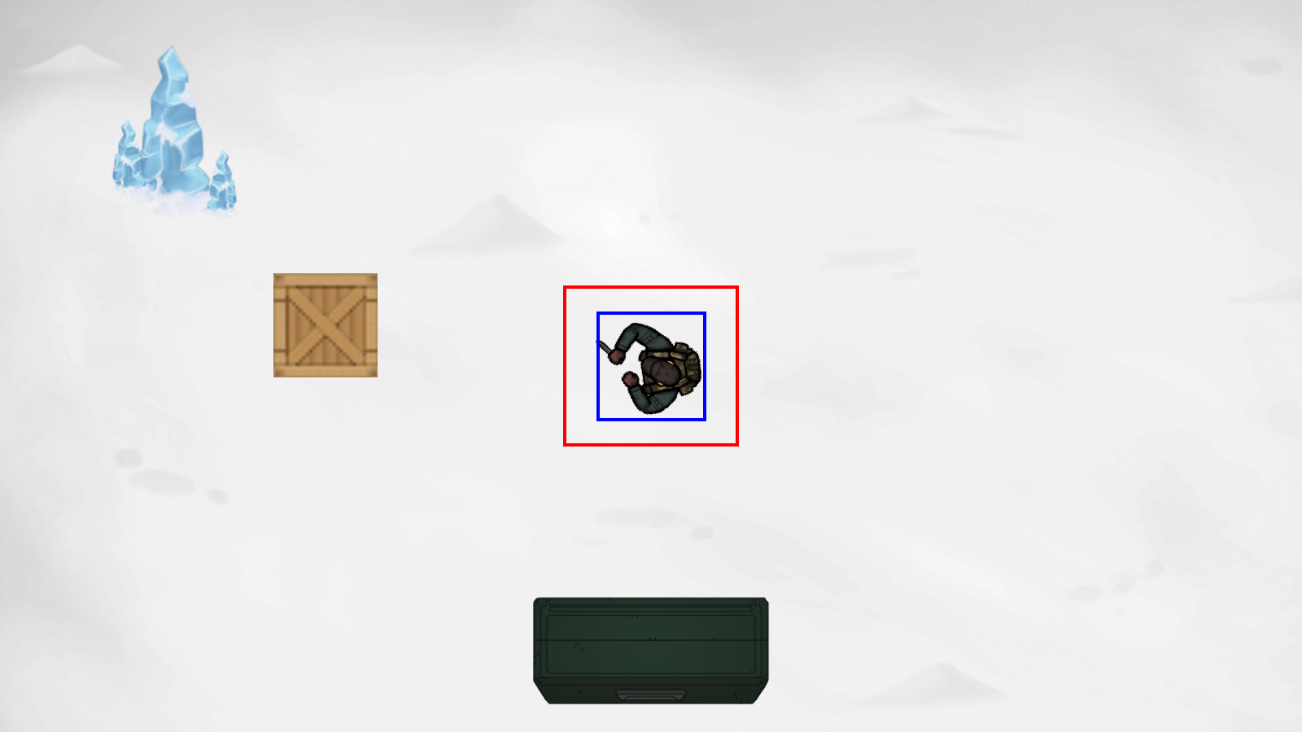

The next step is to add collision physics with the player, these collisions will be handled in the player class. I will use the colliderect() function to get when the player and object are touching.

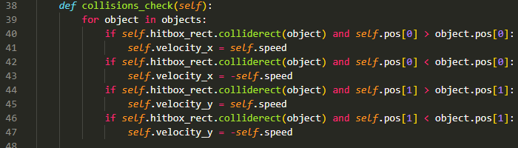

Here is the adapted version of my pseudocode. It will need some ironing out before it works as intended. After a quick test it showed that the player was still able to walk through the objects.

The first change was changing (object) into (object.rect):

Now the program was actually detecting the collision but the player wasn’t being affected and would still be able to walk through the objects. I think this is because, while the velocity is changed here, it is changed again in the user_input method before it is used in the level.camera() method. My solution to this is to make a second velocity variable for collisions and then add both of them before I update the positions.

Two new variables: collision_velocity_x, collision_velocity_y

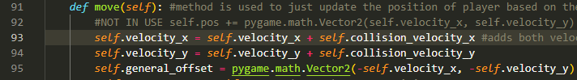They are added here before the general_offset is calculated.

**Test 4**

In this test, when the player collides with an object, they cant walk through the object but then they continue to walk backwards in the offsetted direction, even if no button is held

**Successes**

* Can’t walk through objects

**Problems**

* Player walks off infinitely in different direction even when button not held

**Fix**

This happened because the new variables (collision_velocity_x, collision_velocity_y) were being changed but not reset to 0 after thy stopped colliding, this caused the game to treat the movement like it was colliding with an object even when it wasn’t. Fix: 

**Test 5**

A lot of unexpected issues arose in this test

* When entering the crate from above, the player walks straight through
* When entering the crate from the left or right, they cant walk through but will walk **down** as well
* When entering the crate from below, the player cant walk through but will walk to the right
* When entering the chest from above the collisions work as intended
* When entering the chest from the left or right, they cant walk through but instead walk **up**?
* When entering the chest from below the player walks straight through

**Fix**

First thing I realised is that I am checking the player position against the object position but the object position is not updated when they move, as only the object rect is updated. Added in the camera method:

I tested this and the player doesn’t walk through objects but still moves in weird directions when colliding. Another reason this may be happening is because of the checks im using for collisions. Because I’m checking the player position against the object position and the position is the centre of both of the objects, if just the player’s centre is to the left of the crate, it will think that the player is on the left of the crate, even if the whole player sprite isn’t on the left of the crate. If that makes sense.

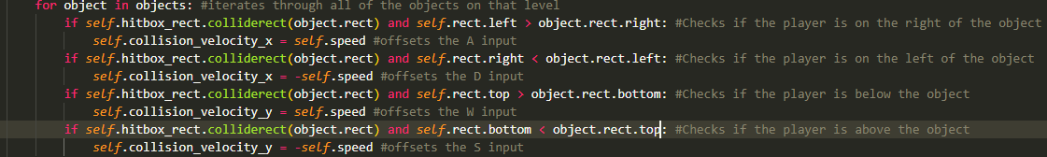

These new position checks allow for a far more precise check of the player in relation to the object. By checking the left side of the player against the right side of the object, the program can get the exact location where the player is on the right of the object.

However when testing, the program detects the collision but the player can walk through the object before it has time to offset the player. 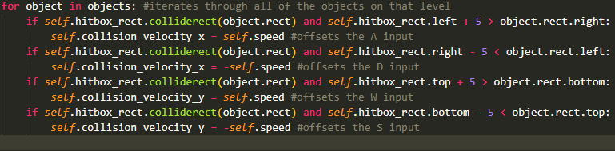First thing I realised is I was using the player.rect when I should have been using the fixed player.hitbox_rect. Then I added 5 pixels of leeway so that the collisions have 5 pixels of room to offset the player so they cant just run straight through.

**Test 6**

The collisions seem to work quite well at this stage except in this one screenshot where I managed to get inside an object so there is clearly something that needs changing. The green borders of the object show where the rect of the objects is.

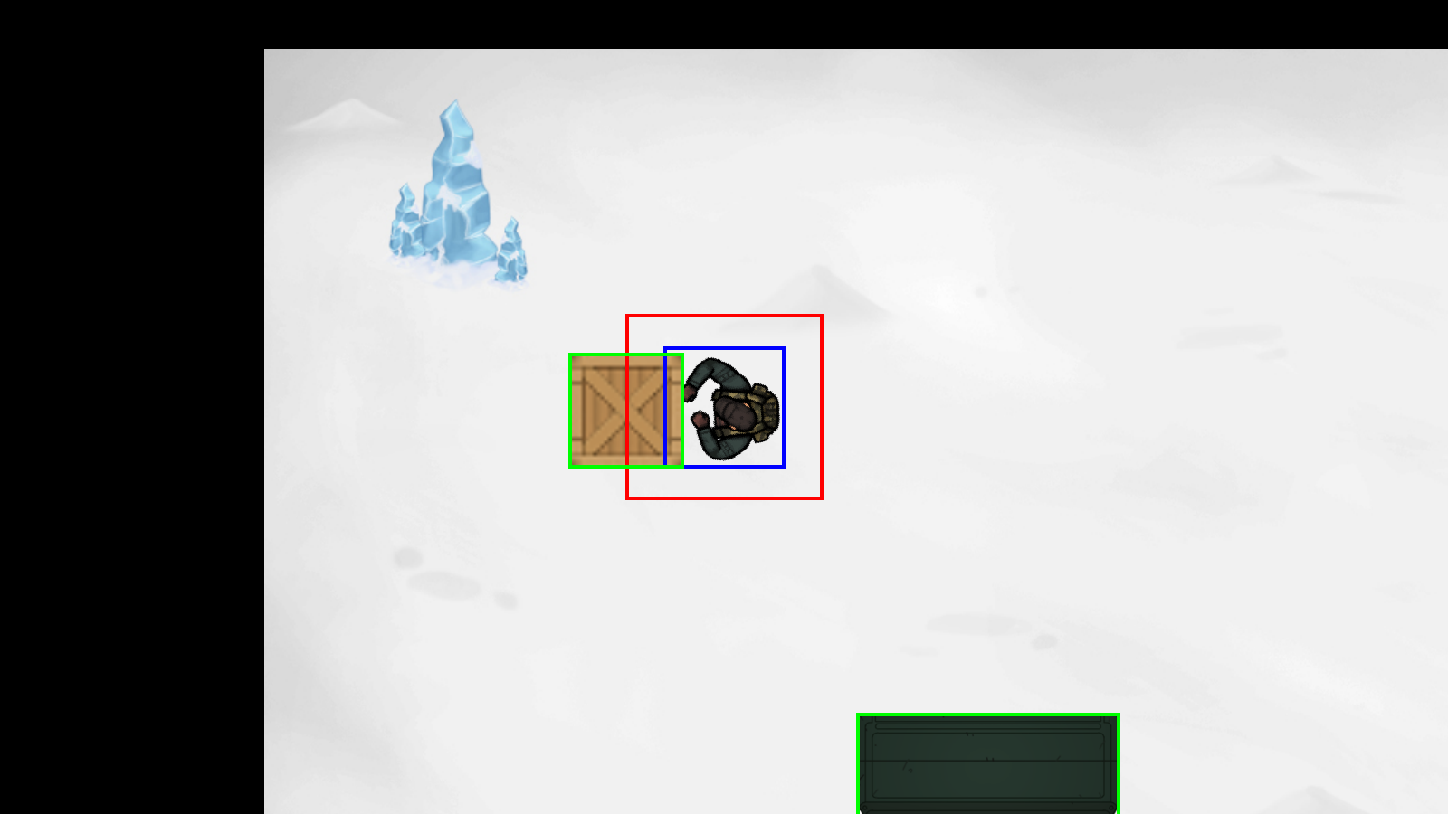

I changed the extra pixel detection from 5 to 10 to allow for a bit more leeway when detecting collisions and it now works quite well.



However, when the hitboxes aren’t being shown, sometimes the player is colliding with an object even though it looks like they aren’t. To fix this I will just reduce the size of the player rect.

This was very easy to do as I can just change the hitbox size in my constantsSettings.py file.

I also decided to add 2 more crates to the screen to better test for bugs.

**Test 7**

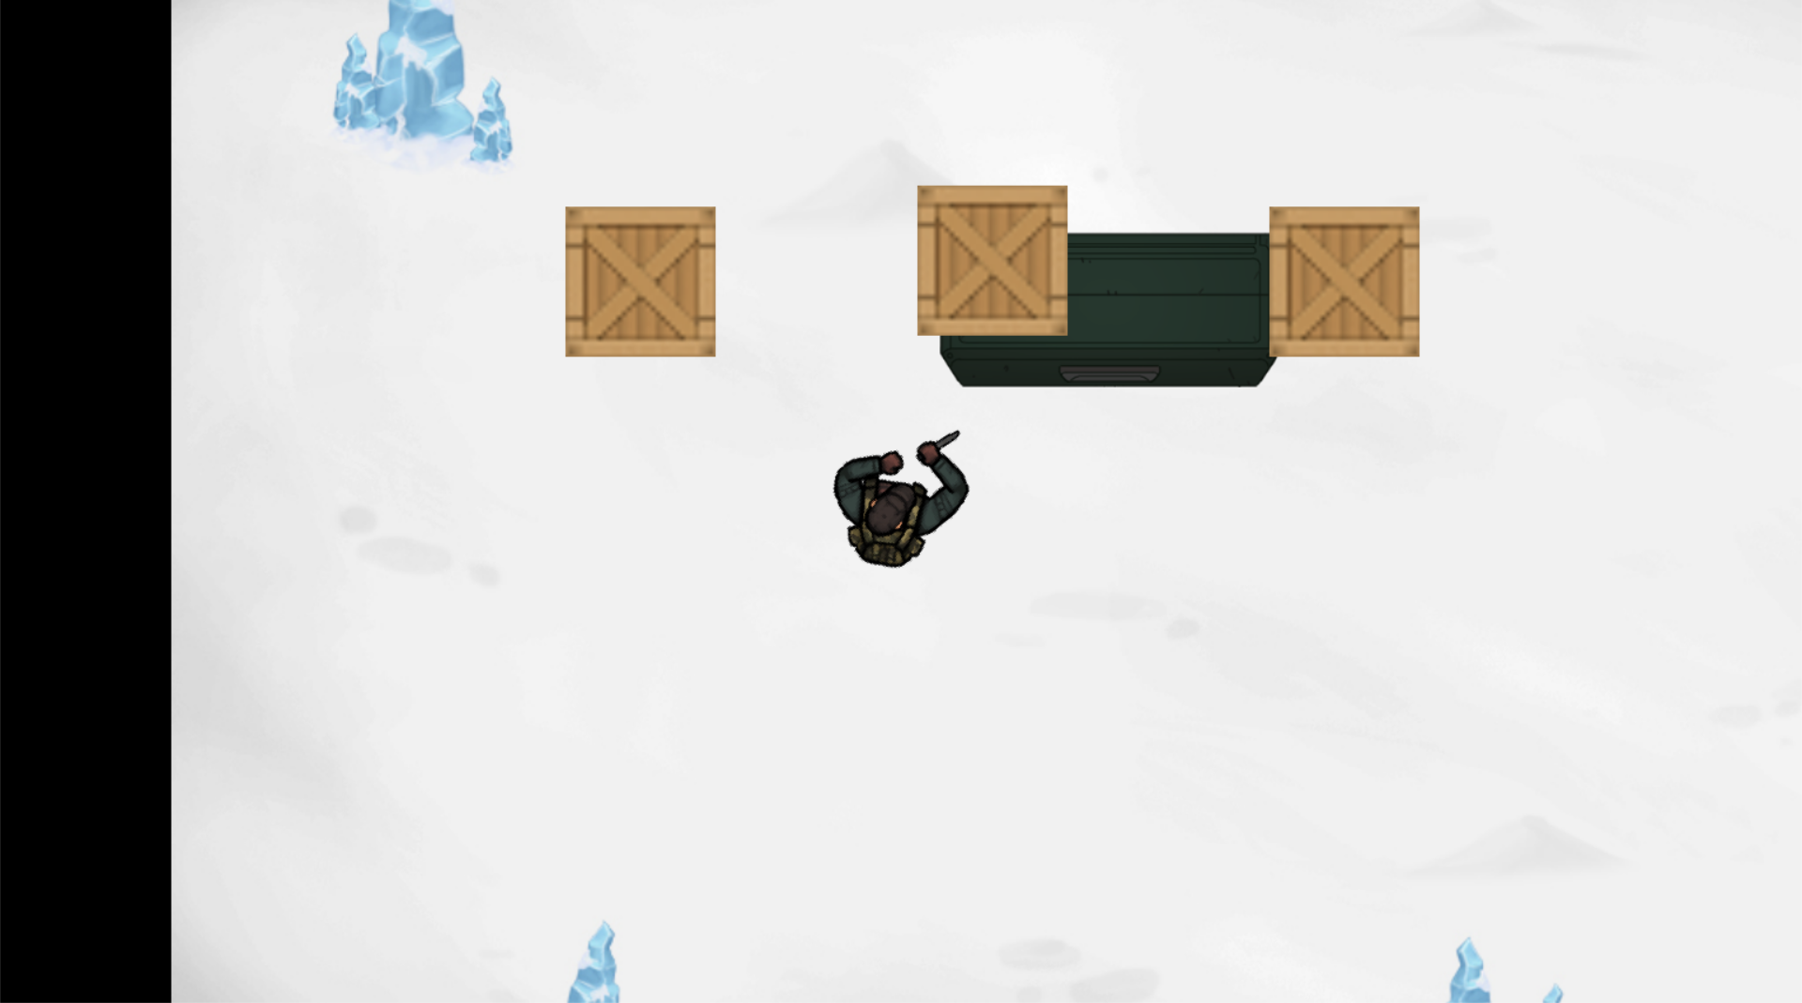

In this test I found a new issue that when the player is moving diagonally, and an object is off screen, it is not offset properly, causing the objects to move disproportionately to each other and cause issues like the one in the screenshot where they are inside of each other.

**Fix**

The first thing to consider is that it only occurs when the player is moving diagonally i.e. holding 2 inputs at once. I am not sure currently why it only occurs when the objects are off screen however.

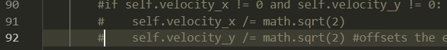

After commenting out this section of code, the bug stops which tells me that this is where the issue lies. However I still want to use this code as the player moves faster diagonally without it.

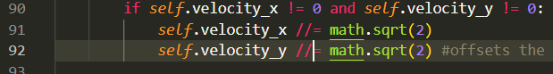 by changing the division to floor division the bug stopped and now the player moves at the correct speed. Im not sure if changing this may have later effects due to the rounding but I cant think of any situations where it may be a problem.

#### **Final test**

To test for correct positions I will print the mouse location and if it matches with the object location when hovering over it, it should show that the image is being drawn in the correct place.

|  |  |  |  |
| --- | --- | --- | --- |
| Test | Expected Output | Actual Output | Success? |
| Crate 1 drawn at correct position | Top left of crate at (400,400) | Top left of crate at (400,400) | ✓ |
| Crate 2 drawn at correct position | Top left of crate at (700,200) | Top left of crate at (700,200) | ✓ |
| Crate 3 drawn at correct position | Top left of crate at (1000,400) | Top left of crate at (1001,401) (mouse was probably off slightly) | ✓ |
| Chest drawn at correct position | Top left of chest at (800,800) | Top left of chest at (800,800) | ✓ |
| Player walk into left of object | Cant walk through, offset to the right | Cant walk through, offset to the right | ✓ |
| Player walk into top of object | Cant walk through, offset down | Cant walk through, offset down | ✓ |
| Player walk into right of object | Cant walk through, offset to the left | Cant walk through, offset to the left | ✓ |
| Player walk into bottom of object | Cant walk through, offset up | Cant walk through, offset up | ✓ |
| ‘W’ key held (not into object) | Object pos[1] increases | Object pos[1] increases  (800,800) -> (800,850) | ✓ |
| ‘A’ key held (not into object) | Object pos[0] increases | Object pos[0] increases  (800,800) -> (975,800) | ✓ |
| ‘S’ key held (not into object) | Object pos[1] decreases | Object pos[1] decreases  (800,800) -> (800,595) | ✓ |
| ‘D’ key held (not into object) | Object pos[0] decreases | Object pos[0] decreases  (800,800) -> (620,800) | ✓ |
| Two direction keys held at once | Object pos[0] and pos[1] change at the same rate | Object pos[0] and pos[1] change at the same rate (800,800) -> (683,683) | ✓ |
| Two direction keys held at once and colliding with object | Player cant walk through object, Object pos[0,1] stays the same. | Player bounces along object and is pushed 5 pixels away from the object | X |

Only one of the tests failed and it is a very minor issue that I can fix later, I believe its maybe due to the 10 pixels of leeway that I gave for the collisions causing them to not offset the player perfectly but this is something that can wait.

### Adding the enemies

Im expecting this section to be more difficult than the others as the pseudocode that I wrote for the enemies is fairly rudimentary and I don’t expect the logic of it to work.

#### Success Criteria

* Enemy class created and initialised
* Enemies walk to destinations held within a list
* Enemies rotate to look towards their destination
* Enemy has a vision cone which when colliding with the player for 60 frames, sets the ‘alive’ variable to be false
* Enemy destinations are updated when the player moves (the camera moves)

#### Coding and testing

The first thing I did was copy paste my pseudocode into the main python file and change the syntax to match pygame. Here is the initialisation method. For the time being, the image I am using will be the same as the players as in stage 2 I will set up all of the animations and sprites that are going to be used in the final product. 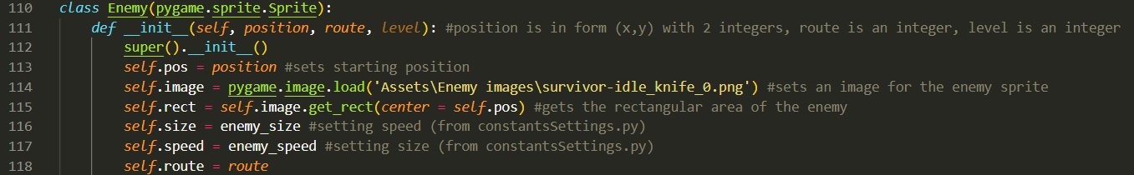  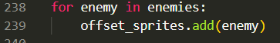

At this stage all that should happen is the enemy drawn to the screen:

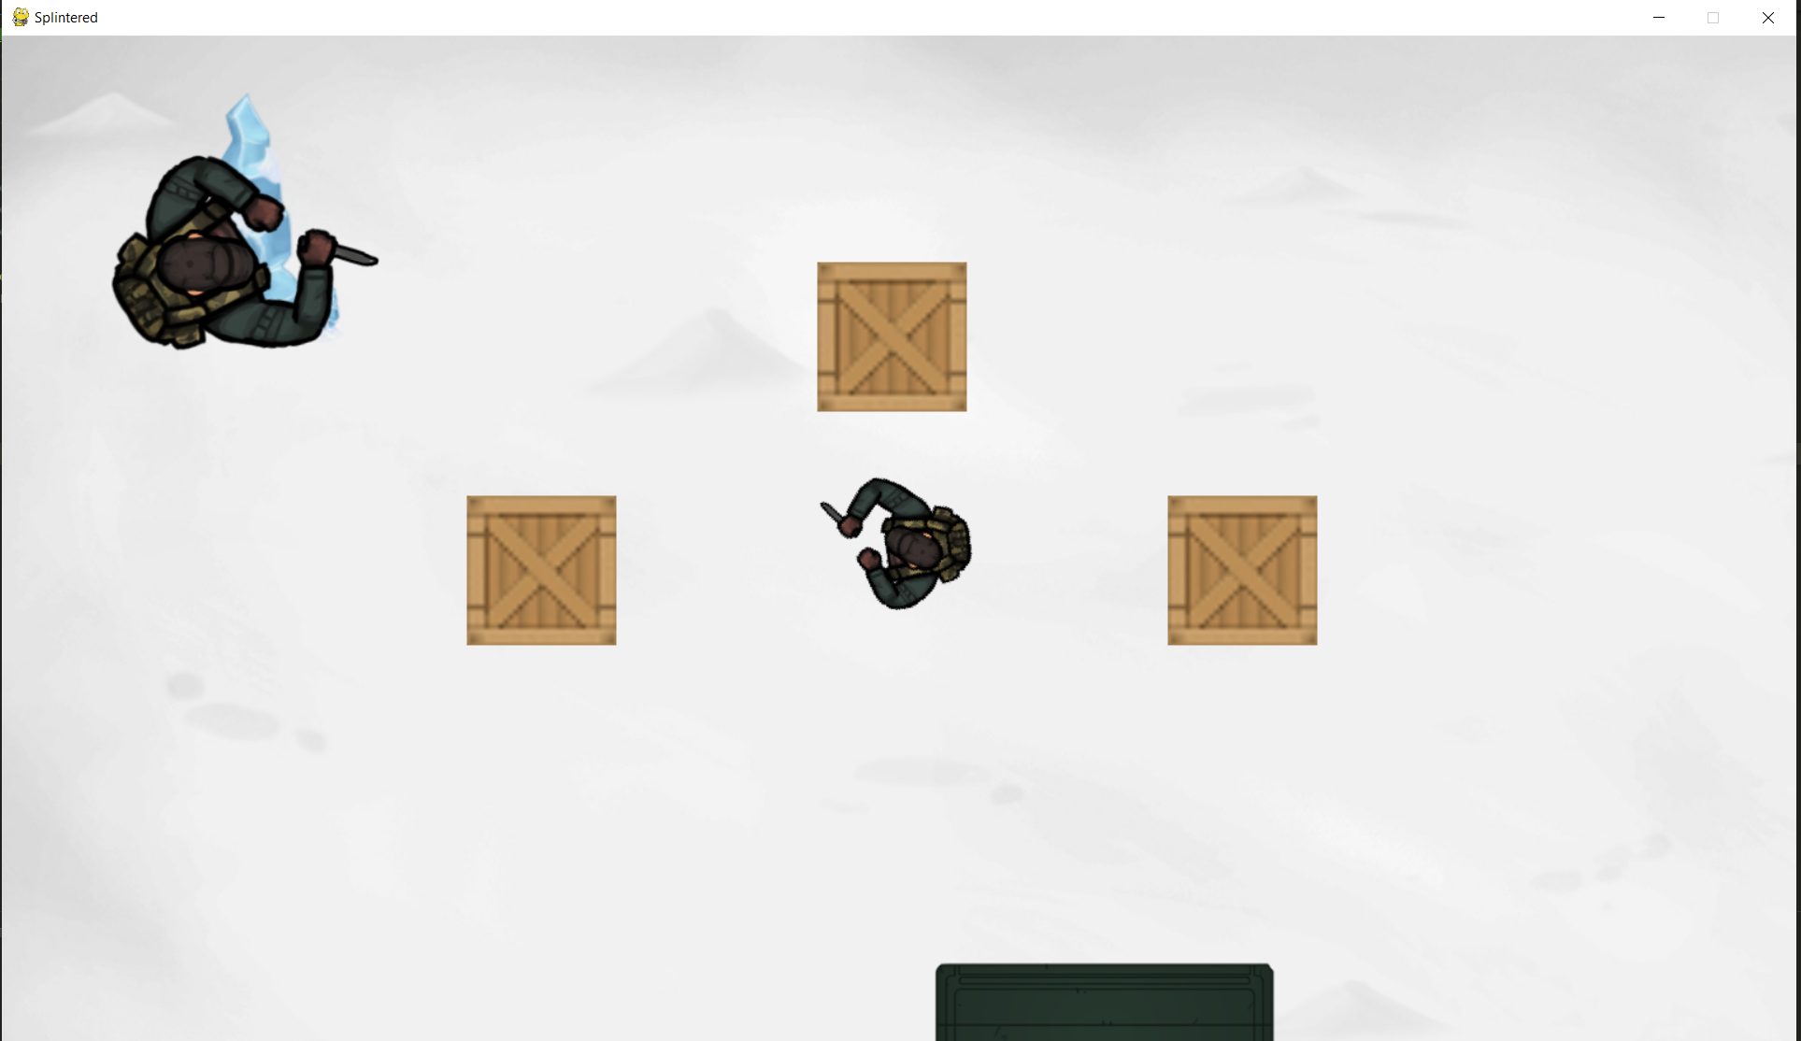

The enemy is slightly too big because I forgot to rotozoom the image using the self.size attribute.

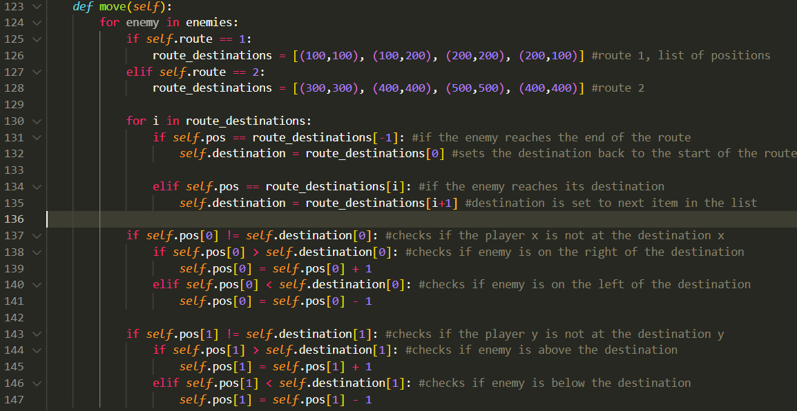

Here is the adapted movement method. Comments should show the genera logic to how the enemies move and I have explained and justified this in the design phase. Before attempting to test this I will actually clean up the routes and change it into large 2d array rather than having lots of separate lists.

 

This line shows how the list within the 2d array is selected. I also added another route for later testing.

When running the code:



This is because I am trying to check a vector against a tuple which results in an error. The only fix I can think for this is to cast each individual tuple as a pygame.math.vector2.

After a lot of small tests the fix was actually more simple:



This now iterates through each tuple in the list and the program can run.

**Test 1**

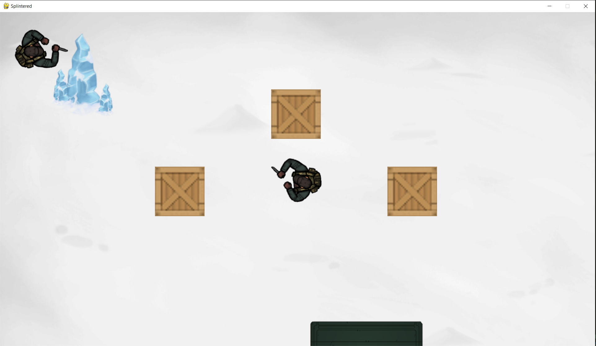

**Successes**

* The program runs
* The enemy is drawn at the correct location and size
* The enemy is offset by the camera when moving

**Problems**

* The enemy doesn’t move whatsoever

**Fix**

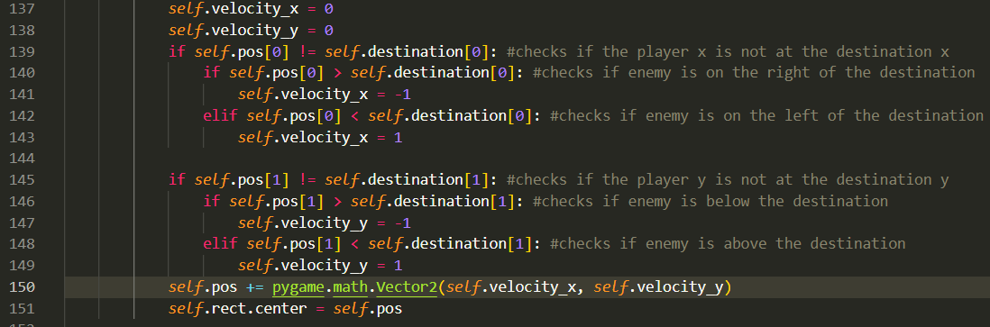

First of all I changed the movement to be similar to the players where the velocity variable Is updated and then the pos variable is updated after all the calculations. The main reason the enemy wasn’t moving was because the rect wasn’t being updated (which is what draws the sprite) so I updated the rect as well.

**Test 2**

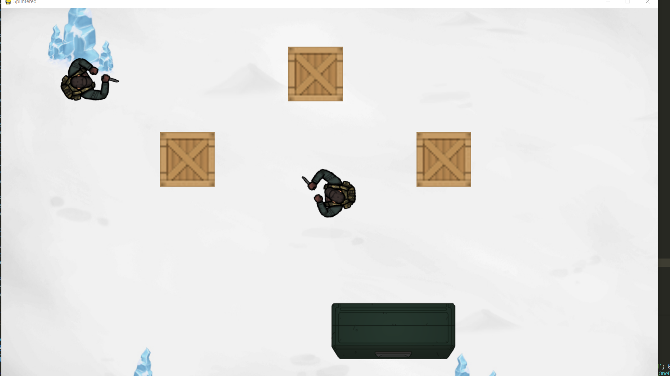

**Successes:**

* The enemy moves along its designated route

**Problems:**

* The route doesn’t change when the camera does, so even though the player is moving around the screen, the enemy will walk to same 4 destinations on the screen

**Fix**



This was the first attempt to fix this however It didn’t have any effect.

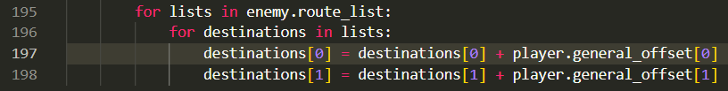

This also didn’t work because tuples don’t support item assignment. So I changed the tuples in the route_list list into lists. This then creates a 3d list. 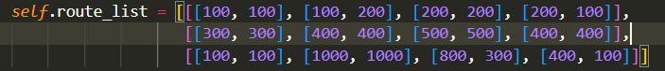

**Test 3**

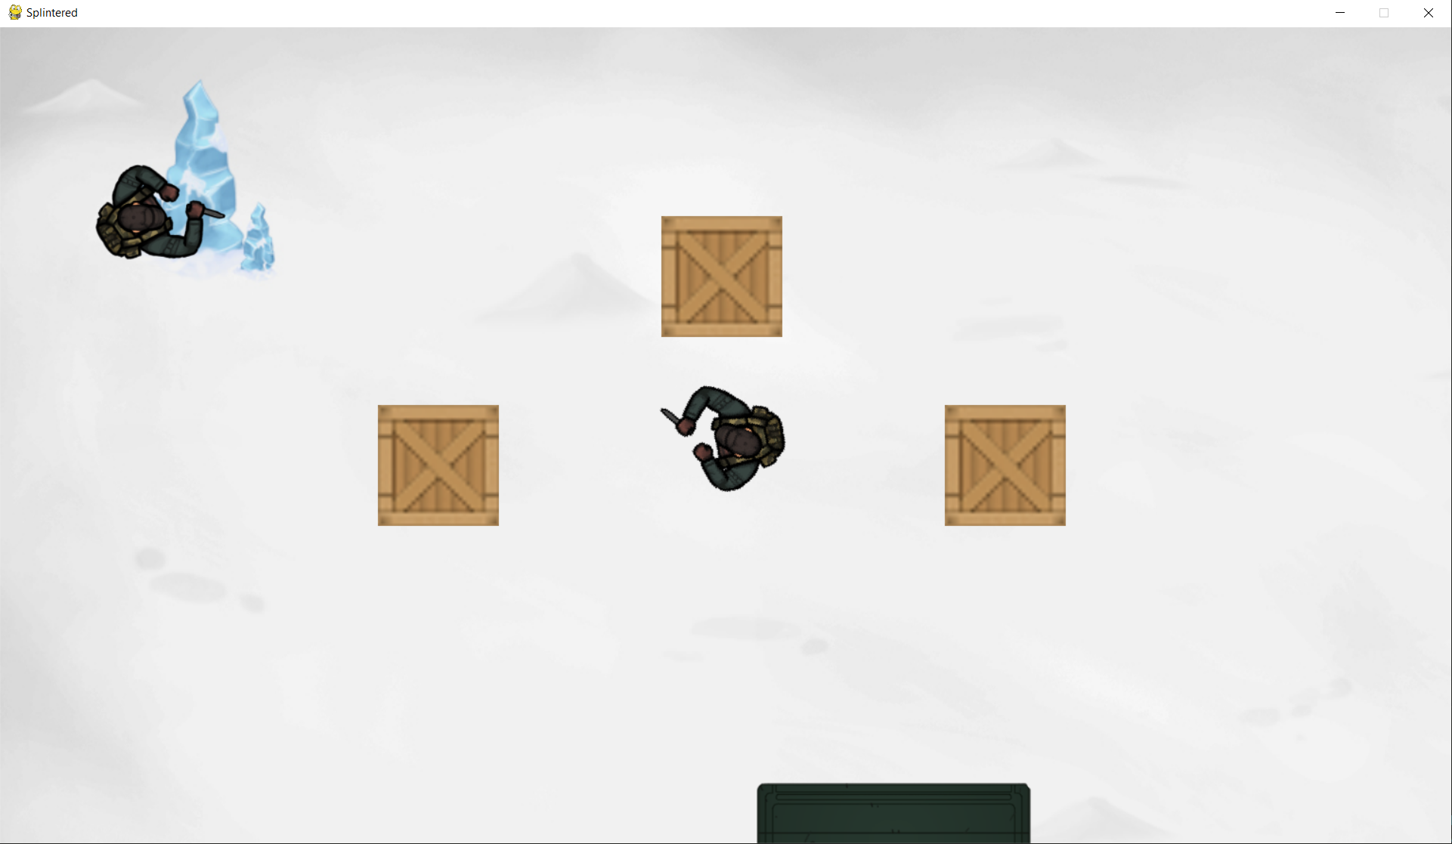

**Successes:**

* The enemies route is now offset so that the enemy moves as intended

The next step is to add the enemies rotation so that it is looking towards its destination at all times.

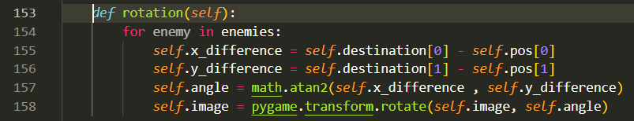

Here is the adapted pseudocode, this code is basically the same as the code for the player rotation but using the destination coordinates instead of the mouse coordinates.

Using what I know from the player rotation I casted the angle to degrees and rotated the base image 90 degrees anticlockwise so that it faces at 0 degrees to begin.





**Test 4**

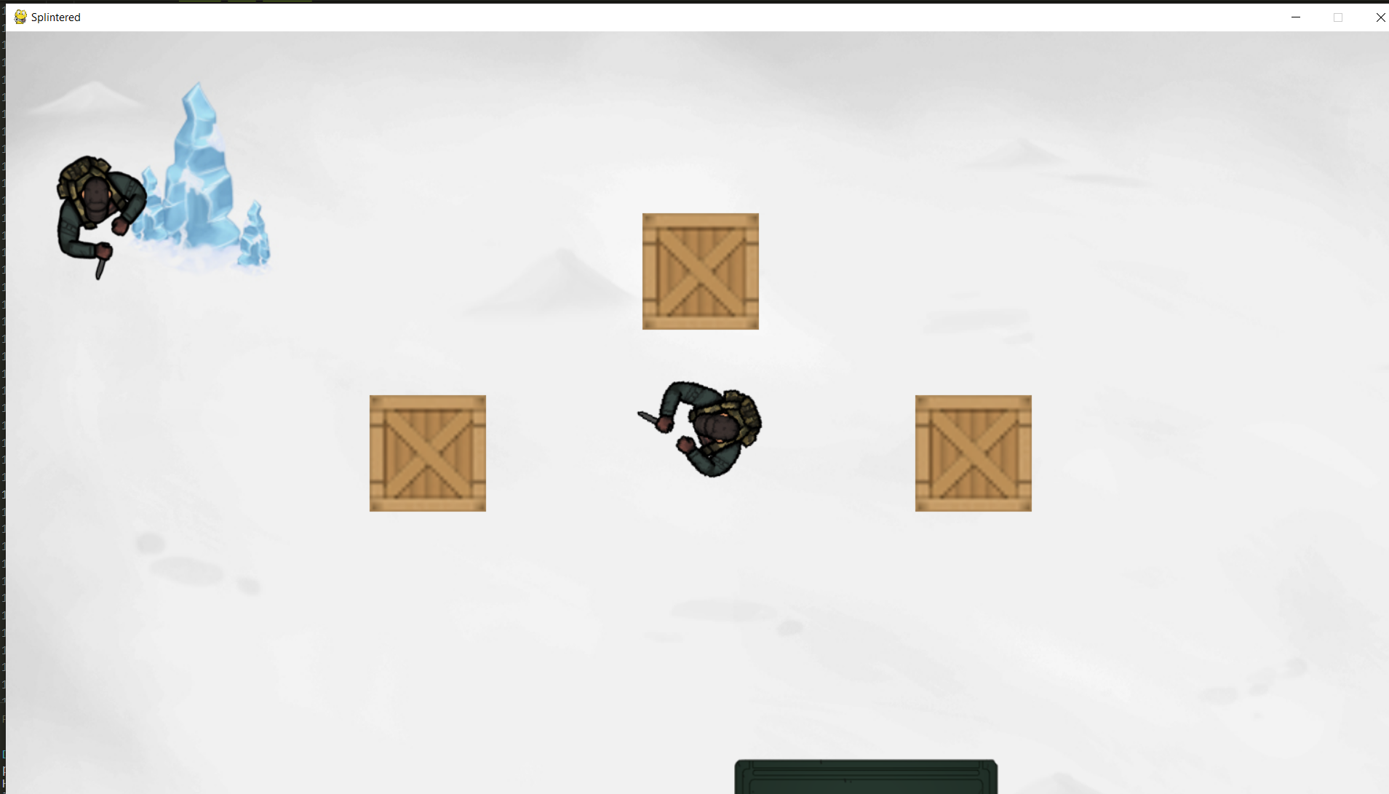

The rotation works until the first destination is reached and then the enemy seems to get stuck in place.

Turns out I wasn’t calling the rotation method.

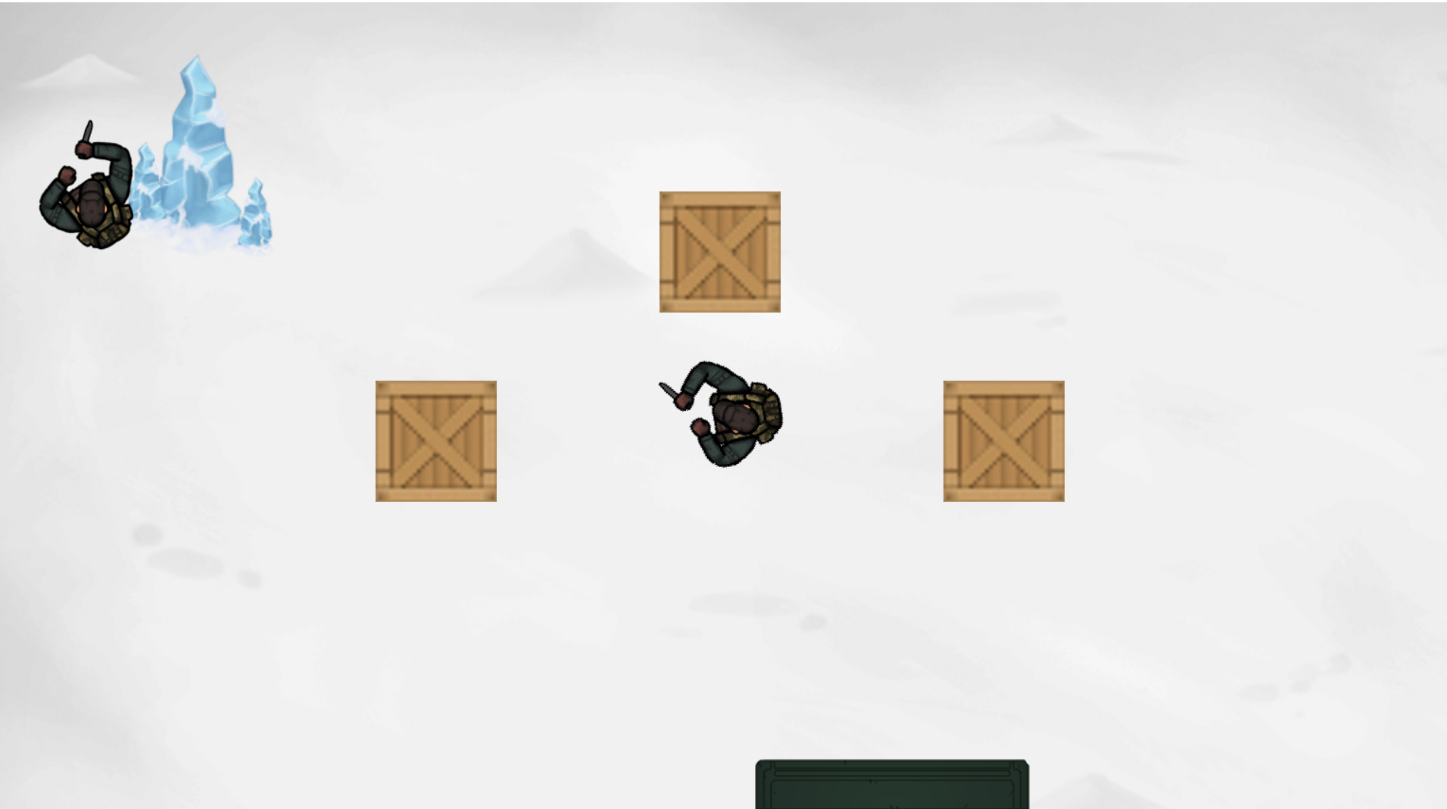

The enemy now flips up and down in place at the destination but at least the method is actually being called more than once.

This is because I had to changed the enemies speed to move 3 pixels per second however this caused the enemies to go from y= 99 to y= 102 in one frame, causing them to not touch the y=100 coordinate so the program never detected them as having reached the destination. My only solution to this currently is having the speed as 2, 4 or 5 as these are all factors of 100.

After changing this the rotation actually works as intended for this enemy, however when testing a second enemy I ran into a lot of issues. A major issue I ran into while testing is that when creating multiple instances of the enemies, they start to break and not work correctly.

The current issue is that only the last enemy instantiated gets offset by the camera while the others aren’t.

After a lot of testing different changes I found the issue:

**Before:**

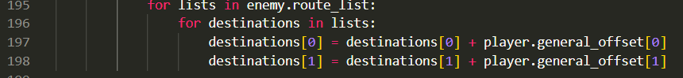Here the destinations list for only the most recently instantiated enemy will be updated

**After:**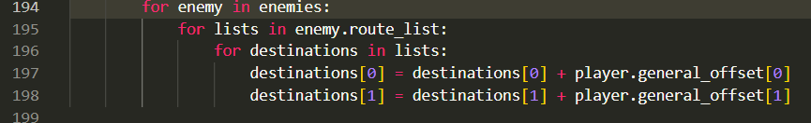

Now every enemy within the enemies list will be properly updated.

I knew it wasn’t the offsetting of the enemy position themselves as the crates were being offset perfectly fine.

Now that the rotation works as intended the next step is to add the vision cones. To begin with I will check the player colliding with the rect of the vision cones but once that is set up I will use **masking** to get a more precise collision detection with the cone as I want it to be as accurate as possible.



Here is where the image for the cone and the cones rect are set up in the initialisation method.

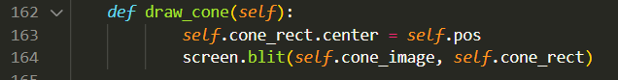

Here is where the cones are actually being drawn. However I don’t want the centre of the image to align with the centre of the player, I want the point of the cone to be at the centre of the player.

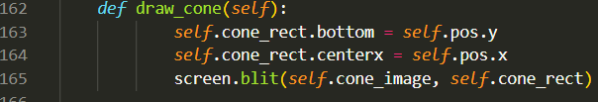

**Test 5**

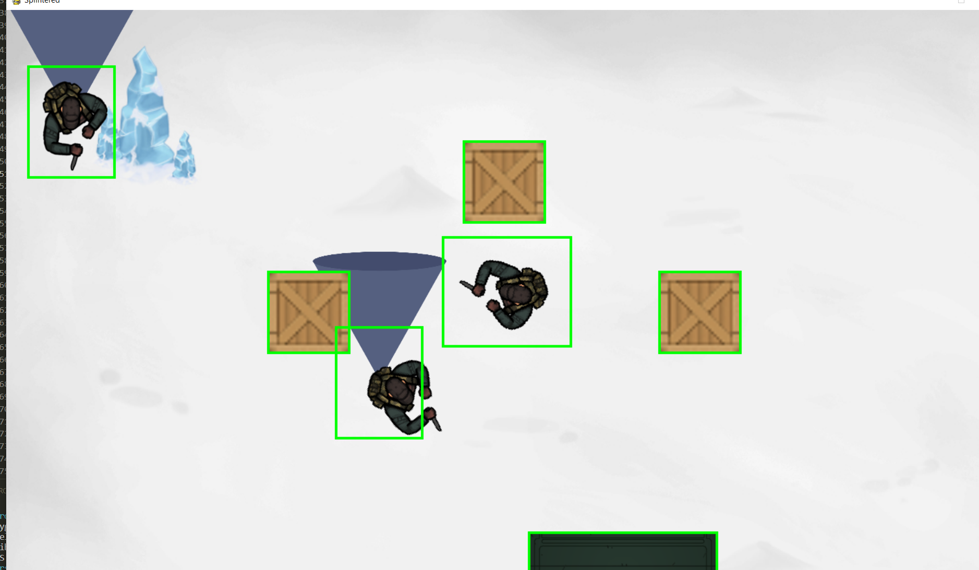

A lot has changed since the last screenshot, there is a second player which is appended to the list the same way as the first (I added a second enemy to test different routes). The green squares are just temporary hitboxes for testing.

The cones are now being drawn at the correct place however they aren’t yet being rotated.



I can use the same angle variable as before as the cone and the enemy should be facing the same way, a new variable cone_base_image is used so that the new rotation is not appended onto the previous rotation.

**Test 6**

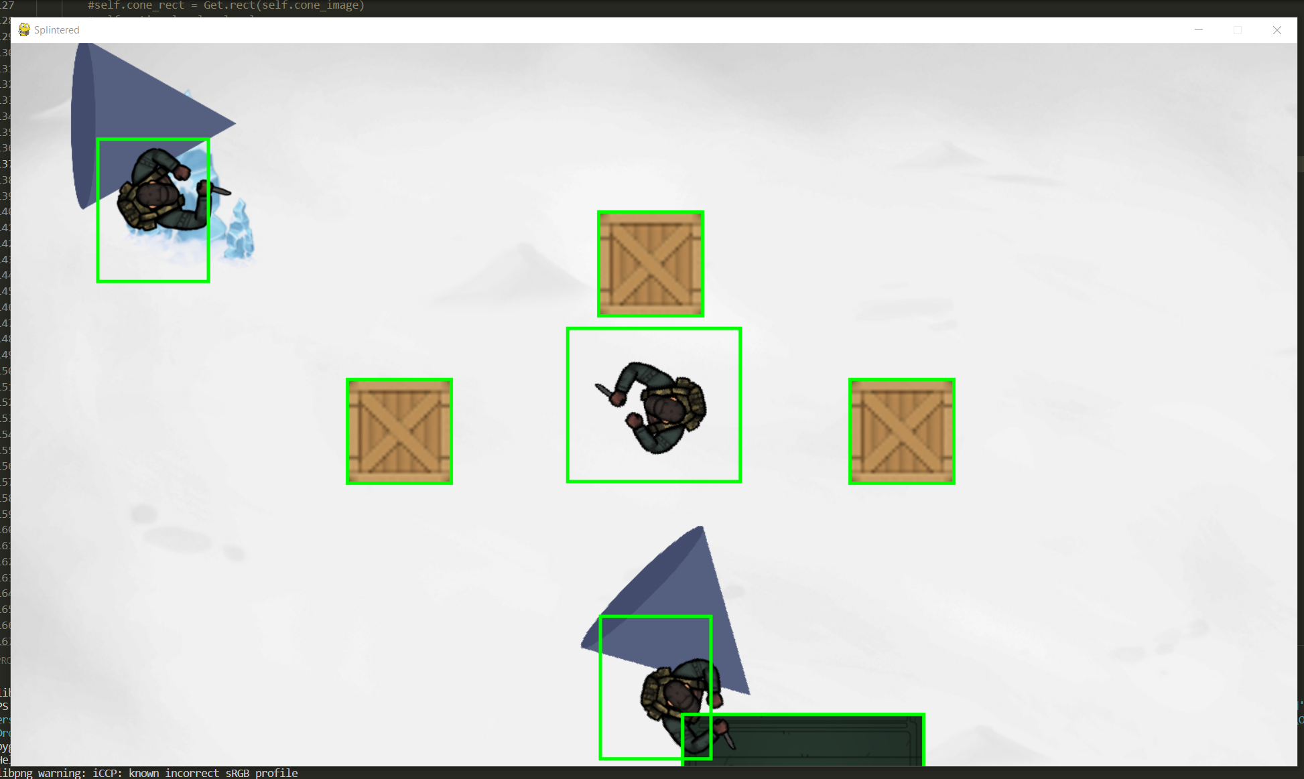

**Problems:**

* Cones are facing the opposite direction
* Cone point only lines up in the right place when the cone is in its base position (without rotation)

To fix the cones facing the wrong direction, I just rotated the base image by 180 degrees as the source image is upside down.

To fix the cones not being in the right position I edited the image to be twice as long so that I can now rotate the image around its centre instead of its base.

Before: 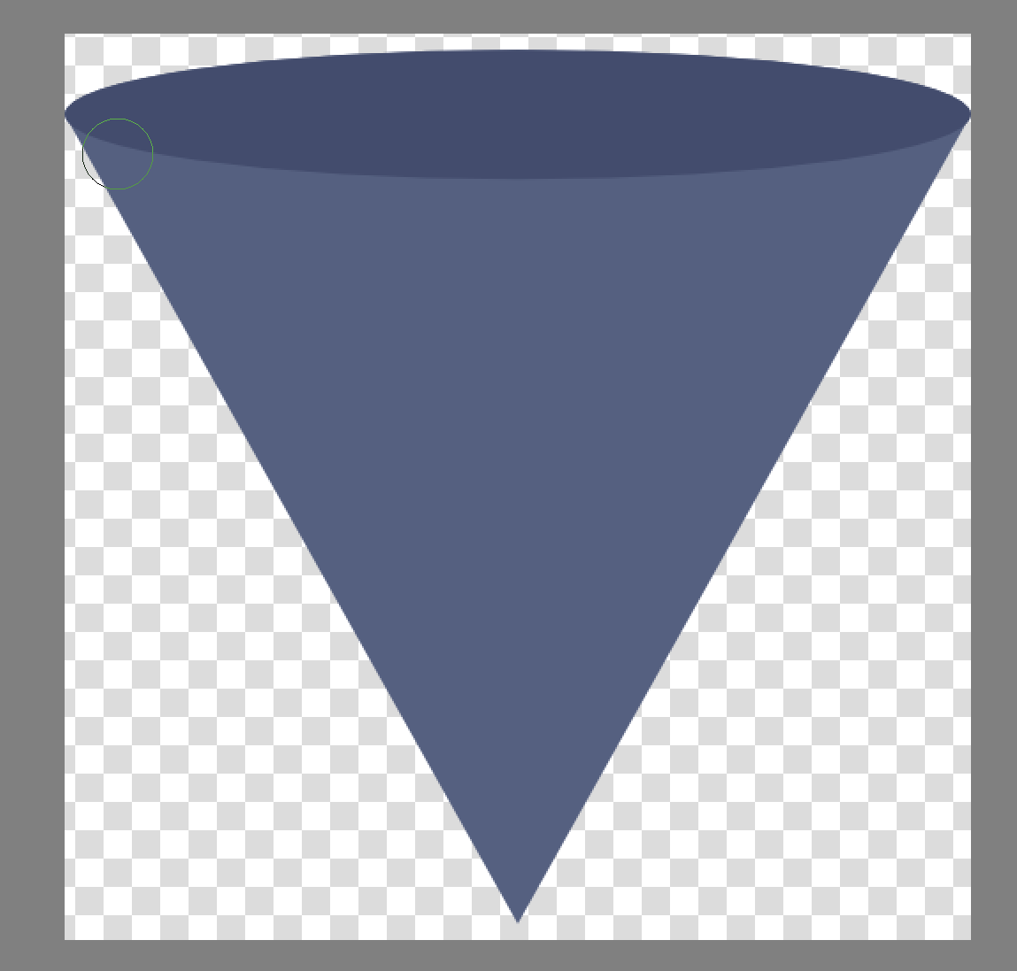 After: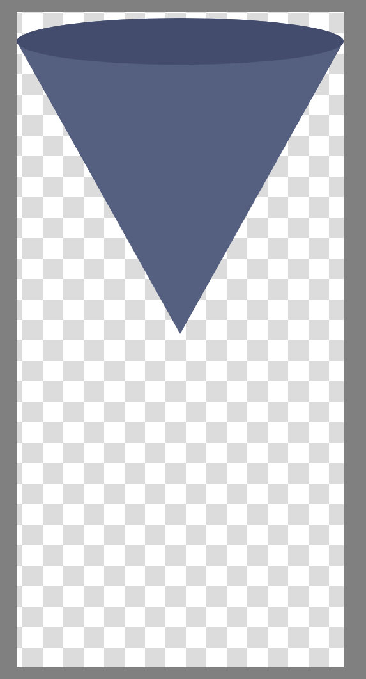

Now even after making this change and rotating around a centre, the cone was still in the wrong position on the screen. This is because ‘When you use pygame.transform.rotate the size of the new rotated image is increased compared to the size of the original image.’ – According to user ‘Rabbid76’ on [stackoverflow](https://stackoverflow.com/questions/4183208/how-do-i-rotate-an-image-around-its-center-using-pygame) (Rabbid76 2023). I couldn’t find any information about this within the official pygame documentation but it does make sense and explains some of the earlier issues I was having with rotation.

This is based on the code provided by ‘Rabbid76’ however is similar to how my code was working before. The rect is now calculated again by getting the rect of the original image(when its been moved to the enemy position) and using the centre of that to know where the centre of the rotated image is.

**Test 7**

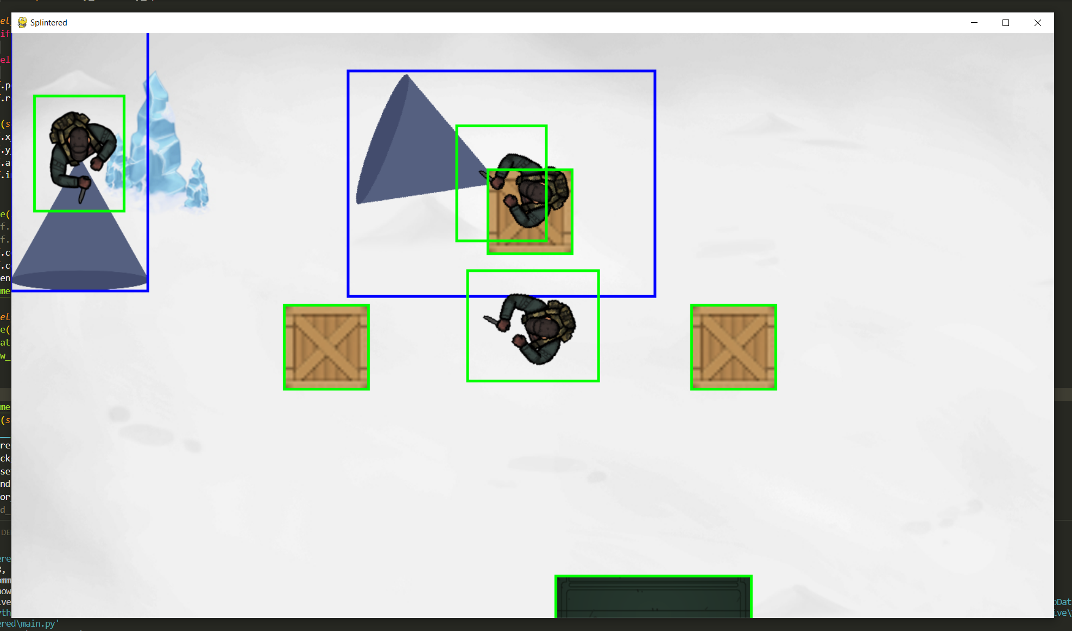

**Successes:**

* Cones now drawn facing the correct direction
* Cones now drawn in the correct location

The next step is to add collisions with the cones, originally I stated I would take collisions from the rects and then change it to take collisions from the masks, but I have decided to just skip checking against the rects and just do the masking option as there’s no point adding a feature that I’m just going to instantly change.

There is currently no built in way to check for a collision between a rect and a mask in pygame so I will have to make a mask for both the player and for the vision cone. Checking masks constantly is more demanding than checking rects so I will only check for a mask collision **if** there has been a rect collision.





This method is picking up collisions but not where they should be i.e. its saying there’s a collision when there isn’t one and saying there’s no collision when the player is clearly contacting a cone.



The cone mask and player mask are now update on each frame after the rotation, meaning the collisions are far more accurate, however the collisions only seem to work with the most recently instantiated enemy (the enemy at the end of the enemies list). To solve this I will check the collisions within the enemy class instead of the player class so that each enemy is checking the collisions individually.

An issue I kept running into is that when colliding with the cone, it would class the cone as the player as both having a collision and not having a collision because while it was touching one cone it wasn’t touching the cone of any of the other enemies on screen.

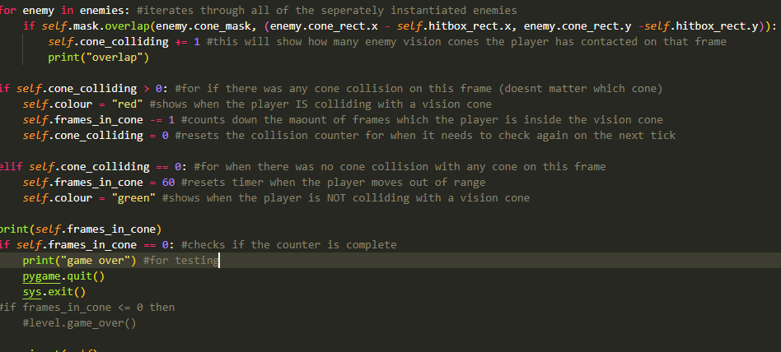

I moved the collision detection back into the player class. The players hitbox should turn red when touching any vision cone on screen, and turn green when no touching any vision cone. Frames_in_cone should decrease by 1 for each frame that the player is touching a cone but should reset to 60 when the collision stops. If the frames_in_cone reaches 0, the program closes itself after printing a game over message.

Provided that this most recent piece of code works as intended, I believe all of the success criteria for the enemy have been met and so will begin the final test for the enemy, and then an analysis of stage 1.

#### **Final test**

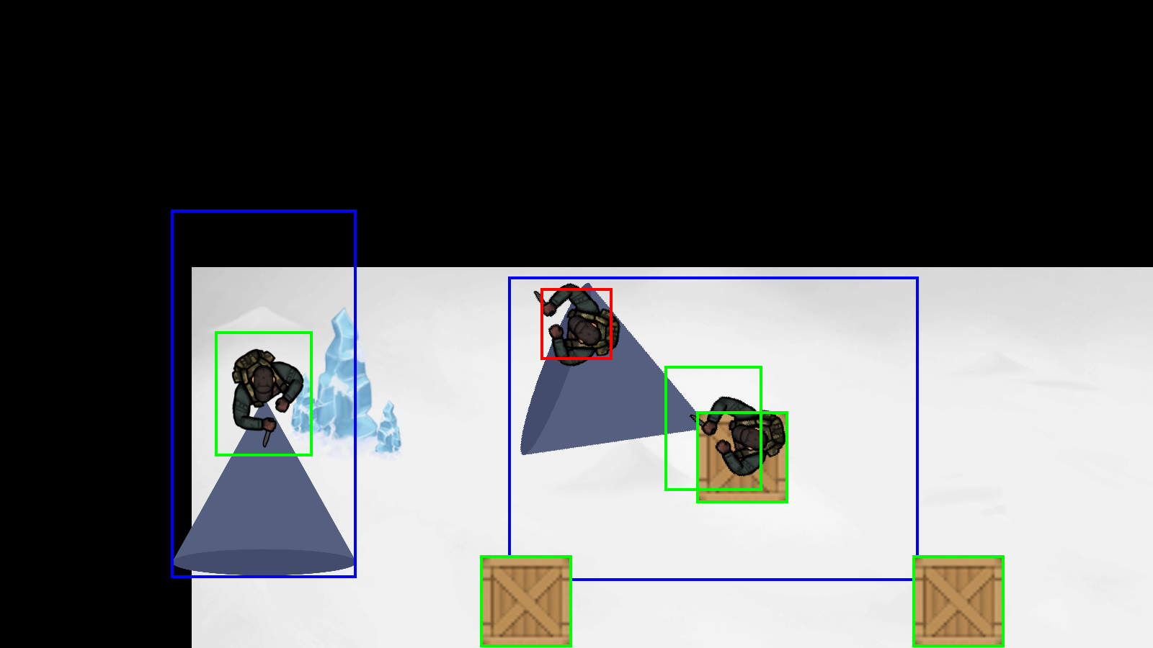

|  |  |  |  |
| --- | --- | --- | --- |
| Test | Expected Output | Actual Output | Success? |
| Enemy walks to each destination [[100, 100], [100, 200], [200, 200], [200, 100]] | Enemy.pos = [100, 100]  Enemy.pos = [100, 200]  Enemy.pos = [200, 200]  Enemy.pos = [200, 100]  Enemy.pos = [100, 100] | [100, 100]  [100, 200]  [200, 200]  [200, 100]  [100, 100] | ✓ |
| Enemy rotates to face each destination (testing enemy route 1) | Looks down  Looks right  Looks up  Looks left | Looks down  Looks right  Looks up  Looks left | ✓ |
| Player moves up 100 pixels (- 100 pixels in the y direction) | Enemy.pos = [100, 200]  Enemy.pos = [100, 300]  Enemy.pos = [200, 300]  Enemy.pos = [200, 200]  Enemy.pos = [100, 200] | [100, 200]  [100, 300]  [200, 300]  [200, 200]  [100, 200] | ✓ |
| Player moves left by 100 pixels (-100 pixels in the x direction) | Enemy.pos = [200, 100]  Enemy.pos = [200, 200]  Enemy.pos = [300, 200]  Enemy.pos = [300, 100]  Enemy.pos = [200, 100] | [200, 100]  [200, 200]  [300, 200]  [300, 100]  [200, 100] | ✓ |
| Cones drawn to screen | Vision cone images are visible | Vision cone images are visible | ✓ |
| Cones drawn at correct location | Cone drawn at the center of the enemy images | The point of the cone is drawn at the center of each enemy image. | ✓ |
| Cones are rotated to face the same direction and remain centred | Cone is facing down  Cone is facing right  Cone is facing up  Cone is facing left | Cone is facing down  Cone is facing right  Cone is facing up  Cone is facing left | ✓ |
| Player stands near cone but not in cone or in rect | No collision | Collision detected | X |
| Player stands near cone but not in cone or in rect (Updated) | No collision | No collision | ✓ |

Im happy with the state of the first stage of the game, I’ve met my criteria of creating a player, enemy with vision cone, objects with collision physics and a camera which follows the player. (For the last test I changed one of the rect variables to hitbox_rect which is how I fixed the issue)

## Stage 2

In this stage I have a few aims as a lot of this section will be focused on cleaning up all of the things created in the last stage and putting everything together.

Success criteria:

* Menu screen with interactable buttons
* Properly designed levels, with objects in correct places
* Enemy routes actually follow the level and don’t go through objects and walls
* Game over has a screen rather than just ending the program
* Adding animations for both the player and the enemies on screen(movement animation, idle animation, attack animation)

### Creating a menu screen

For the menu I will have a centred image which is larger than the screen size and then have the buttons drawn as separate objects. This is so that the menu is centred and works on any display no matter the screen size or resolution.

There will be one button at this stage to just start a new game, when more levels are added, there will be a level select button to choose which level to start on.

#### Success Criteria

* Menu background which appears at the start of the game
* Button which when clicked begins the game loop
* Button changes when the mouse is hovering over it

#### Coding + Testing

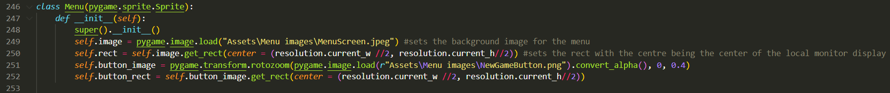

Here is where the menu is initialised to set up the background image for the menu and its rect, and the button image and its rect. The reason these both have rects is so that the program knows where they should be drawn to the screen rather. With rects its easier to manipulate the centre of an image than just using raw coordinates.



This is a method used to check if the players mouse is on the button (within the boundaries of the button_rect) and if the mouse is left clicked (pygame.mouse.get_pressed() == (1, 0, 0)). This is currently the only menu method but if I were to add more buttons, I could either make separate attributes for each button or make button its own class and then make multiple different instances of the button class.

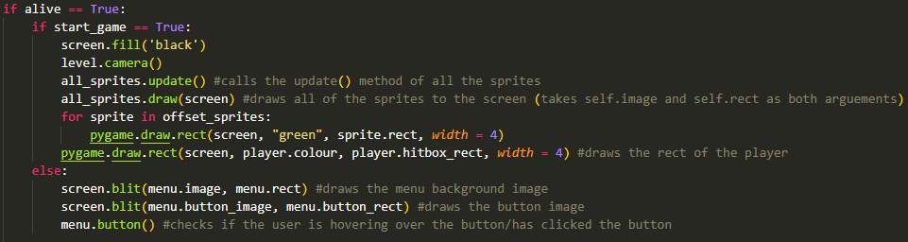

Here is where in the game loop the menu and button are drawn to the screen and the button() method is called. When the button method updates start_game to true (as it’s a global variable) it will then run the main program, calling al of the update functions and drawing all of the sprites to the screen

#### **Final test**

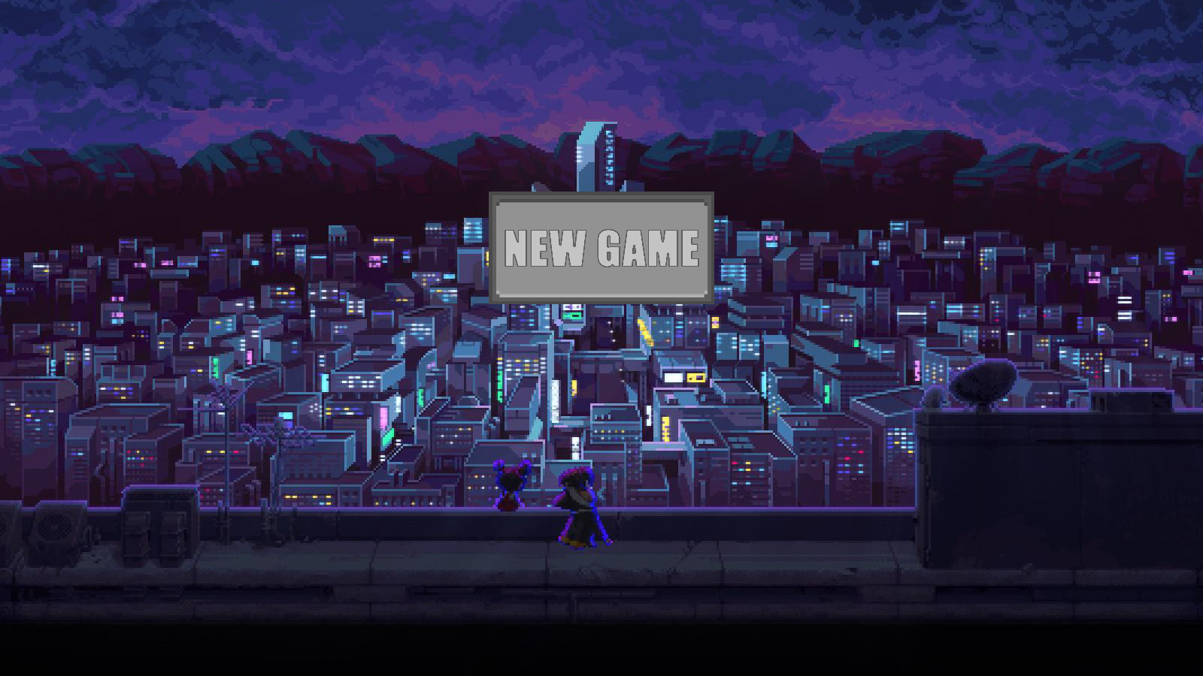

|  |  |  |  |
| --- | --- | --- | --- |
| Test | Expected Output | Actual Output | Success? |
| Program run | Draw menu background, draw button | Draws menu background, draws button at correct position | ✓ |
| Mouse hover over button | Button image changes | Button image changes to the alternative image | ✓ |
| Mouse hover edge of button | Button image changes | Button image changes to the alternative image | ✓ |
| Mouse not over button (checking collision) | No change to button image | No change to button image | ✓ |
| Mouse left click button | Menu screen and button stop being drawn. Main game loop begins with all objects being drawn to screen | Main game loop begins as it did before, menu screen and button stop being drawn to screen | ✓ |
| Mouse left click not on button (checking collision) | No effect | No effect | ✓ |
| Mouse right click button | No effect | No effect | ✓ |
| Mouse right click not on button (checking collision) | No effect | No effect | ✓ |

### Organising the level

This task will likely not involve a lot of new code but will be focused on using the code I’ve written for all of the objects on screen and organising them to create an actual playable level. Currently the enemies are placed at random locations and the same is with the crates and such.

First I will construct the level backgrounds which will be used for the levels in the final product and then get the coordinates of those backgrounds where I want to actually place objects and enemies.

#### Success Criteria

* Background for level one
* All objects for level one in correct places
* All enemies spawn at correct locations
* All enemies have correct routes
* All walls in level one added and functional

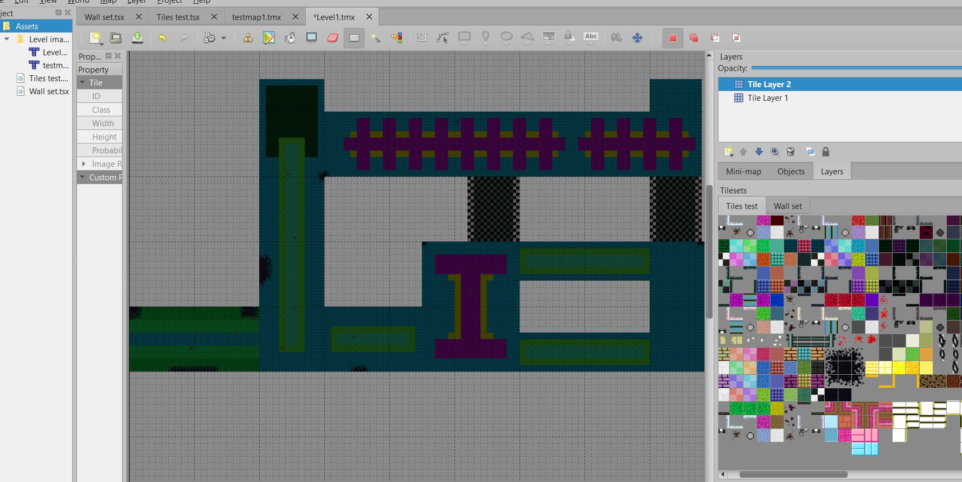

This is the background for my first level which I made on tiled. These tiles are from a game (Hotline Miami) which I actually researched in my analysis section. As I don’t plan to distribute or sell my project and it is purely for educational use, it is okay for me to use these tiles and sprites.

This is only the floor plan as the walls will be their own separate objects so that collisions can be taken with them.

#### Coding + Testing



This is where I implemented the new background image, and as the image was too small I decided to scale it up. Originally I used the pygame.transform.rotozoom function however this resulted in a blurry image when upscaled so I opted to use pygame.transform.scale, 8000x8000 is the new scale as the image is originally 1600x1600 pixels, (5x the original).

The next issue was that the player would spawn in the top left of the map (which is a large transparent space). Because the player is locked to the middle of the screen, I couldn’t move the player so I had to offset the background rect.

Here is some of the coordinate maths:

1. The starting square is the 5 square down and 44th square across.
2. This makes it square (45, 6).
3. To calculate its pixel coordinates both values are multiplied by 16 (because each square is 16 pixels in height and width) and then multiplied again by 5 (because the image has been scaled up by 5x) this gives coordinate (x = 3600, y = 480).
4. However this is the coordinate for the bottom left of the square so -40 pixels (as that is half of the width and height of a square) from both the x and y to get the centre of this square.
5. This results in the final coordinate of (3560, 440)

The next step is applying this to the program. This pixel in the image needs to be lined up with the players staring position (the centre of the screen).



The top line calculates the difference between the y coordinate of the player and the start position. The bottom line does the same for the x position. I realised later that the following code did the same thing but was neater.



**Test 1**

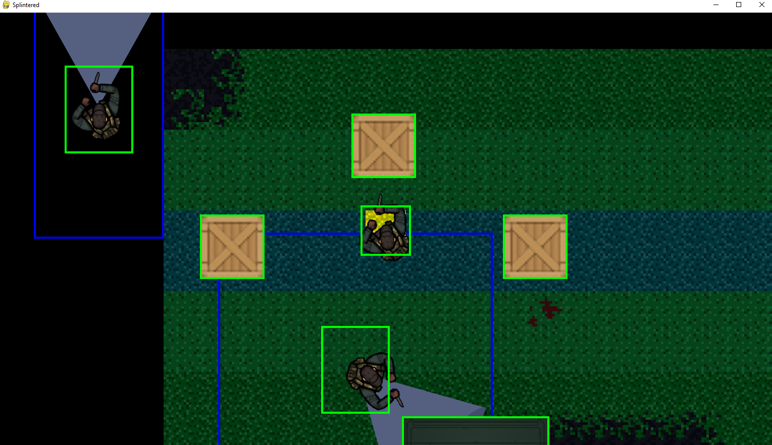

**Successes**

* New background added
* Background scaled to appropriate size
* Background offset to correct location

I then changed it so that the corner of the map lined up with (0,0) so that when I added objects it would be easier to calculate the correct locations. This just makes adding the walls and arranging enemies easier as I’m basing their position in relation to 0,0 rather than the centre of the display which changes between monitors.



Next step is adding the walls. I will create a method to construct walls of different length by using a combination of the left end, middle and right end images of the wall to make one singular surface which will be drawn to the screen. These walls will be added to a list which will be drawn each frame and have collision physics.

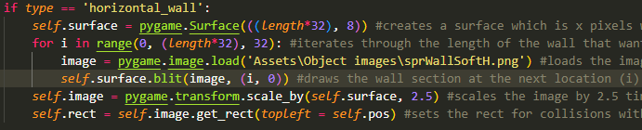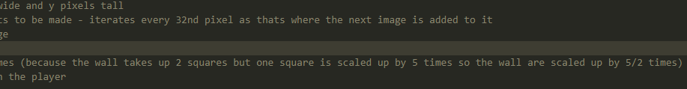

This code is used to create longer sections of wall. A typical wall image would take up 1 tile of the map so hundred of separate images would need to be made and drawn each frame which would be inefficient and slow down the program. This draws longer wall sections based on the parameter (length) of the wall.

Creates a surface based using the length passed in as x and the y value is fixed as 8(y value of the source image). The length is multiplied by 32 as that is the length of the base image. Then iterates through the length and draws a new image every 32 pixels (if it drew a wall on each pixel there would be overlap). The image is then scaled by 2.5 times (explained in comment) and then the object is assigned a rect.



Here is where it instantiated for the test

**Test 2**

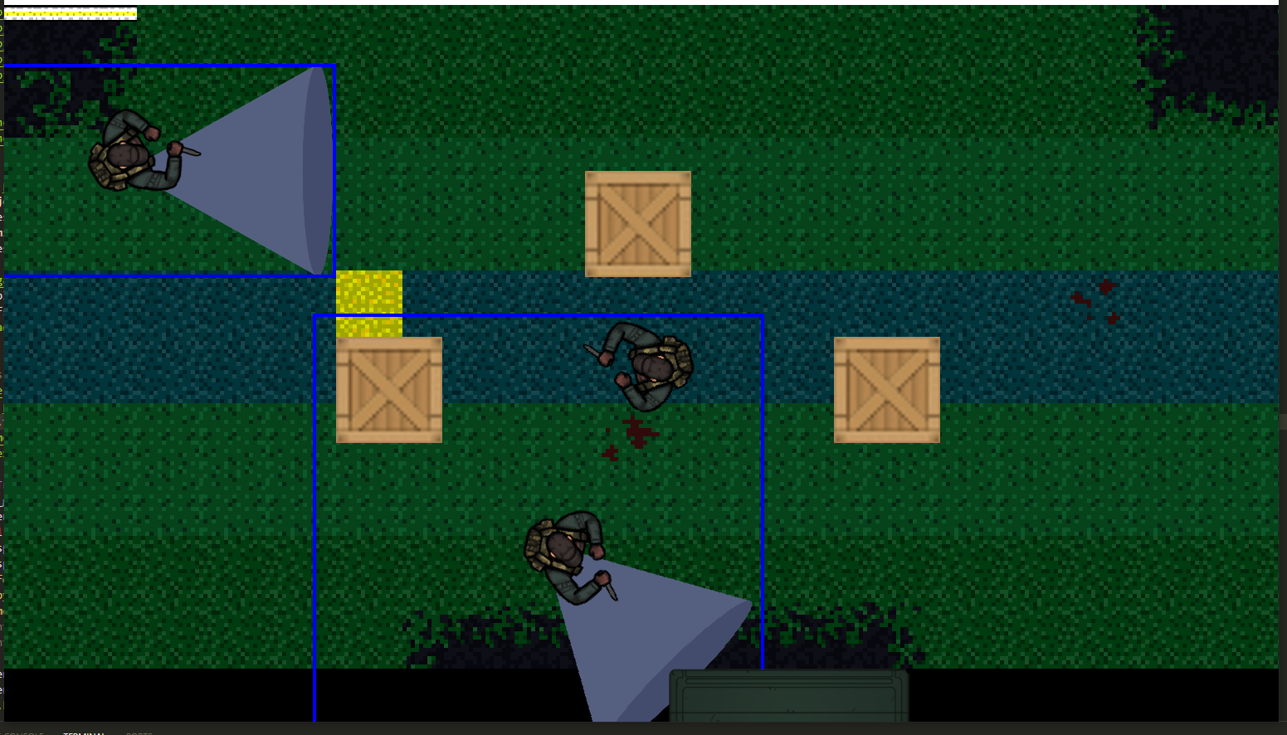

**Successes:**

* Wall drawn at correct location
* Wall correct inputted length
* Wall has collisions with player (uses same collisions as other objects)

**Problems**:

* Each wall segment needs to be instantiated separately
* No vertical wall objects yet
* Enemies can walk through walls

The issue that enemies can walk through walls is not a real issue as they will be given set routes that don’t involve them walking through walls

To instantiate the walls I will create a list for the horizontal and for the vertical walls containing all of the information to be passed in.

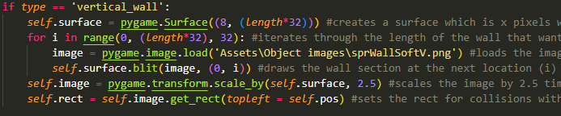

This Is the code for creating vertical walls which is basically the same as the horizontal walls but altered with the x and y values and using a different image.

Here is the instantiation for all the walls of just the first room: 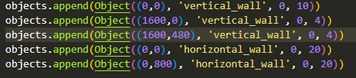

**Test 3**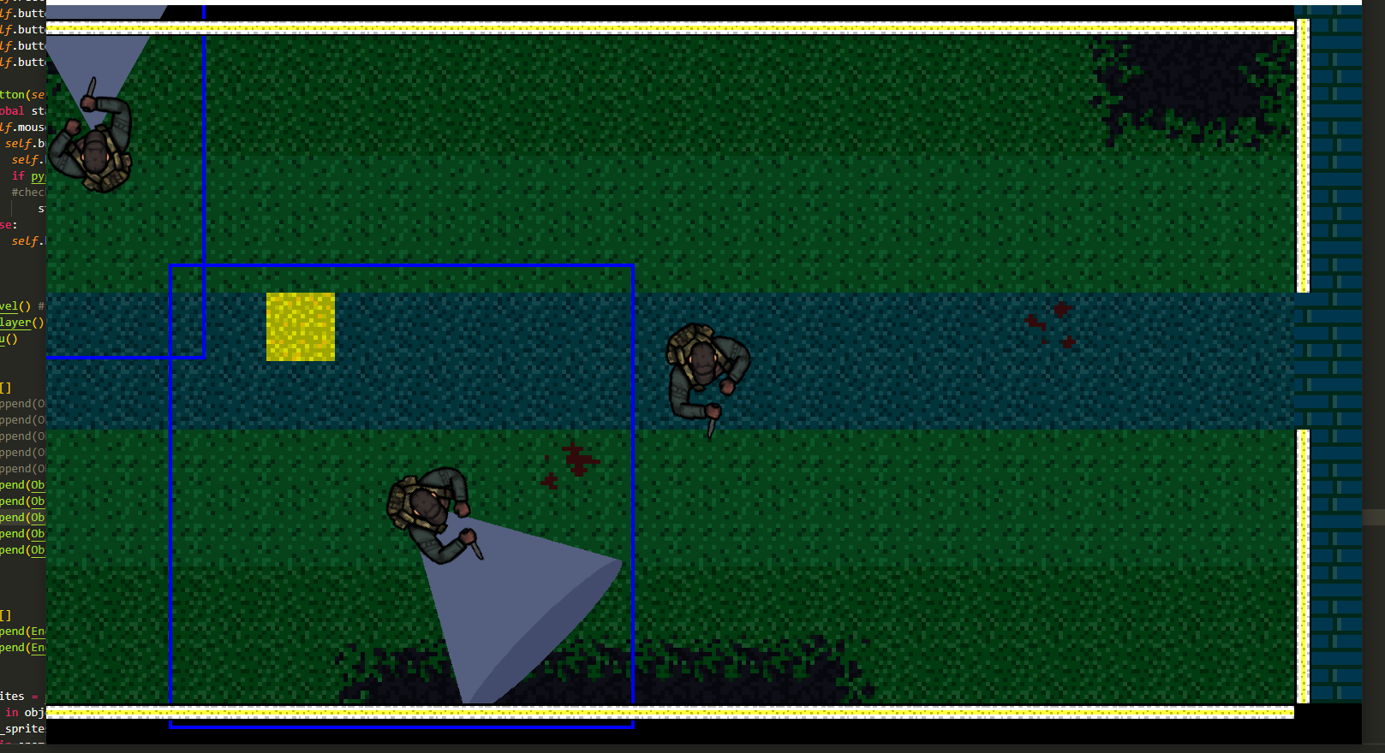

**Successes:**

* Vertical walls added – correct locations and length

**Problems**

* Horizontal walls need to be drawn on the inside of the edge of the map rather than the outside, causes issues like the empty corner of wall in the bottom left.
* Walls overlap at the corners but this is only a minor visual issue which will be ignored for the time being
* Wall instantiation is messy and unorganised

To draw the horizontal walls on the inside, - 8 from the y coordinate (only applies to walls on the south side of rooms)

To draw vertical walls on the inside, - 8 from the x coordinate (only applies to walls on the east side of rooms)

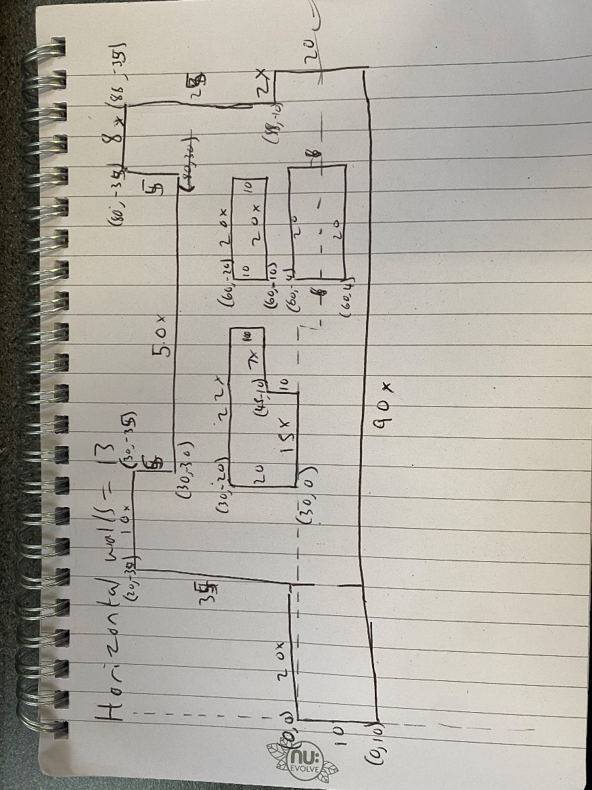

This is an abstracted diagram which I used to calculate the coordinates of where the topleft coordinate of every horizontal wall will be and also calculate the length. These coordinates were calculated in terms of the tiles so all coordinates are multiplied by 80 (height and width of tile) to find the pixel coordinates. For horizontal walls on the underside of a room, they had -8 to the y coordinate so that they were on the inside of the room rather than the outside.



Here is the list of wall objects after the coordinates and lengths were applied.



Here is the list after realising that I should -20 from the south walls as (8*2.5 = 20) to account for scaling the walls

**Test 4**

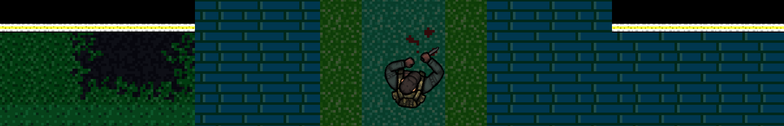

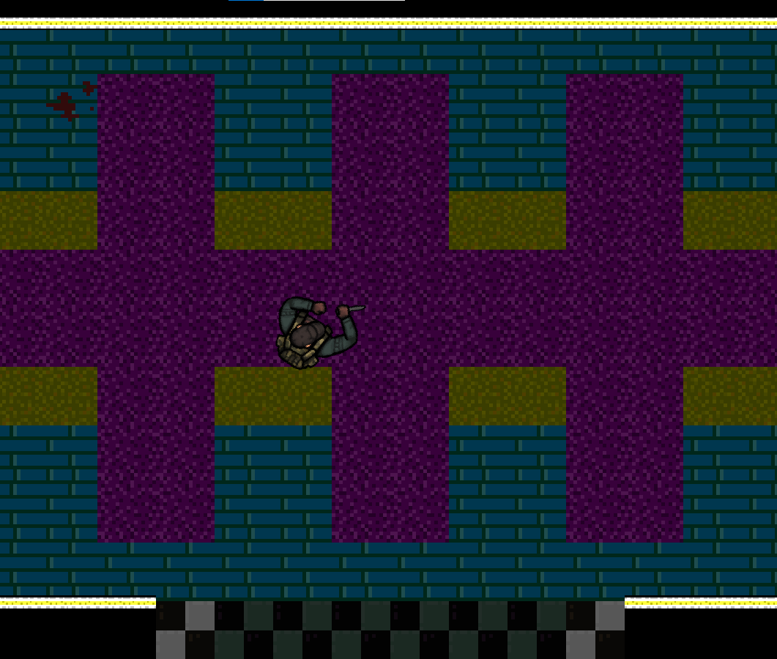

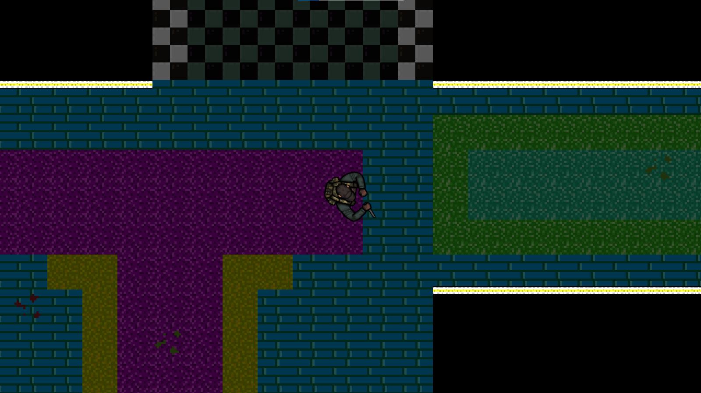

**Successes:**

* All the horizontal walls are now in the correct locations
* All the horizontal walls are of the correct length
* Horizontal walls on the bottom of rooms are on the inside not the outside

**Problems**

* Vertical walls not yet all implemented
* Enemy routes not yet changed
* Object locations not yet changed

While adding the vertical walls, I found that the walls overlap on top left corners but have empty space on bottom right:

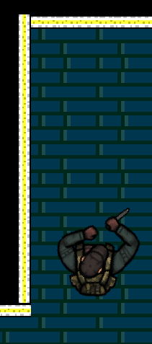 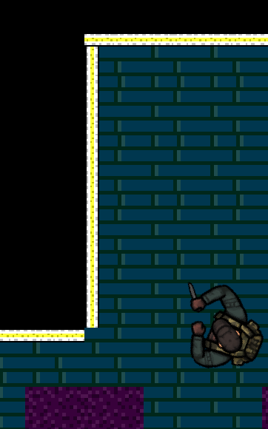

To fix this I decided to have the vertical walls be on the outside of the rooms and have the horizontal walls be on the inside of the walls. This solves both issues present in this image. Left is before, right is after.

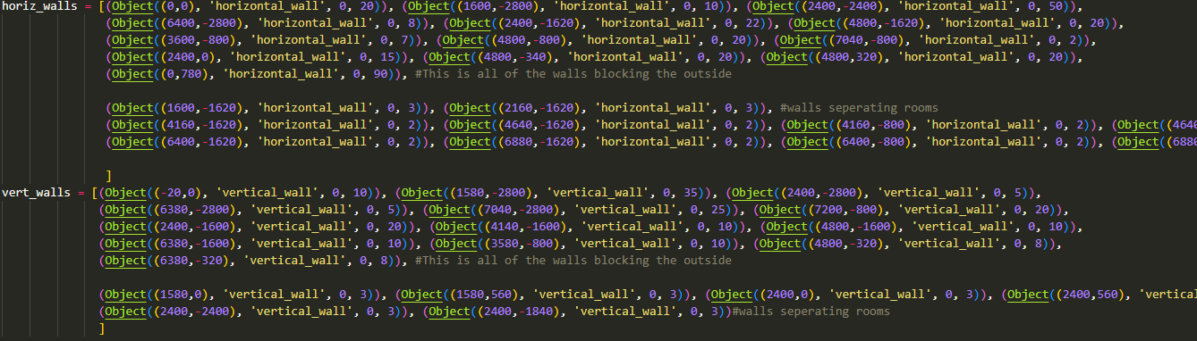

Here is the list of all the walls which will be in level one. A lot of small tests were ran just to test if coordinates were correct and so the only errors I ran into were just errors in the maths when I was calculating the coordinates which Is why I haven’t documented those tests specifically.

**Test 5**

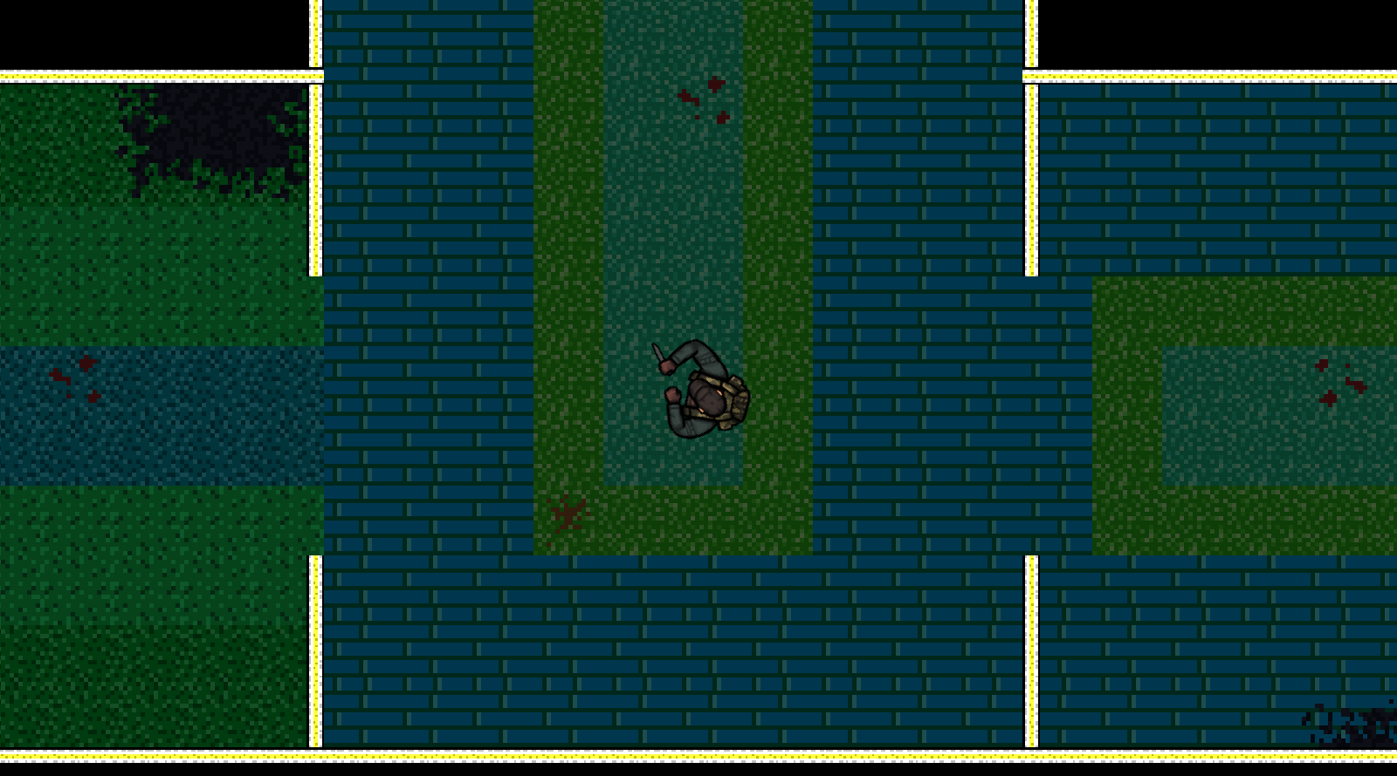

**Successes:**

* All walls (vertical + horizontal) in correct places and of correct length

**Problems:**

* Objects still not in correct positions
* Enemies still not in correct places

**Sorting out the objects**



First I tidied up my objects class by using the parameter in the string for selection rather than using a long list of if statements like I had before e.g. if type == chest, if type == crate, if type == pool table etc.

This is faster and more efficient.

It checks that the type isn’t a wall because the walls are handled differently to the other objects so cant be used in this general function. Some other objects may need their own specific changes to rect or scaling and would also be handled outside of this code.

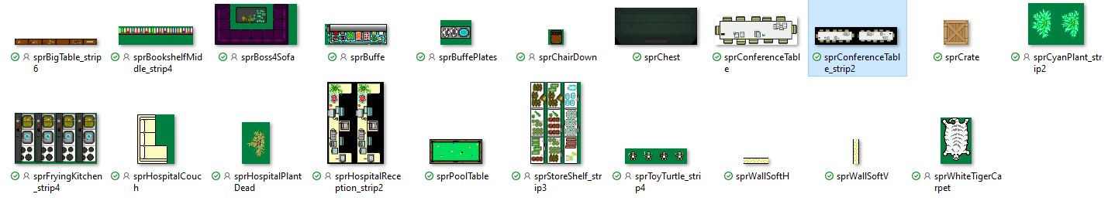This is the folder holding all of the sprites for the objects in my game. All the sprites have the prefix ‘spr’ which is used in the code to access the sprites.



This is an example of how an object Is instantiated. The parameters are (coordinates, type of object, level, length (only applies to walls)).

Results in:

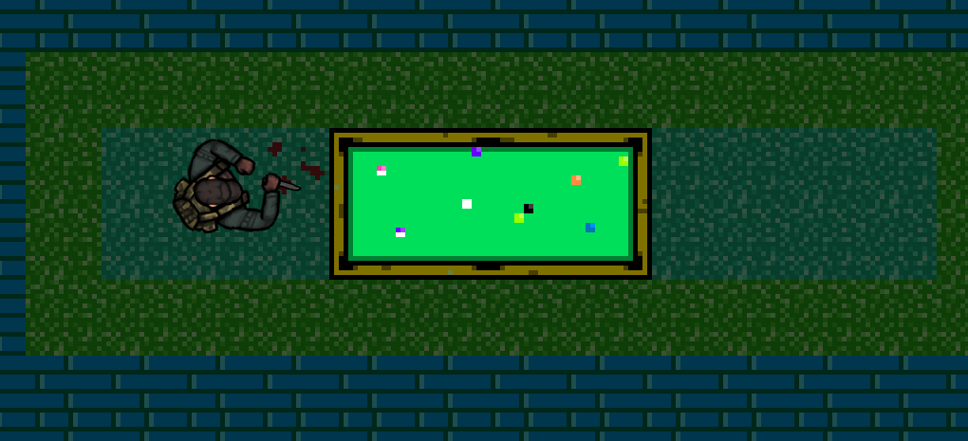

As I wrote all of the code for objects and for collisions earlier in development, its now just a case of using that reusable code to implement all of the objects.

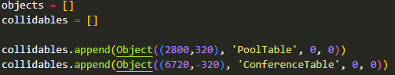

Made a new list called ‘collidables’ – this contains all of the objects which will have collisions with the player so that I can also have objects in the objects list which don’t have collisions e.g. carpets, rugs or other minor decorations.

 All items in ‘collidables’ are then added to ‘objects’. The program functions the same as before but there is just now the capability to add objects without collision physics.

I also decided to make an entirely new class for handling walls. This is because walls needed a length as a parameter which didn’t apply to other objects ; and objects needed an angle of rotation as a parameter which didn’t apply to the walls. This led to a lot of parameters that had no use most of the time which was inefficient. New code:

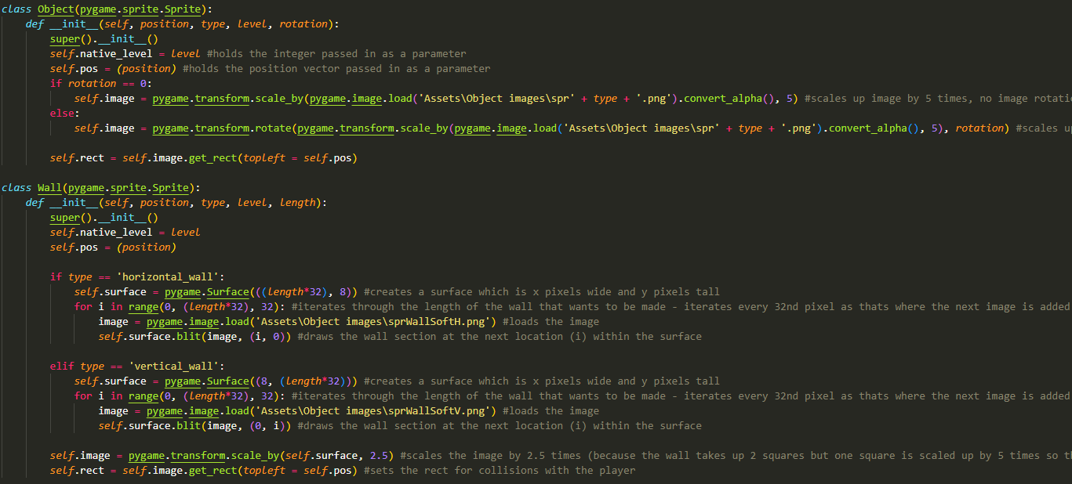

The bulk of the code is the same but is just arranged in a more efficient and easier to edit way.

**Test 6**

There is no screenshot for this test. This test was just to check that the program ran the same as it did before the changes to collidable/non-collidable objects and the changes to the wall and object class. Found no errors and code functioned the same.

**Rerouting the Enemies**

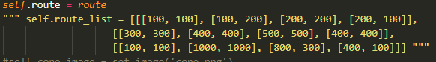

I’ve decided to remove the route_list (3d array holding the lists of destinations for all of the enemies in the game). Instead, each enemy will have a route passed as a parameter so that they only have the route they need rather than a lot of unnecessary data.



Here is an example of an enemy being instantiated. Enemy((Destination), route[], level)

**Test 7**

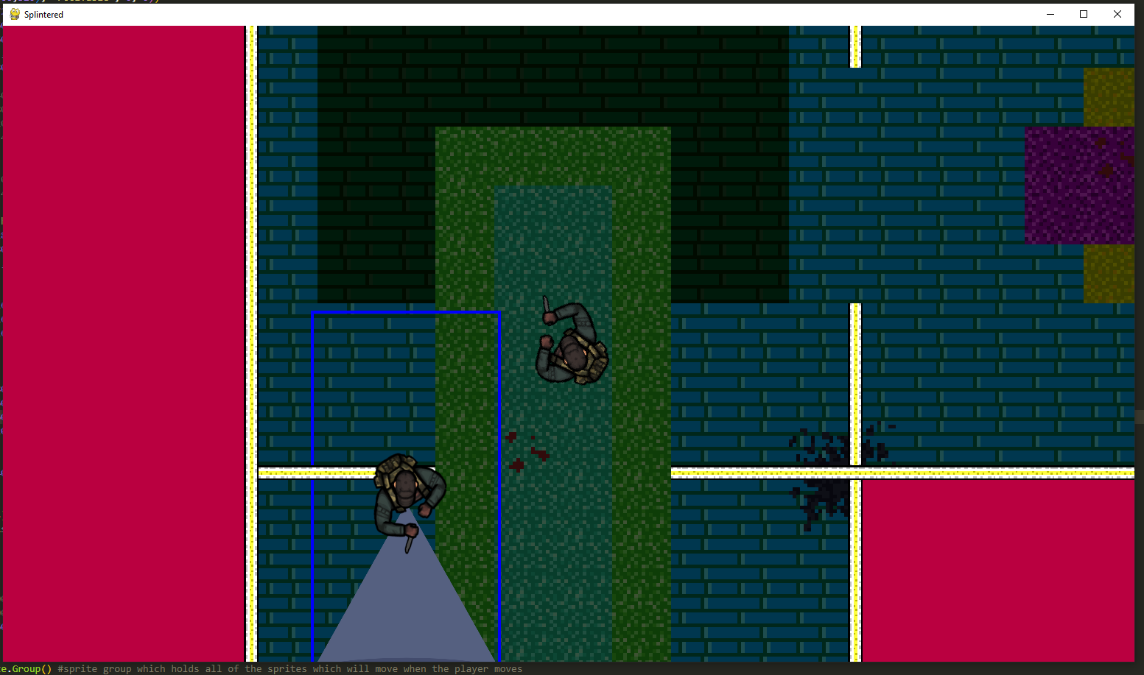

**Successes:**

* The enemy follows the correct route
* The enemy now only holds the route it needs and has no unused data

**Problems**

* Enemy Walks through walls
* Enemy is too easy to avoid

To fix the issue with it walking through walls the route will just need to be altered so that the route doesn’t pass through walls.

To fix the issue with the enemy being too easy to avoid, I will implement multiple solutions:

* More enemies
* Larger cone of vision
* Less time taken to get caught (currently a 60 frame timer)

**More enemies:**



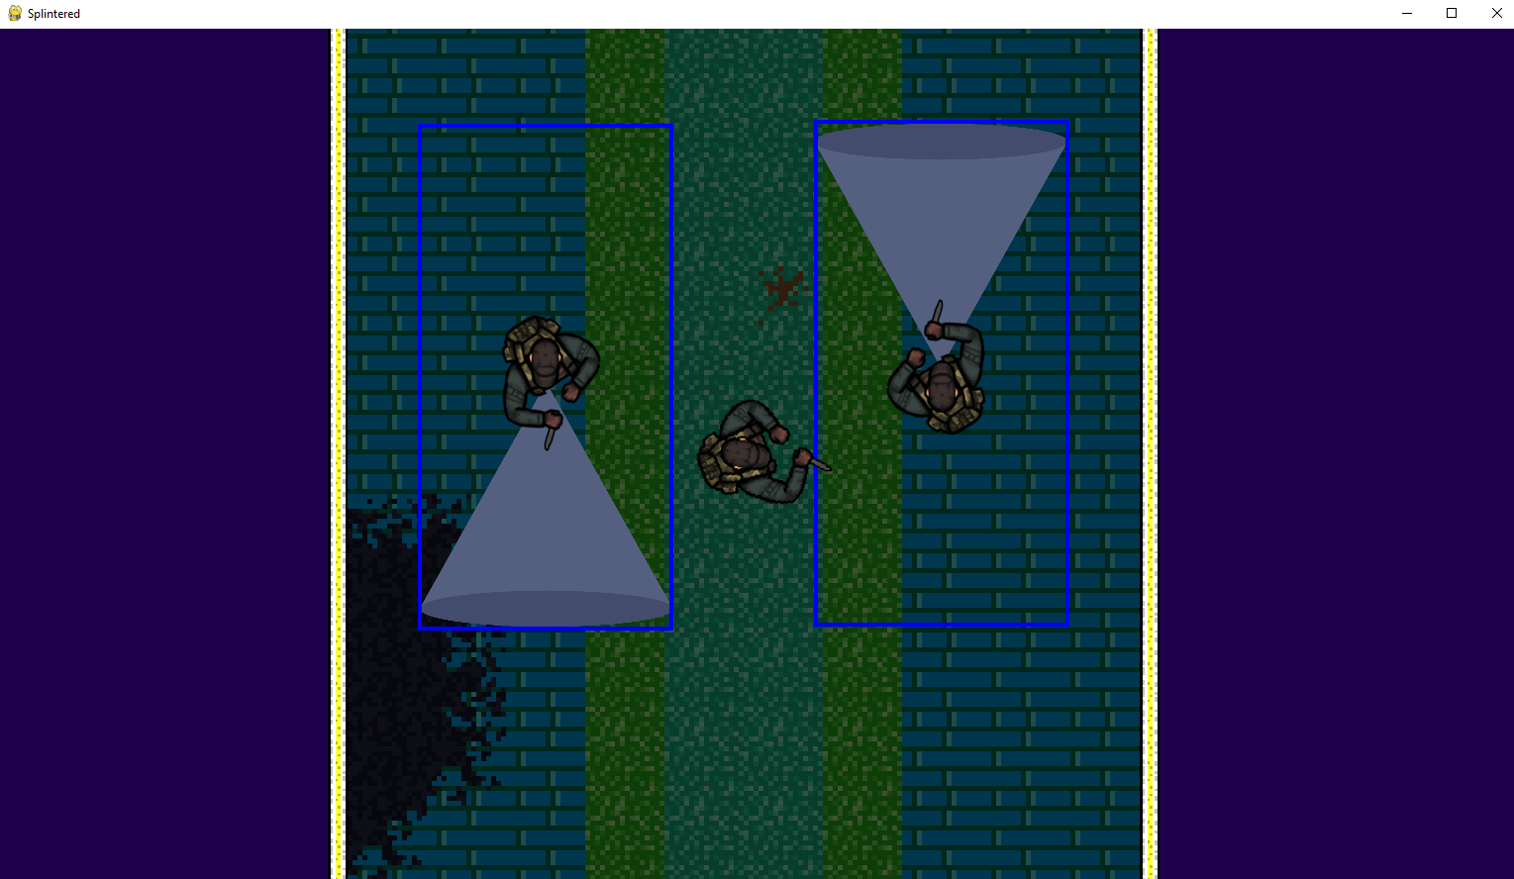

**Larger cones:**

Upon making the cones larger, the program ran significantly slower and was running horribly. My assumption is that this is due to it needing to create a much larger mask which is then moved every frame.

I then tested this with the same size cones as before but with far more enemies which also resulted in worse speeds.

**Here is how I optimised the cones:**



This represents the rect area of the display (changes based on monitor resolution)



The method now checks if the cone is colliding with the screen, this mean that the code only runs for the cones which are currently visible and on screen, so having a lot of enemies makes no difference to performance provided that they aren’t all on screen at once (which they wont be). This doesn’t completely fix the problem as if there is a densely packed area with enemies there will still be issues, but it does massively reduce the strain on the program.

**Test 8**

The code doesn’t work. The cones aren’t being drawn even when they should be on screen.

This is because the cones would only have their position updated if they were on screen, which couldn’t occur because they couldn’t move into the screen. Here is the updated code: the cones now move regardless of whether they are on screen or not, but the image is only drawn and the mask is only updated if the cone is on screen.

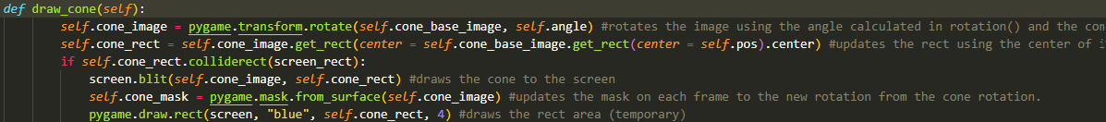



Time spent in cone before a game over is also reduced: 

**Test 9**

**Successes:**

* Cones are now larger and harder to avoid
* Program runs much smoother even with more enemies and larger cones

**Problems:**

* Game still needs more enemies



The enemies now take a speed as a parameter. This allows for different enemies to have different speeds and also allows for enemies to be stationary if their speed is set to 0. This allows for more variety between enemies and was easy to implement because of the pre-existing code.

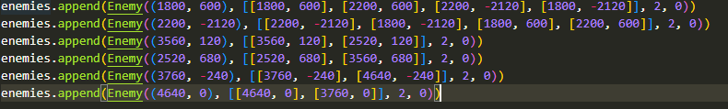

Here are all of the enemies so far.

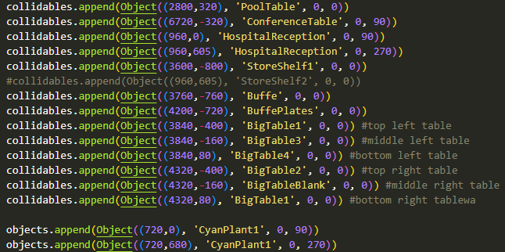

Here are all of the objects so far.

These are not all of the objects and enemies that will be in the final product but for the sake of time I will move onto the next section as adding more enemies and objects is not very complex and not very code based but is very time consuming as it is a lot of coordinate geometry. Because of this I will conduct the final test of the level organisation section.

#### **Final test**

There will be multiple screenshots for this test:

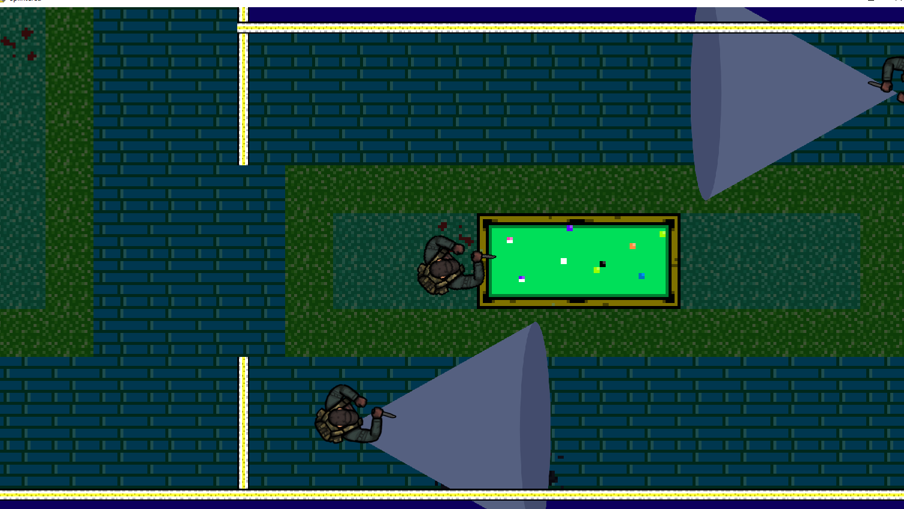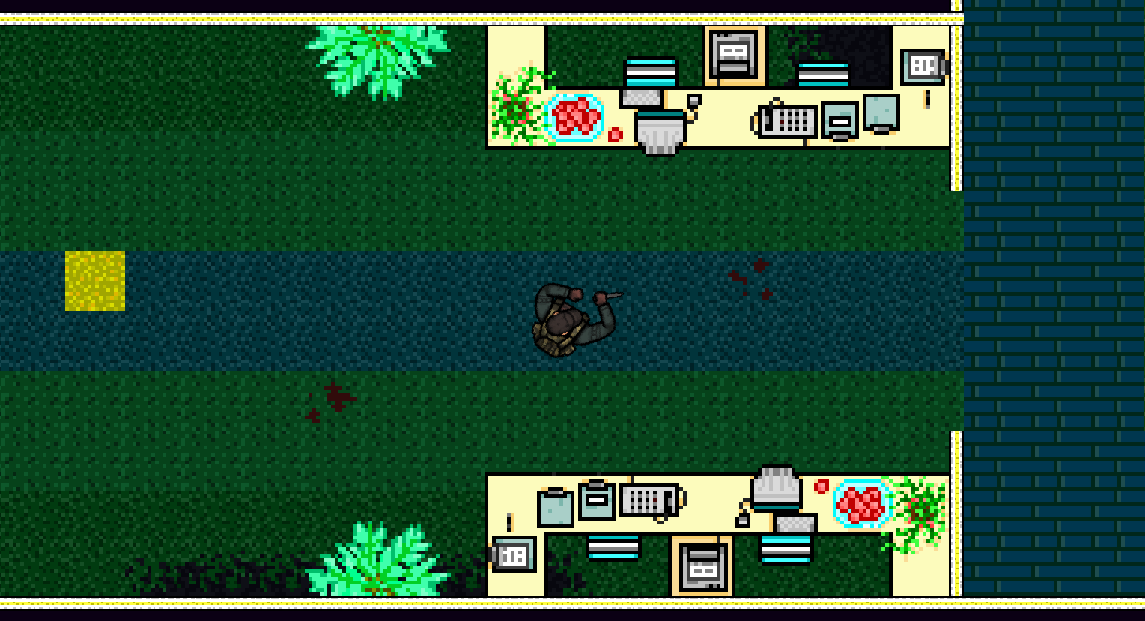

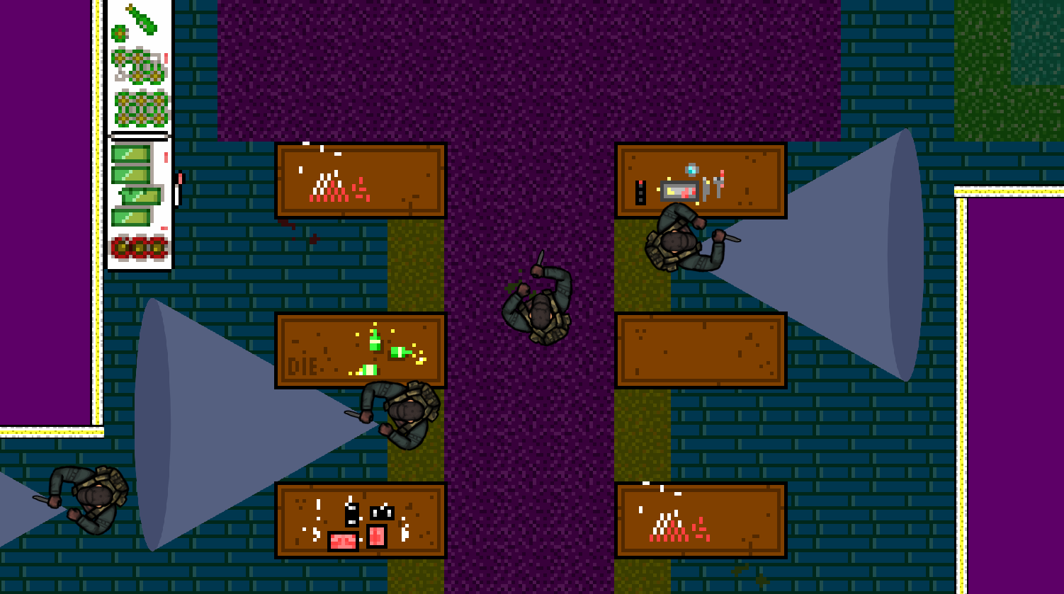

|  |  |  |  |
| --- | --- | --- | --- |
| Test | Expected Output | Actual Output | Success? |
| Run Program | Program runs | Program runs | ✓ |
| Border horizontal walls in correct locations | All border horizontal walls in correct locations, none too long/sticking out or interfering with the level | All border horizontal walls in correct locations, no issue with walls sticking out or any interference | ✓ |
| Inner horizontal walls in correct locations | All inner horizontal walls in correct locations, not too long too short, no issues with player not being able to get through open areas | All inner horizontal walls in correct locations, of correct size, no issues with interference | ✓ |
| Border vertical walls in correct locations | All border vertical walls in correct locations, none too long/sticking out or interfering with the level | All border vertical walls in correct locations, no issue with walls sticking out or any interference | ✓ |
| Inner vertical walls in correct locations | All inner vertical walls in correct locations, not too long too short, no issues with player not being able to get through open areas | All inner vertical walls in correct locations, of correct size, no issues with interference | ✓ |
| Walls of correct length | All walls are of correct length | All walls are of correct length | ✓ |
| Walls offset correctly with camera (*uses the same offset algorithm as the objects and enemies classes which have already been tested earlier in development) | Player holds “W” -> Walls move down  Player holds “A” -> Walls move right  Player holds “S” -> Walls move up  Player holds “D” -> Walls move left | Player holds “W” -> Walls move down  Player holds “A” -> Walls move right  Player holds “S” -> Walls move up  Player holds “D” -> Walls move left | ✓ |
| Collision with walls  (*Uses the same collision algorithm as created earlier) | Player cannot walk through walls (Tested from above, left, below and right of the object) | Player cannot walk through walls Player does shake while colliding and 2 inputs held. | ✓ |
| Object locations | All objects are in correct locations that are passed in as parameters during instantiation | All objects are in correct locations | ✓ |
| Object collisions (collidable objects only) (*) | Player cannot walk through objects(tested from above, left, below and right of the object) | Player cannot walk through objects. Player does shake while colliding and 2 inputs held. | ✓ |
| Object collisions with non collidable objects | Player walks through objects | Player walks through objects and is drawn above the objects | ✓ |
| Objects offset correctly with camera (*) | Player holds “W” -> Objects move down  Player holds “A” -> Objects move right  Player holds “S” -> Objects move up  Player holds “D” -> Objects move left | Player holds “W” -> Objects move down  Player holds “A” -> Objects move right  Player holds “S” -> Objects move up  Player holds “D” -> Objects move left  (Also works with diagonal movement) | ✓ |
| Enemy spawn(*) | Enemies spawn at the correct locations | Enemies spawn at the correct locations | ✓ |
| Enemies routes (*) | Enemies follow correct route (walk to one location, rotate to face the next location, walk to next location) | Enemies follow correct route, only works if the enemies speed is a factor of its destination (otherwise it wont align with its destination) | ✓/ X (addressed below) |
| Player stands in cone for 30 frames | Window closes, program closes | Window closes, program closes | ✓ |
| Player stands in cone for 29 frames | Game continues as normal, self.frames_in_cone is reset to 30 | Game continues as normal, self.frames_in_cone is reset to 30 | ✓ |
| Program runs smoothly | Program has no lag or visible performance issues, | When enemy cones are too large or there are lots of enemies on screen, the program drops in performance(due to the masks). Program runs perfectly fine outside of those instances. | ✓ / X (addressed below) |

All sections marked(*) are tests which I have already performed earlier which is why they may be in less detail as I already know the code itself works, I just had to test if it worked within these instances.

While a lot of work went into this section and the program looks almost completely different to the sections prior, there was not a lot of new code as a lot of this section was just properly utilising the code I had already written in the previous sections.

The issue with low performance when a lot of enemies are on screen is something I will consider while coding but has no real fix. When the enemies are killed they will be removed as objects entirely which will increase performance but still not fully solve the problem.

The issue with enemies and needing the speed to line up with their destinations lies in the logic of the program which is not something I intend to change. It is just a factor I will bear in mind when creating new enemies and giving them their routes.

### Creating a game over screen

This screen will have a background image telling the player they have received a game over. It will also have two buttons: “New game”, “Exit”. New game will need to begin the player from the start of the game with everything the same as it would be in a fresh save. Exit will just close the program.

#### Success Criteria

* Background image clearly showing the player a game over
* “New game” button to start a new game
* “Exit” button to exit the program

#### Coding + Testing

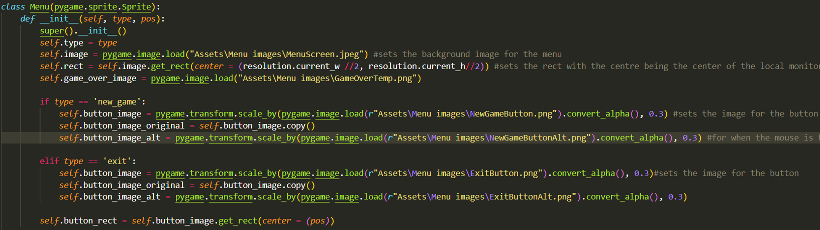Here is the new code for the menu class. It allows for different button types to be made “new game” and “exit” which are passed as parameters as ‘type’.

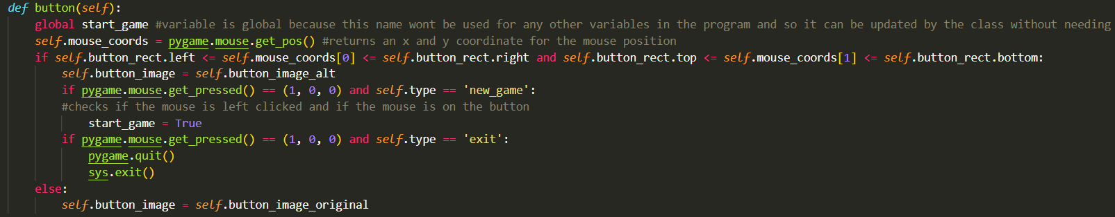Here is the updated button method which performs different actions based on if the button is for a new game or to exit the game.

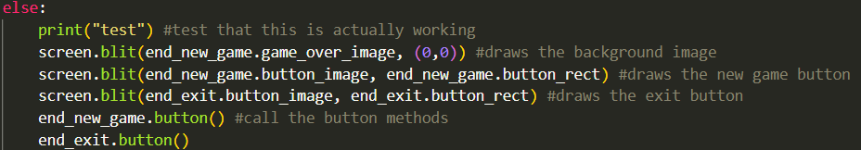

This is the code for drawing the new images to the screen and calling the button methods to check for clicks. This code is looped while the alive variable == False.



Here is where the 3 objects are instantiated (3 buttons)

**Test 1**

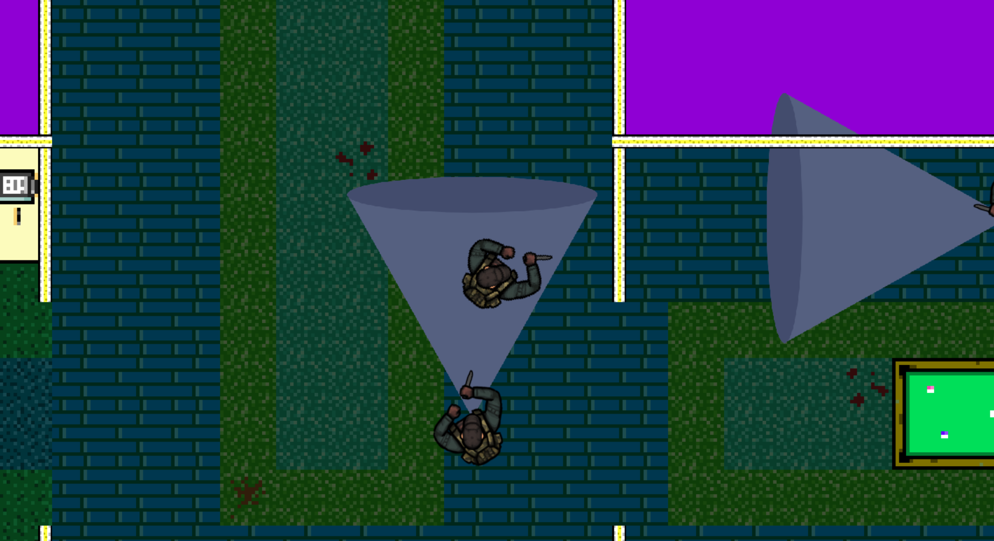

Upon getting caught the game stops but the game over screen and its buttons don’t appear. The text ‘test’ is printed so the correct loop is running but nothing is happening.

The problem was that I wasn’t calling the pygame.display.update() function so none of the image changes were taking place. 

**Test 2**

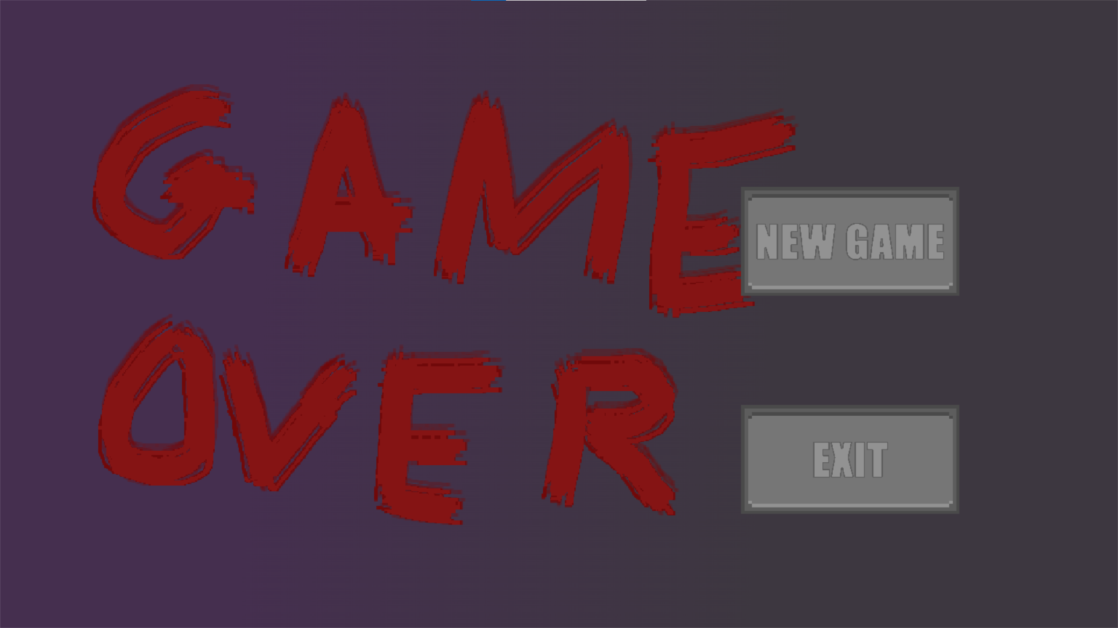**Successes:**

* Screen shows up when the player gets caught
* 2 buttons show up in correct places
* Exit button closes the program

**Problems:**

* New game button has no response when clicked – nothing happens



This code checks if the player has clicked the new game button on the game over screen. If true then it calls a new method in the level class.

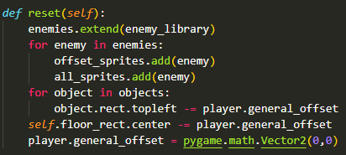

Here the enemies are placed back into the enemies list with their original attributes, they are then added back to the sprite groups. All of the objects then have their offsets reset to be back where they originally were a the start of the game. The same occurs for the background. The players offset is then reset.

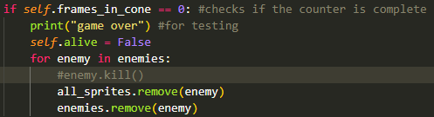

This happens when the player dies. The idea being that all of the enemies are removed from the game and then are placed back in the game at their original locations when the player starts a new game.

**Test 3**

When the new game button is pressed, the game resumes but nothing is reset to where it was originally. The enemies also move in strange directions when the movement keys are pressed. The function is being called but has some logic errors.

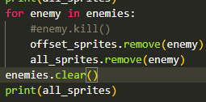

This code now removes the enemies from the enemies list once it has been iterated through for the sprite groups. This now means that al of the enemies are removed from the sprite groups as opposed to what was happening before. This solves the issue of the enemies moving weirdly but still nothing is being reset.

This is because general_offset was being reset every frame. This meant the general_offset was set to (0,0) meaning that it was doing nothing when being subtracted from the background and the objects.



The variable total_offset tracks how much everything has been offset by since the start of the game, this allows for the offset to be reversed when a new game begins.

**Test 4**

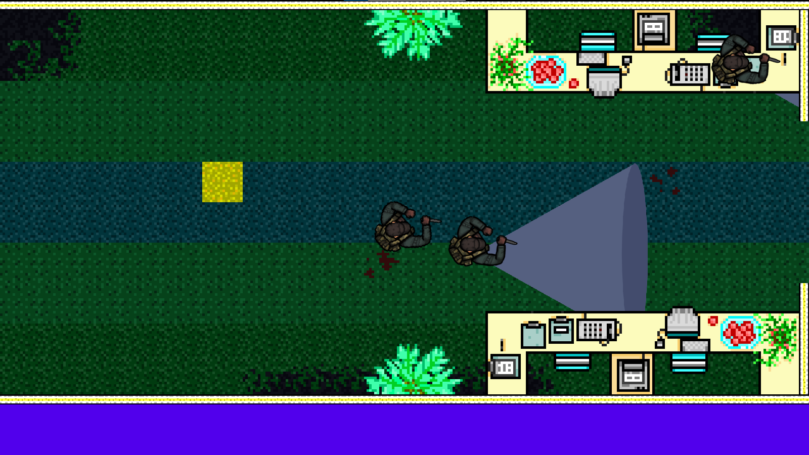

**Successes:**

* New game button starts a new game
* All objects are reset properly
* Background is reset properly
* Enemies removed upon death

**Problems**

* Enemies are not moved back to original locations when they are spawned
* Enemy routes are not reset to original routes

The enemies are removed fine but the issue lies when they are added back to the game. The reason I didn’t want to cancel out the offset for the enemies is because logically, if they were deleted and respawned, they would have the original coordinates that I had passed into them at the start

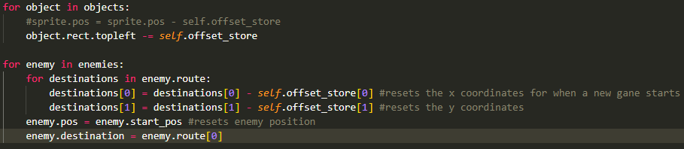Here the enemy destinations are reset to how they are at the start of the game, the position is reset to how it is at the start of the game and the destination Is set to the first position in the list (how It would at the start of a new game).

#### **Final test**

|  |  |  |  |
| --- | --- | --- | --- |
| Test | Expected Output | Actual Output | Success? |
| Player dies | Game over screen shows. Rest of program stops being updated and drawn | Game over screen shows. Rest of program stops being updated and drawn | ✓ |
| Player dies | New game button is drawn  Exit button is drawn | New game button is drawn  Exit button is drawn | ✓ |
| Mouse hover over button (no click) | New game button changes image, exit button changes image | New game button changes image, exit button changes image | ✓ |
| Mouse click not on button | Nothing happens | Nothing happens | ✓ |
| Mouse click on exit button | Screen closes, program stops | Screen closes, program stops | ✓ |
| Mouse click on new game | Game over screen closes, all objects and enemies moved back to original locations | Game over screen closes, all objects and enemies moved back to original locations | ✓ |
| Right click (anywhere on screen) | Nothing happens | Nothing happens | ✓ |

I am happy to conclude this section as being completed.

### Animations

In this section I will be using new sprites for the player and the enemies. Again, these sprites are from Hotline Miami however as I don’t intend to use this project for commercial use and is just for educational purposes, it is okay for me to use these assets.

#### Success Criteria

* Have walking animation for the player and for the enemy
* Have legs animation independent from the upper body animation
* Have an attack animation for the player that plays when the left click is pressed

#### Coding + Testing

For my sprite sheet function, I decided to create it in a separate file as it was going to be a function which can be used by all of the classes.

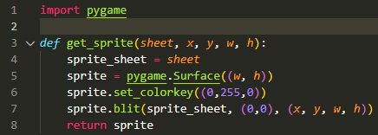

It utilises a similar logic to when I created the wall segments by creating a new surface, blitting the images to it, and then storing that surface as a new image. This function receives the sprite sheet image, x value, y value, width, height as parameters. The surface is set using the height and width and then the spritesheet is drawn to it at the x and y and with the section of the sheet that I want to be drawn.

The colorkey is used to make the background transparent as I have set the background of all the player images to be RGB(0,255,0)



The move_sheet variable just stores the image of the sprite sheet I am using for movement. In the assignment of self.image, I am calling the get_sprite function and passing the sprite sheet, the x and y are 0 because I want to get only the first part of the image, and the width and height are 44 because the width and height of the sprites in this sheet are 44x44.

**Test 1**

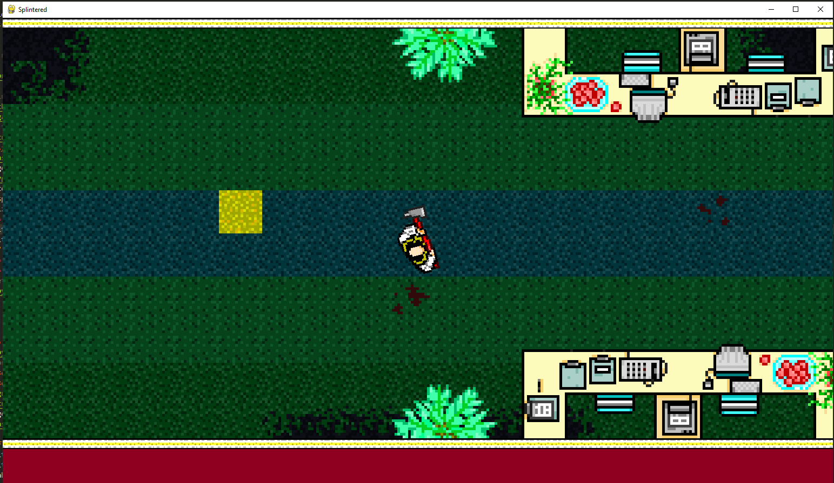

**Successes**

* Correct part of image
* Drawn at correct location, rotates and moves the same as before
* Transparent background

**Problems**

* Movement not animated yet

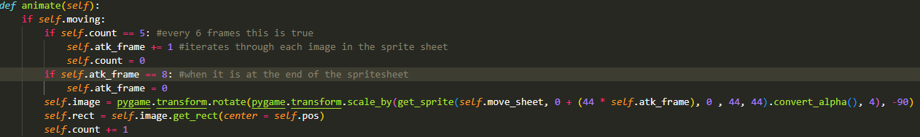

This animate method checks if the player is moving and then counts using a counter. Every 6 frames, the variable atk_frame is incremented which moves the image to the next sprite in the sheet. Once this hits 8 (the space after the last sprite) it is reset to 0 which is the start of the animation.

**Test 2**

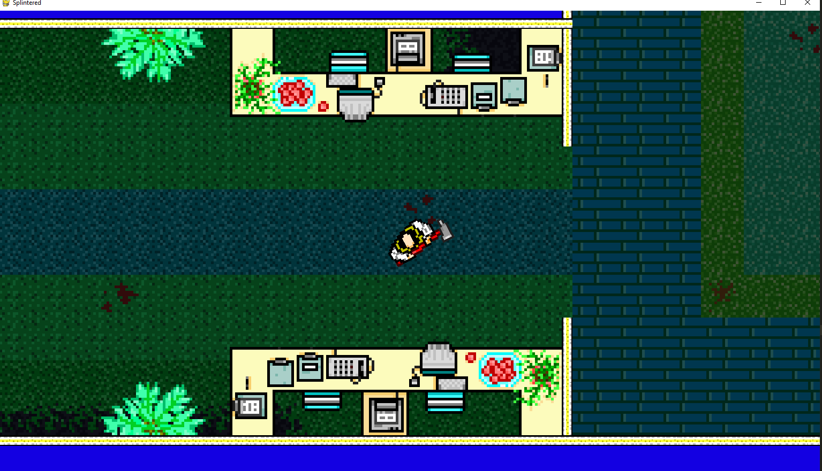

**Successes**

* The animation works

**Problems**

* The player isn’t being rotated

To fix this, I set the angle of rotation to be self.angle which is calculated in the rotation method. As the image needs to be rotated 90 degrees anticlockwise, I subtracted 90 from the angle.

**Test 3**

**Successes:**

* Animation works
* Rotation works

**Problems**

* Legs not yet animated

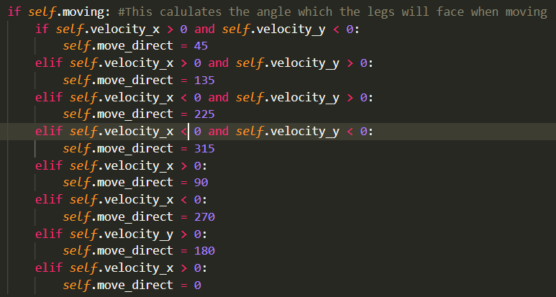

This code checks which direction the player is moving in (8 separate directions) and assigns an angle of rotation to the self.move_direct attribute. This is done in 8 if statements which while it seems an inefficient way, most solutions I came up with ended up leading back to a lot of selection statements.



This is where the spritesheet for the legs is assigned



This is where the legs image variable is assigned

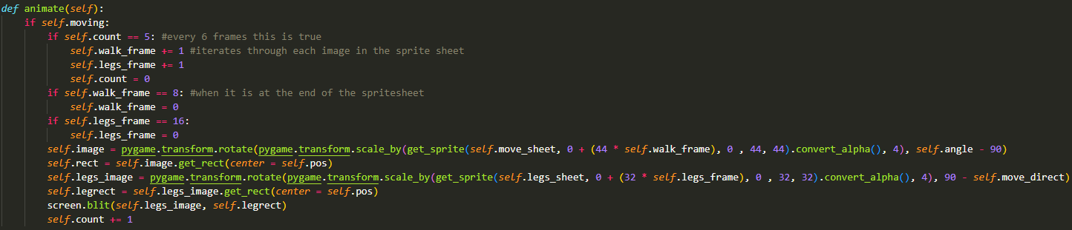

Im using the same animate method to handle the leg movement. The logic works the same as the upper body and uses the same counter attribute. This counter has to be an attribute and not a local variable as I need to keep its value after the method has finished, because I will need that stored value in counter for the next frame.

To have independent counters for both the legs and the upper body, I would need to create a new attribute.

The angle of rotation for the legs is move_direct which is assigned earlier in the program.

**Test 4**

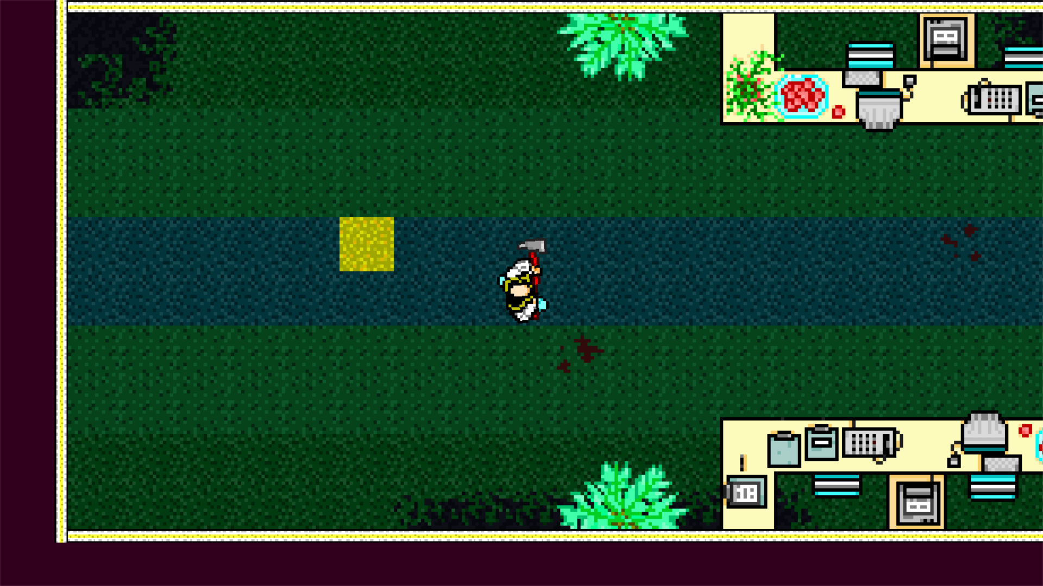

**Successes**

* Legs drawn at correct position
* Legs rotated to correct direction
* Legs properly animated

**Problems**

* Leg animation too slow
* Enemy movement not yet animated

To animate the enemies I copied the method used in the player animation. I could’ve potentially reused the code by using a function outside of the classes and then calling this within the classes but I want the animations and other factors of the animation to differ between the enemies and the player, so I just copy pasted the code and passed in the relevant images and parameters.

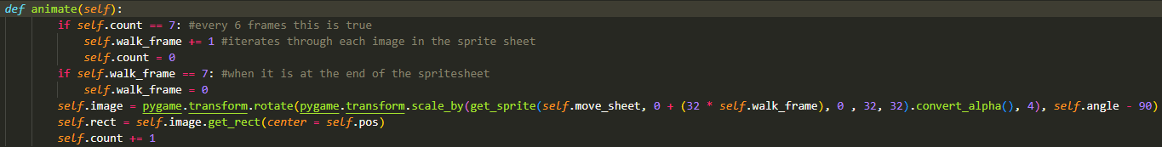

**Test 5**

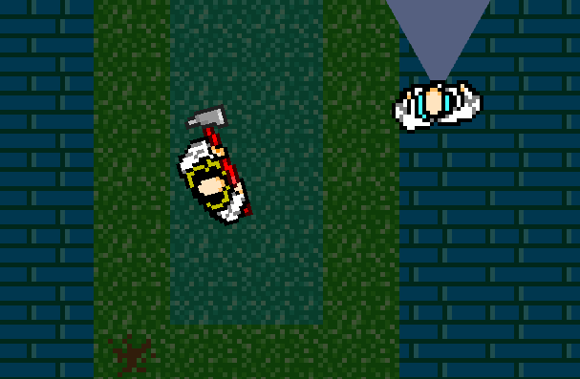

**Successes**

* Enemies properly animated at correct speeds

**Problems**

* Player cant attack yet so cant implement an animation for attacking

#### **Final test**

|  |  |  |  |
| --- | --- | --- | --- |
| Test | Expected Output | Actual Output | Success? |
| W key | Player legs face up | Player legs face up | ✓ |
| A key | Player legs face left | Player legs face left | ✓ |
| S key | Player legs face down | Player legs face down | ✓ |
| D key | Player legs face right | Player legs face right | ✓ |
| Combination of movement keys held | Player legs face the correct direction of the 8 directions available | Player legs face the right direction | ✓ |
| Any movement key held | Player upper body plays animation  Player legs plays animation | Player upper body plays animation + player legs play animation | ✓ |
| Player mouse moves | Upper body rotates to face mouse  Legs don’t rotate to follow mouse | Upper body rotates to face mouse  Legs don’t rotate to follow mouse | ✓ |
| Run program | Enemy movement animation plays | Enemy movement animation plays | ✓ |

I wasn’t able to add an attacking animation as there is no method of attacking yet, I intend to add that in stage 3 of development. With that said, I am happy with the current state of the program and believe it meets my success criteria which I outlined at the start of stage 2. I will now move onto stage 3.

## Stage 3

In this stage I intend to add 2 major features and maybe some other smaller features. Mainly in this stage the player will be able to attack, which when performed on enemies will kill them and remove them from the game. I also will add an end to the level which for the time being will just result in a win screen but in the future may lead to the next level.

Success Criteria:

* Player attacking + animation
* Enemy death
* Level ending
* (Potentially) points system
* Sound + Music

### Player attacking

In this section, I will implement the ability for players to attack, add an animation for this, and make is so that enemies are removed from the game upon death.

#### Success Criteria

* Attacking when left mouse clicked
* Animation for attack
* Enemy objects removed on death
* Enemies re-added to game when a new game begins

#### Coding + Testing

For when the player attacks, I want the attack to work only when the player is actually facing the enemy and it looks like the attack hits, to do this originally I wanted to create a rect when attacking that if the enemy collides with then dies. This wouldn’t work however as a rect cant be rotated about 360 degrees.

The solution I created was as follows:

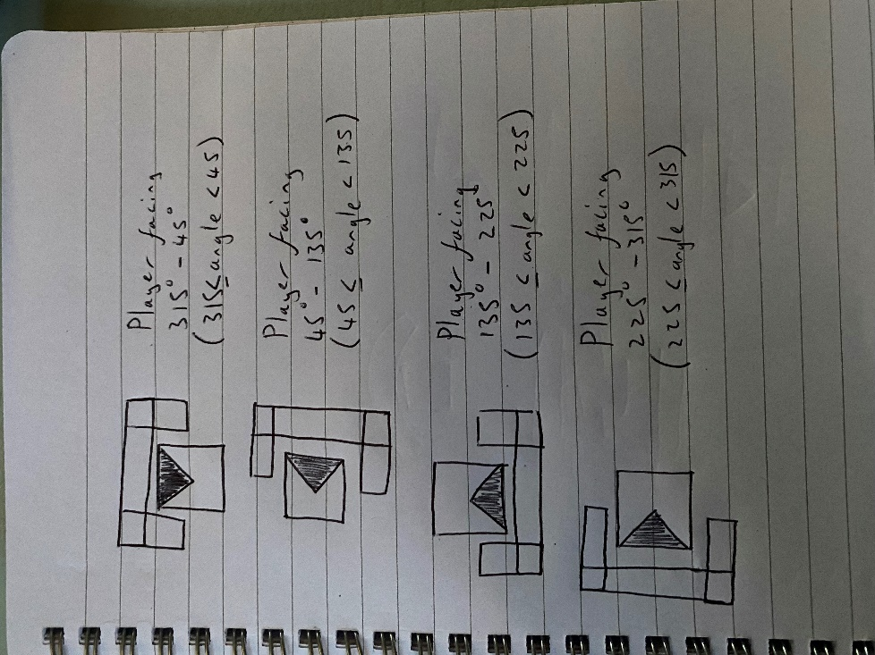While drawing this diagram I had planned to use 3 separate rects to make up a shape but upon second thought it would make more sense to just have one rect that fills the space of the three rects (see the red rectangle).

There will be 4 orientations of this rect based on which direction the player is facing (calculated based on which of the 4 ranges the ‘angle’ attribute meets). This is because a rect can only be horizontal or vertical in pygame so this is the best solution to the problem that I could think of.

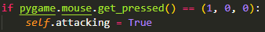This is taken in user_input() and checks for a left click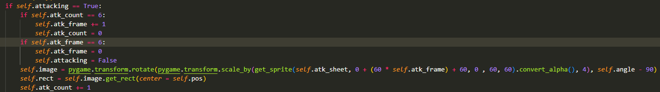

This is the animation for the attack, works the same as the other animations. I updated the movement animation to only play when the player is NOT attacking so that the 2 animations don’t try to play simultaneously.

**Test 1**

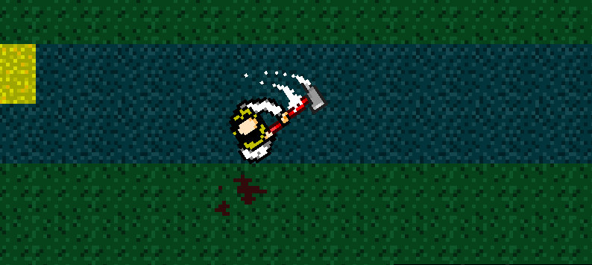

**Successes**

* Animation plays when mouse left clicked

**Problems**

* Animation stops as soon as the player starts moving
* Movement animation doesn’t play regardless of whether the player is attacking

Turns out the issue was that I forgot to indent some of the code for the movement animation.

**Test 2**

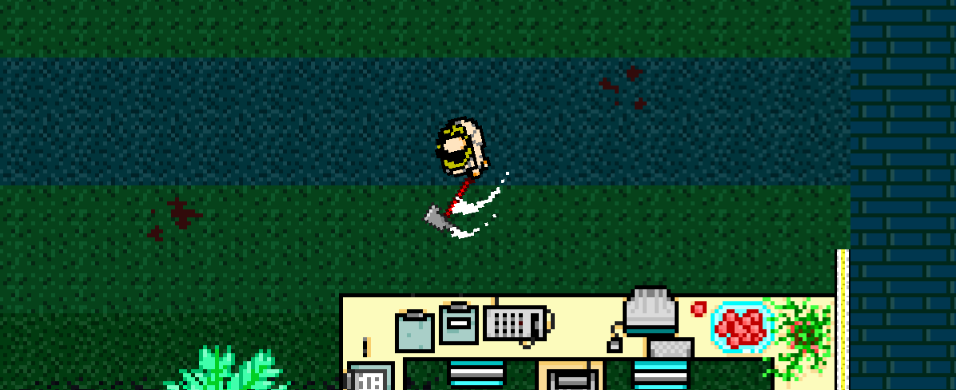

**Successes**

* Animation plays when mouse left clicked
* Animation continues while player moving
* Movement animation plays but only when not attacking

**Problems**

* Attacking doesn’t kill enemies

A new problem which I ran into was that the rotation method hadn’t been working how I thought this whole time. Instead of rotating about 360 degrees. It rotates from 0 to 180 one way, and 0 to -180 in the other direction. The angle ranges will have to be modified to account for this.

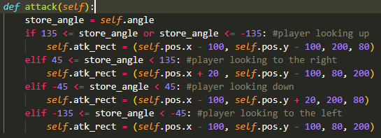

This is the method for attacking which creates a rect based on the direction the player is facing. And here is where it is called in the update method: 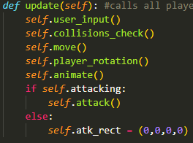

**Test 3**

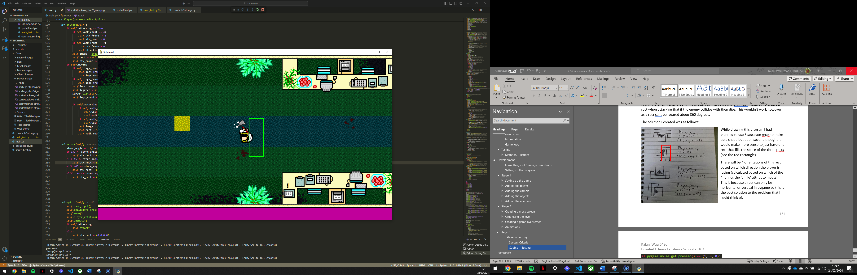

The rects are now drawn in the correct place, only while attacking and only while the angle requirements are met.

Next step is to get the enemy collisions.

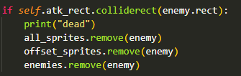

This was easy as I just checked collisions the same as before, however the main issue was respawning the dead enemies when a new game was begun. This issue took a long time to fix and a lot of testing so I will attempt to keep it brief.

Before: 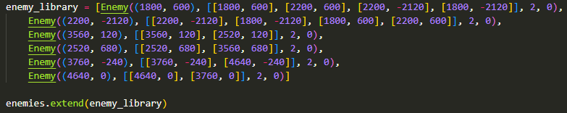After: 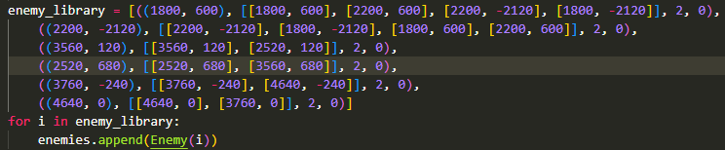

This means that the objects are only made when they are added to the enemies list (holds all currently alive enemies). The enemies library then only holds the parameters for the enemy objects instead of the actual objects themeselves. This means that if an object is deleted from the enemies list it is deleted from the program entirely.

Before:

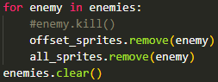

After:

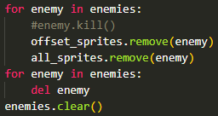

The objects were now being fully deleted, beforehand they would keep some of theire attributes from before the enemy was killed which caused them to not be fully reset when the player starts a new game.

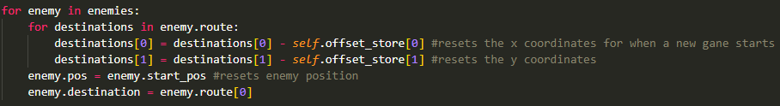

This entire section of code was REMOVED as the position and destinations were reset when the enemies were deleted and re-instantiated.

**Test 4**

**Successes**

* Enemies deleted when hit by attack
* Enemies respawn at correct locations when new game begun
* Enemies have correct routes when new game begun

**Problems**

* Attacking range potentially too big

#### **Final test**

|  |  |  |  |
| --- | --- | --- | --- |
| Test | Expected Output | Actual Output | Success? |
| Left mouse clicked | Attack once – full animation | Attack once – full animation | ✓ |
| Left mouse held | Attack until let go of mouse, finishes the animation of the last attack | Attacks until the player stops holding, finishes the animation of the last attack | ✓ |
| Right mouse click/hold | No output | No output | ✓ |
| Attack | Creates hitbox of attack, changes location based on rotation | Creates hitbox of attack, changes location based on rotation | ✓ |
| Attack | Attack is fully animated and isn’t interrupted by other animations | Attack is fully animated and isn’t interrupted by other animations | ✓ |
| Attack enemy( in range) | Enemy is removed from all sprite groups and removed from enemies list – stops being drawn to screen | Enemy is removed from all sprite groups and removed from enemies list – stops being drawn to screen | ✓ |
| Attack enemy(out of range) | No output | No output | ✓ |
| Start new game (no enemies killed) | All enemies spawn in correct locations  All enemies have correct routes | All enemies spawn in correct locations  All enemies have correct routes | ✓ |
| Start new game (enemies killed) | All enemies spawn in correct locations  All enemies have correct routes | All enemies spawn in correct locations  All enemies have correct routes | ✓ |

### Adding music

For the music, my friend recorded it himself and is allowing me freely use the music in my game. There is a intro track which I want to play in the menu, and a main track which will be looped in the main game.

I also want to add sound effects for attacking and potentially moving and interacting with menu buttons.

There wont be images of my game for this sections as obviously you cant take pictures of sound.

#### Success Criteria

* Game will have music for both the menu and the main game
* Music will loop until program closed
* Sound effects

#### Coding + Testing



Here pygame.mixer is initialised and is what I will be using for the music and the sounds in the game.



This loads the intro track into the player and will be looped through in the menus.

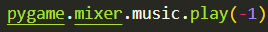

This loops the song stored in the player indefinitely (-1 repeats indefinitely). All of this occurs outside of the game loop as if it was in the loop, it would just loop the first few milliseconds of the song each frame.

**Test 1**

**Successes**

* Music now plays

**Problems**

* Same track plays in the menus and in the main game

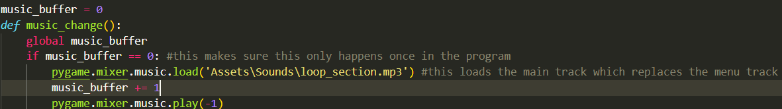

Here is the function to start playing the second (main) track. This loads the second track and then sets it to play indefinitely and the if statement is used to guarantee that this process only happens once.

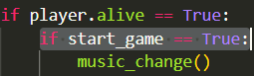

Here’s where it is called in the game loop which is why the if statement is needed so that this function doesn’t reset the music on each frame.

**Test 2**

**Successes**

* The song switches when the new game button is pressed

**Problems**

* Song changes instantly and doesn’t wait for the previous track to end

To make this change, I had to overhaul the original system that I had set up for playing the music.

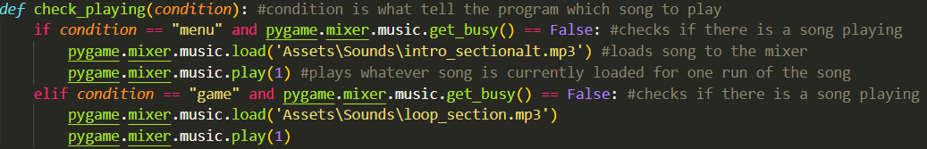

This function is called every frame and will check if there is a song playing. If there is a song playing, nothing will happen: if there is no song playing, it will play the intro song (if the player is still in the menu) or play the main song if the player is in the main game. This makes it so that the intro song is played until its end even if the main game begins, this allows the intro song to properly lead into the main song rather than getting cut off as soon as the game begins.

**Test 3**

**Successes**

* The song switches when the new game is pressed and the intro song plays until its end.

Now I intend to add sound effects for attacking and for when the player interacts with the menus. Adding sound effects is fairly simple, the only real issue is playing multiple sounds and songs at the same time however this can e solved by using different channels to play different audio files at the same time.



This code plays the sound effect for when a player clicks a menu button. Channel 0 I will use for the menu sounds.

For attacking I have made a list of sound effects which are selected randomly to be played at the start of each attack. I added this random aspect by importing the random module to generate a random number in the range 0-4 and using this number to select one of the sound effects to play.

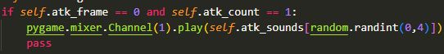

**Test 4**

**Successes**

* Sounds play correctly and at the right time
* Attacking sounds are randomised and only play once per attack

#### **Final test**

|  |  |  |  |
| --- | --- | --- | --- |
| Test | Expected Output | Actual Output | Success? |
| Menu music | Same 8 second track loops until the new game button is clicked | Same 8 second track loops until the new game button is clicked | ✓ |
| Transition to in-game music | When new game pressed, menu track continues until the track ends and then starts playing the main game track | When new game pressed, menu track continues until the track ends and then starts playing the main game track | ✓ |
| In game music | Same 41 second track loops until the program is closed | Same 41 second track loops until the program is closed | ✓ |
| Attacking sound effect | Plays sound once per attack | Plays sound once per attack animation | ✓ |
| Impact sound effect | Plays sound once when hitting an enemy | Plays sound once when hitting an enemy | ✓ |
| Button sound effect | Plays sound once when clicking a button | Plays sound once when clicking a button | ✓ |
| Multiple sounds playing at once | Sounds play at the same time | No issues, sounds played at the same time because of the different channels | ✓ |

### Adding the ending

For the sake of time, the game will only have one level so the ending of level 1 will lead to the end of the game. This will work by having the player walk into an elevator at the end of the game (collide with an object).

#### Success Criteria

* Elevator object which when collided with will result in the winning screen
* Elevator drawn above the player
* Elevator has different collision physics to other objects

#### Coding + Testing

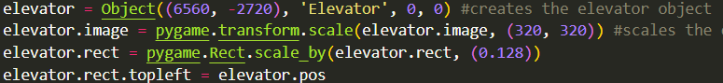

Here the elevator object is instantiated. It is instantiated differently to the other objects in the game as I don’t want this to have regular collision physics and I don’t want it to be in a sprite group as I want to draw it separately (so it is drawn after the player).

It has to be scaled because the object class scales every object up by 5 times which I want for every other object except for the elevator.

**Test 1**

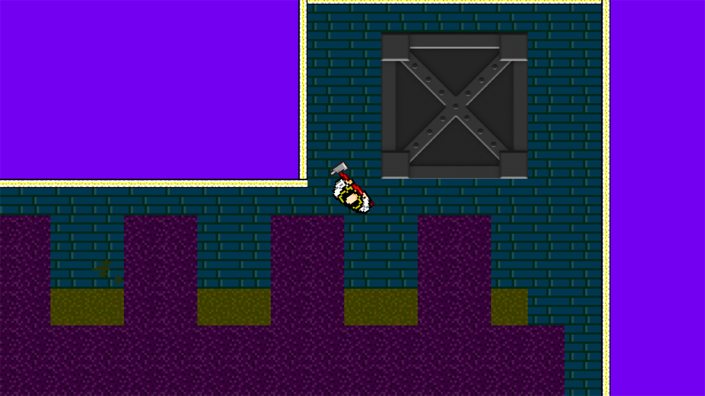

**Successes**

* Drawn at correct location
* Correct size

**Problems**

* No collision detection
* Nothing happens after

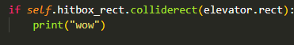

**Test 2**

Collision works as expected.

To add a game won screen, I was able to reuse most of the methods and attributes used for the game over screen, the only difference being the background image. 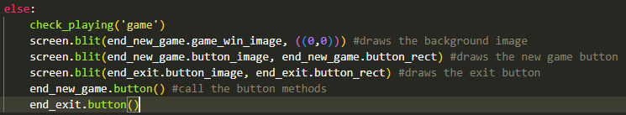

This code occurs in the game loop if the condition ‘game_won’ == True, this is set to true in the player class if the player collides with the elevator for more than 20 frames. (similar to the cone collisions:

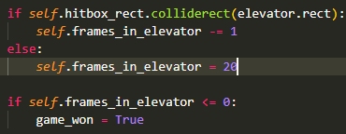

**Test** **2**

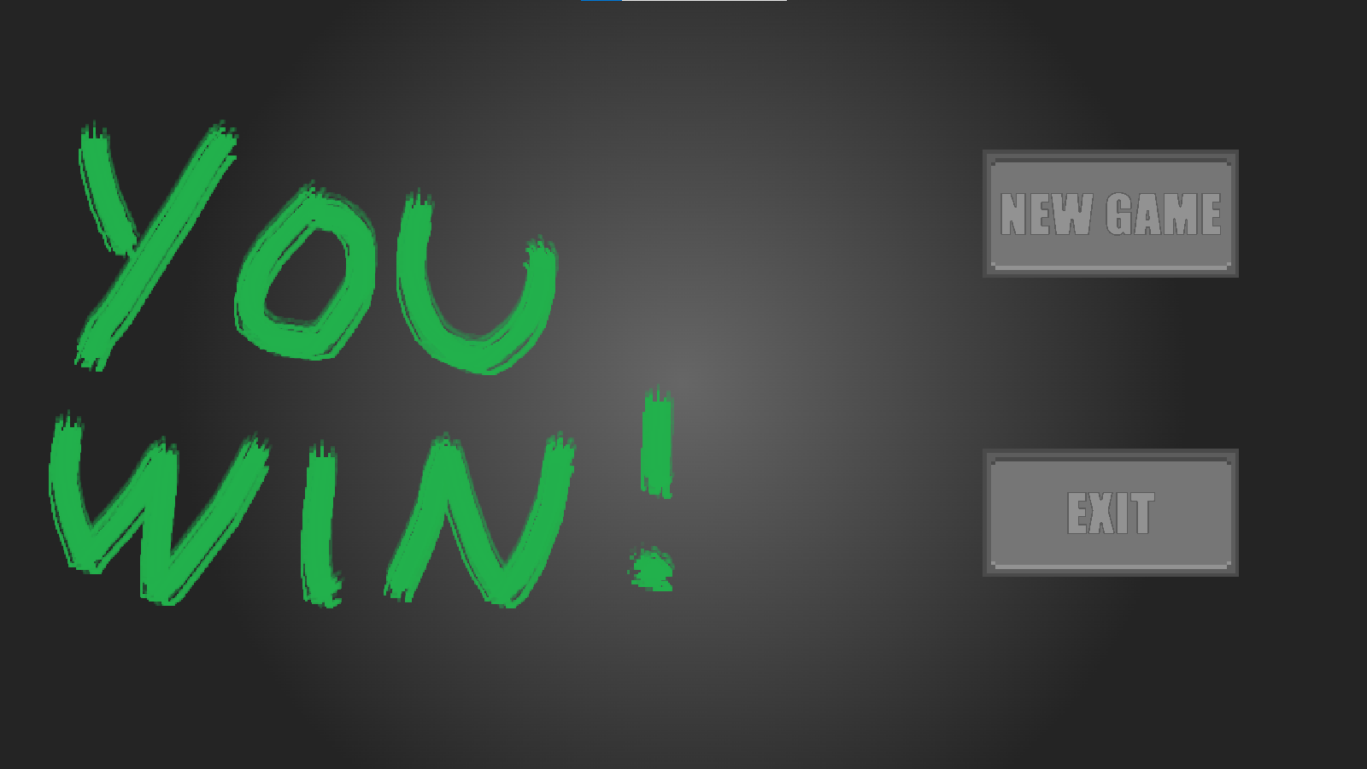

I think the program is ready for its final test of this section.

#### **Final test**

|  |  |  |  |
| --- | --- | --- | --- |
| Test | Expected Output | Actual Output | Success? |
| Elevator drawn | Image drawn to screen at correct size and at correct location | Elevator image is drawn to the screen at correct size and at correct location | ✓ |
| Elevator offset | Elevator image and rect offset by player movement | Elevator image and rect offset by player movement | ✓ |
| Elevator collision | Collision with elevator for 20 frames results in win screen | Collision with elevator for 20 frames results in win screen | ✓ |
| Win screen drawn | Win screen drawn at correct size, location, only after collision | Win screen drawn at correct size, location, only after collision | ✓ |
| New game button | Starts new game when clicked, no response when not clicked | Starts new game when clicked, no response when not clicked | ✓ |
| Exit button | Closes game when clicked, no response when not clicked | Closes game when clicked, no response when not clicked | ✓ |
| Music | Music plays correctly and loops while on the win screen | Music plays correctly and loops while on the win screen | ✓ |

With the ending being added, I think that I have met my essential success criteria for the finished game.

### Bonus Features

In this stage I will mainly clean up the code and add a few smaller features which I outlined in the design and analysis sections. This will be different as I wont outline a success criteria for this section as it will just be any features I have decided to add in the time I have remaining.

#### Points system

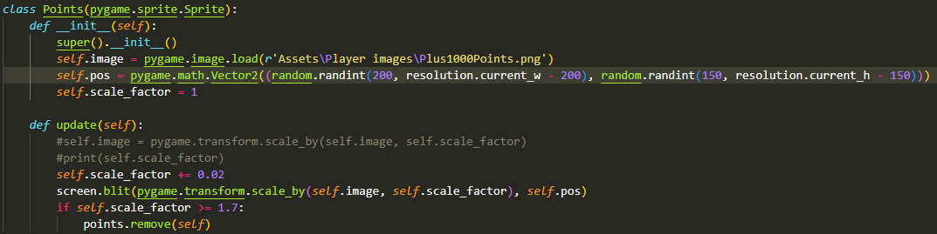

This code displays an image showing “+1000” when the player kills an enemy. It increases in size each frame until a certain size when it is deleted.





This writes the score to the screen each frame.

#### Colour changing background

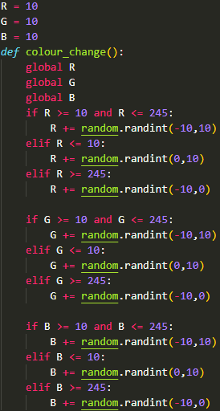

Very simple function which just randomly increments or decrements the RGB colour values of the background. This is very simple and uncomplex code and I only wanted to add it for aesthetic purposes which is why it is not thoroughly documented like the rest of my code.

## Final code

import pygame

import sys

import math

import random

from pygame.sprite import Group

#from pygame import mixer

from constantsSettings import *

from spriteSheet import *

from copy import copy, deepcopy

pygame.init()

pygame.mixer.init()

#This code is responsible for getting the resolution of the screen, setting the screen to size, setting the name of the screen,

#and making a variable for manipulating the clock to set FPS

resolution = pygame.display.Info()

screen = pygame.display.set_mode((resolution.current_w , resolution.current_h),pygame.RESIZABLE) #Fits the screen to the size of the display

pygame.display.set_caption('Splintered')

background = pygame.transform.scale(pygame.image.load("Assets\Level images\Level1elevator.png").convert_alpha(), (8000,8000))

#background = pygame.transform.rotozoom(pygame.image.load("Assets\Level images\BackgroundPlaceholderIce.jpg").convert_alpha(), 0, 1.5) #sets the image for the background

bg_rect = background.get_rect(*center* = ((resolution.current_w // 2, resolution.current_h // 2))) #This is to get the rectangular area of the backround and set the centre of the image to the center of the background

clock = pygame.time.Clock()

screen_rect = (0, 0, resolution.current_w, resolution.current_h)

start_game = False #game doesnt start immediately but rather opens the menu until the user interacts with the button.

game_won = False

pygame.mixer.music.set_volume(0.6)

score = 0

font = pygame.font.Font('Assets\Player images\pixel-millennium\Pixel Millennium.ttf', 64)

*class* Player(pygame.sprite.Sprite):

*def* __init__(*self*):

        super().__init__() #initialises the inherited superclass (pygame.sprite.Sprite) which allows it to be added to sprite groups

*self*.pos = pygame.math.Vector2((resolution.current_w // 2, resolution.current_h // 2)) #The starting position coordinates of the player (with respect to the top left of the display)

*self*.move_sheet = pygame.image.load("Assets\Player images\sprPWalkAxe_strip8green.png")

*self*.legs_sheet = pygame.image.load("Assets\Player images\sprLegs_strip16green.png")

*self*.atk_sheet = pygame.image.load("Assets\Player images\sprPAttackAxe_strip7green.png")

        #self.image = pygame.transform.rotate(pygame.transform.scale_by(pygame.image.load("Assets\Player images\Knife\idle\survivor-idle_knife_0.png").convert_alpha(), player_size), -90)

*self*.image = pygame.transform.rotate(pygame.transform.scale_by(get_sprite(*self*.move_sheet, 0, 0, 44, 44).convert_alpha(), 4), -90)

*self*.legs_image = pygame.transform.rotate(pygame.transform.scale_by(get_sprite(*self*.legs_sheet, 0, 0, 32, 32).convert_alpha(), 4), -90)

*self*.base_image = *self*.image.copy() #copy made for if I need to easily switch back to the original image

*self*.mask = pygame.mask.from_surface(*self*.image) #creates a mask based on the players image

*self*.rect = *self*.image.get_rect(*center* = *self*.pos) #creates a rect from the player image (left, top, width, height)

*self*.hitbox_rect = pygame.Rect(*self*.pos[0] - player_hitbox_width//2 ,*self*.pos[1] - player_hitbox_height, player_hitbox_width,player_hitbox_height) #sets a square as the hitbox rect for the player, will update in size if the variables are changed in the constantsSettings.py file

*self*.hitbox_rect.center = *self*.pos

*self*.speed = player_speed #variable will be used to update the velocity x and y variables

*self*.size = player_size

*self*.general_offset = pygame.math.Vector2(0,0) #setting up as 0,0 for later use

*self*.collision_velocity_x = 0

*self*.collision_velocity_y = 0

*self*.colour = "green"

*self*.cone_colliding = 0

*self*.frames_in_cone = coneFrames

*self*.alive = True #determines if the game can continue or should be closed

*self*.total_offset = pygame.math.Vector2(0,0)

*self*.move_direct = 0 #these attributes are for the animations and timing them

*self*.walk_frame = 0

*self*.legs_frame = 0

*self*.walk_count = 0

*self*.legs_count = 0

*self*.atk_frame = 0

*self*.atk_count = 0

*self*.attacking = False

*self*.atk_rect = pygame.Rect(0,0,0,0)

*self*.atk_sounds = [pygame.mixer.Sound(*r*'Assets\Sounds\attackmp3\swosh-08.mp3'), pygame.mixer.Sound(*r*'Assets\Sounds\attackmp3\swosh-10.mp3'), pygame.mixer.Sound(*r*'Assets\Sounds\attackmp3\swosh-11.mp3'), pygame.mixer.Sound(*r*'Assets\Sounds\attackmp3\swosh-15.mp3'), pygame.mixer.Sound(*r*'Assets\Sounds\attackmp3\swosh-18.mp3')] #these lists store the sound files which would play when a certain action is played

*self*.impact_sounds = [pygame.mixer.Sound(*r*'Assets\Sounds\hits\hit09.mp3.flac'), pygame.mixer.Sound(*r*'Assets\Sounds\hits\hit15.mp3.flac'), pygame.mixer.Sound(*r*'Assets\Sounds\hits\hit17.mp3.flac'), pygame.mixer.Sound(*r*'Assets\Sounds\hits\hit18.mp3.flac'), pygame.mixer.Sound(*r*'Assets\Sounds\hits\hit19.mp3.flac')]

*self*.kill_sounds = [pygame.mixer.Sound(*r*'Assets\Sounds\Death\deathh.wav'), pygame.mixer.Sound(*r*'Assets\Sounds\Death\die1.wav'), pygame.mixer.Sound(*r*'Assets\Sounds\Death\die2.wav'), pygame.mixer.Sound(*r*'Assets\Sounds\Death\Wilhelm Scream - Gaming Sound Effect (HD).ogg')]

*self*.points_image = pygame.image.load(*r*'Assets\Player images\Plus1000Points.png')

*def* player_rotation(*self*):

*self*.mouse_coords = pygame.mouse.get_pos() #gets the pixel position of where the mouse pointer is on the screen

        #print(self.mouse_coords)

*self*.x_difference = *self*.mouse_coords[0] - *self*.pos[0] #finds the x difference of the mouse and player

*self*.y_difference = *self*.mouse_coords[1] - *self*.pos[1] #finds the y difference of the mouse and player

*self*.angle = math.degrees(math.atan2(*self*.x_difference, *self*.y_difference)) #finds the angle of rotation between the player and mouse

*self*.image = pygame.transform.rotate(*self*.base_image, *self*.angle) #rotates the image based on the angle of rotation

*self*.rect = *self*.image.get_rect(*center* = *self*.pos) #updates the rect

*self*.mask = pygame.mask.from_surface(*self*.image) #updates the mask on each frame to the new rotation for the players image

*def* collisions_check(*self*):

        global game_won

        global score

*self*.collision_velocity_x = 0 #resets the offset movement so that it only occurs while colliding

*self*.collision_velocity_y = 0

        keys = pygame.key.get_pressed() #gets any keypressed and stores them in a variable

        if keys[pygame.K_LCTRL] or keys[pygame.K_LSHIFT]:

*self*.speed /= ctrl_speed #speed is halved when ctrl button is held

        for object in collidables: #iterates through all of the collidable objects on that level

            if *self*.hitbox_rect.colliderect(object.rect) and *self*.hitbox_rect.left + 15 > object.rect.right: #Checks if the player is on the right of the object

*self*.collision_velocity_x = *self*.speed #offsets the A input

            if *self*.hitbox_rect.colliderect(object.rect) and *self*.hitbox_rect.right - 15 < object.rect.left: #Checks if the player is on the left of the object

*self*.collision_velocity_x = -*self*.speed #offsets the D input

            if *self*.hitbox_rect.colliderect(object.rect) and *self*.hitbox_rect.top + 15 > object.rect.bottom: #Checks if the player is below the object

*self*.collision_velocity_y = *self*.speed #offsets the W input

            if *self*.hitbox_rect.colliderect(object.rect) and *self*.hitbox_rect.bottom - 15 < object.rect.top: #Checks if the player is above the object

*self*.collision_velocity_y = -*self*.speed #offsets the S input

*self*.speed = player_speed

        if *self*.hitbox_rect.colliderect(elevator.rect):

*self*.frames_in_elevator -= 1

        else:

*self*.frames_in_elevator = 20

        if *self*.frames_in_elevator <= 0:

            game_won = True

        for enemy in enemies: #iterates through all of the seperately instantiated enemies

            if *self*.hitbox_rect.colliderect(enemy.cone_rect):

                if *self*.mask.overlap(enemy.cone_mask, (enemy.cone_rect.x - *self*.rect.x, enemy.cone_rect.y -*self*.rect.y)): #checks if the player mask is touching the enemies mask and returns a true/false value

*self*.cone_colliding += 1 #this will show how many enemy vision cones the player has contacted on that frame

                    #print("overlap")

            if *self*.atk_rect.colliderect(enemy.hitbox_rect):

                pygame.mixer.Channel(2).play(*self*.impact_sounds[random.randint(0,4)])

                pygame.mixer.Channel(3).play(*self*.kill_sounds[random.randint(0,3)])

                #print("kill")

                all_sprites.remove(enemy)

                offset_sprites.remove(enemy)

                enemies.remove(enemy)

                score += 1000

                points.append(Points())

        if *self*.cone_colliding > 0: #for if there was any cone collision on this frame (doesnt matter which cone)

*self*.colour = "red" #shows when the player IS colliding with a vision cone

*self*.frames_in_cone -= 1 #counts down the maount of frames which the player is inside the vision cone

*self*.cone_colliding = 0 #resets the collision counter for when it needs to check again on the next tick

        elif *self*.cone_colliding == 0: #for when there was no cone collision with any cone on this frame

*self*.frames_in_cone = coneFrames #resets timer when the player moves out of range

*self*.colour = "green" #shows when the player is NOT colliding with a vision cone

        #print(self.frames_in_cone)

        if *self*.frames_in_cone == 0: #checks if the counter is complete

            pygame.mixer.Channel(0).play(pygame.mixer.Sound('Assets\Sounds\Female\game_over.ogg'))

            #print("game over") #for testing

            #print(enemies)

*self*.alive = False

            for enemy in enemies:

                #enemy.kill()

                offset_sprites.remove(enemy)

                all_sprites.remove(enemy)

            for enemy in enemies:

                del enemy

            enemies.clear()

            #print(enemies)

*def* user_input(*self*):

*self*.mouse_coords = pygame.mouse.get_pos()

*self*.velocity_x = 0 #assigns variables to int 0 (no movement detected yet)

*self*.velocity_y = 0

        keys = pygame.key.get_pressed() #gets any keypressed and stores them in a variable

        if keys[pygame.K_LCTRL] or keys[pygame.K_LSHIFT]:

*self*.speed /= ctrl_speed #speed is halved when ctrl button is held

        if keys[pygame.K_w]:

*self*.velocity_y = -*self*.speed #player moves in the negative y direction (up)

        if keys[pygame.K_a]:

*self*.velocity_x = -*self*.speed #player moves in the negative x direction (left)

        if keys[pygame.K_s]:

*self*.velocity_y = *self*.speed #player moves in the positive y direction (down)

        if keys[pygame.K_d]:

*self*.velocity_x = *self*.speed #player moves in the positive x direction (right)

*self*.speed = player_speed #speed is reset in case it was changed by holding CTRL

        if *self*.velocity_x != 0 or *self*.velocity_y != 0: #checks if the player is moving at all

*self*.moving = True

        else:

*self*.moving = False

        if *self*.moving: #This calculates the angle which the legs will face when moving

            if *self*.velocity_x > 0 and *self*.velocity_y < 0:

*self*.move_direct = 45

            elif *self*.velocity_x > 0 and *self*.velocity_y > 0:

*self*.move_direct = 135

            elif *self*.velocity_x < 0 and *self*.velocity_y > 0:

*self*.move_direct = 225

            elif *self*.velocity_x < 0 and *self*.velocity_y < 0:

*self*.move_direct = 315

            elif *self*.velocity_x > 0:

*self*.move_direct = 90

            elif *self*.velocity_x < 0:

*self*.move_direct = 270

            elif *self*.velocity_y > 0:

*self*.move_direct = 180

            elif *self*.velocity_y < 0:

*self*.move_direct = 0

        if *self*.velocity_x != 0 and *self*.velocity_y != 0: #checks if the player is moving diagonally (two directions at once)

*self*.velocity_x //= math.sqrt(2)

*self*.velocity_y //= math.sqrt(2) #offsets the extra speed of moving diagonally

        if pygame.mouse.get_pressed() == (1, 0, 0) and start_game == True:

*self*.attacking = True

*def* move(*self*): #method is used to just update the position of player based on the velocity

        #NOT IN USE self.pos += pygame.math.Vector2(self.velocity_x, self.velocity_y) #updates the position with all changes from this tick

*self*.velocity_x = *self*.velocity_x + *self*.collision_velocity_x

*self*.velocity_y = *self*.velocity_y + *self*.collision_velocity_y

*self*.general_offset = pygame.math.Vector2(-*self*.velocity_x, -*self*.velocity_y) #calculates the offset by which all objects on screen will be affected

*self*.total_offset += *self*.general_offset

*self*.rect.center = *self*.pos #updates the rect position

*self*.hitbox_rect.center = *self*.pos

*def* animate(*self*):

        if *self*.attacking == True:

            if *self*.atk_frame == 0 and *self*.atk_count == 1: #so that it only plays the sound once at the start of an animation

                pygame.mixer.Channel(1).play(*self*.atk_sounds[random.randint(0,4)])

                pass

            if *self*.atk_count == 4: #These loops allow for the frames of the animations to be iterated through, the 'count' allows for longer intervals between frames of animation

*self*.atk_frame += 1

*self*.atk_count = 0

            if *self*.atk_frame == 7:

*self*.atk_frame = 0

*self*.image = pygame.transform.rotate(pygame.transform.scale_by(get_sprite(*self*.atk_sheet, 0 + (60 * *self*.atk_frame), 0 , 60, 60).convert_alpha(), 4), *self*.angle - 90) #updates the image using the get_sprite function

*self*.rect = *self*.image.get_rect(*center* = *self*.pos)

*self*.atk_count += 1

        if *self*.moving:

            if *self*.legs_count == 3:

*self*.legs_frame += 1

*self*.legs_count = 0

            if *self*.legs_frame == 16:

*self*.legs_frame = 0

*self*.legs_image = pygame.transform.rotate(pygame.transform.scale_by(get_sprite(*self*.legs_sheet, 0 + (32 * *self*.legs_frame), 0 , 32, 32).convert_alpha(), 4), 90 - *self*.move_direct)

*self*.legrect = *self*.legs_image.get_rect(*center* = *self*.pos)

            screen.blit(*self*.legs_image, *self*.legrect)

*self*.legs_count += 1

            if *self*.attacking == False:

                if *self*.walk_count == 5: #every 6 frames this is true

*self*.walk_frame += 1 #iterates through each image in the sprite sheet

*self*.walk_count = 0

                if *self*.walk_frame == 8: #when it is at the end of the spritesheet

*self*.walk_frame = 0

*self*.image = pygame.transform.rotate(pygame.transform.scale_by(get_sprite(*self*.move_sheet, 0 + (44 * *self*.walk_frame), 0 , 44, 44).convert_alpha(), 4), *self*.angle - 90)

*self*.rect = *self*.image.get_rect(*center* = *self*.pos)

*self*.walk_count += 1

        if *self*.atk_frame == 0:

*self*.attacking = False #sets attacking to false after the animation ends

*def* attack(*self*): #these create one of 4 rectangles depending on which way the player is facing when they attack

        store_angle = *self*.angle

        if 135 <= store_angle or store_angle <= -135: #player looking up

*self*.atk_rect = pygame.Rect(*self*.pos.x - player_atk_length//2, *self*.pos.y - 20 - player_atk_width, player_atk_length, player_atk_width)

        elif 45 <= store_angle < 135: #player looking to the right

*self*.atk_rect = pygame.Rect(*self*.pos.x + 20 , *self*.pos.y - player_atk_length//2, player_atk_width, player_atk_length)

        elif -45 <= store_angle < 45: #player looking down

*self*.atk_rect = pygame.Rect(*self*.pos.x - player_atk_length//2, *self*.pos.y + 20, player_atk_length, player_atk_width)

        elif -135 <= store_angle < -45: #player looking to the left

*self*.atk_rect = pygame.Rect(*self*.pos.x - 20 - player_atk_width, *self*.pos.y - player_atk_length//2, player_atk_width, player_atk_length)

*def* update(*self*): #calls all player methods which need to be called each frame

*self*.user_input()

*self*.collisions_check()

*self*.move()

*self*.player_rotation()

*self*.animate()

        if *self*.attacking:

*self*.attack()

        else:

*self*.atk_rect = pygame.Rect(0,0,0,0) #so that the attacking rect is not affecting anything while not in use

*class* Points(pygame.sprite.Sprite):

*def* __init__(*self*):

        super().__init__()

*self*.image = pygame.image.load(*r*'Assets\Player images\Plus1000Points.png')

*self*.pos = pygame.math.Vector2((random.randint(200, resolution.current_w - 200), random.randint(150, resolution.current_h - 150)))

*self*.scale_factor = 1

*def* update(*self*):

*self*.scale_factor += 0.02

        screen.blit(pygame.transform.scale_by(*self*.image, *self*.scale_factor), *self*.pos)

        if *self*.scale_factor >= 1.7:

            points.remove(*self*)

*class* Enemy(pygame.sprite.Sprite):

*def* __init__(*self*, *parameters*): #position is in form (x,y) with 2 integers, route is a 2d array, speed is an integer, level is an integer

    #def __init__(self, position, route, speed, level): #position is in form (x,y) with 2 integers, route is a 2d array, speed is an integer, level is an integer

        super().__init__()

*self*.start_pos = pygame.math.Vector2(*parameters*[0])

*self*.pos = pygame.math.Vector2(*parameters*[0]) #sets starting position

*self*.move_sheet = pygame.image.load("Assets\Enemy images\sprEWalkUnarmed_strip8green.png")

*self*.image = pygame.transform.rotate(pygame.transform.scale_by(get_sprite(*self*.move_sheet, 0, 0, 32, 32).convert_alpha(), 4), -90) #sets an image for the enemy sprite, rotates the image 90 degrees anticlockwise, scales the image based on the enemy size variable in constantsSettings.py

*self*.base_image = *self*.image.copy()

*self*.cone_image = pygame.transform.rotate(pygame.transform.scale_by(pygame.image.load("Assets\Enemy images\coneY.png").convert_alpha(), 0.7), 180)

*self*.cone_image.set_alpha(220)

*self*.cone_rect = *self*.cone_image.get_rect(*center* = *self*.pos)

*self*.cone_base_image = *self*.cone_image.copy()

*self*.cone_mask = pygame.mask.from_surface(*self*.cone_image)

        #self.cone_colliding = 0

*self*.rect = *self*.image.get_rect(*center* = *self*.pos) #gets the rectangular area of the enemy

*self*.hitbox_rect = pygame.Rect(*self*.pos[0] - 40 ,*self*.pos[1] - 40, 80, 80)

*self*.hitbox_rect.center = *self*.pos

*self*.size = enemy_size #setting speed (from constantsSettings.py)

*self*.speed = *parameters*[2] #setting size (from constantsSettings.py)

*self*.base_route = *parameters*[1]

*self*.route = deepcopy(*self*.base_route)

*self*.walk_frame = 0

*self*.count = 0

*self*.destination = *self*.route[0]

*def* move(*self*):

            #route_destinations = self.route_list[self.route] #selects list within the 2d array based on the self.route integer

            for I in range((len(*self*.route)-1)):

                if *self*.pos == *self*.route[-1]: #if the enemy reaches the end of the route

*self*.destination = *self*.route[0] #sets the destination back to the start of the route

                elif *self*.pos == *self*.route[I]: #if the enemy reaches its destination

*self*.destination = *self*.route[i+1] #destination is set to next item in the list

*self*.velocity_x = 0

*self*.velocity_y = 0

            if *self*.pos[0] != *self*.destination[0]: #checks if the player x is not at the destination x

                if *self*.pos[0] > *self*.destination[0]: #checks if enemy is on the right of the destination

*self*.velocity_x = -*self*.speed

                elif *self*.pos[0] < *self*.destination[0]: #checks if enemy is on the left of the destination

*self*.velocity_x = *self*.speed

            if *self*.pos[1] != *self*.destination[1]: #checks if the player y is not at the destination y

                if *self*.pos[1] > *self*.destination[1]: #checks if enemy is below the destination

*self*.velocity_y = -*self*.speed

                elif *self*.pos[1] < *self*.destination[1]: #checks if enemy is above the destination

*self*.velocity_y = *self*.speed

*self*.pos += pygame.math.Vector2(*self*.velocity_x, *self*.velocity_y)

*self*.rect.center = *self*.pos

*def* rotation(*self*):

*self*.x_difference = *self*.destination[0] - *self*.pos[0] #gets horizontal difference between where the enemy is and its destination

*self*.y_difference = *self*.destination[1] - *self*.pos[1] #gets vertical difference between where the enemy is and its destination

*self*.angle = math.degrees(math.atan2(*self*.x_difference , *self*.y_difference)) #calculates the angle of rotation between the two points using the 2 lengths

*self*.image = pygame.transform.rotate(*self*.base_image, *self*.angle) #rotates the enemy’s image

*def* draw_cone(*self*):

*self*.cone_image = pygame.transform.rotate(*self*.cone_base_image, *self*.angle) #rotates the image using the angle calculated in rotation() and the cones base image, so that rotations aren’t appended

*self*.cone_rect = *self*.cone_image.get_rect(*center* = *self*.cone_base_image.get_rect(*center* = *self*.pos).center) #updates the rect using the center of its original image(with center pos)

            if *self*.cone_rect.colliderect(screen_rect):

                screen.blit(*self*.cone_image, *self*.cone_rect) #draws the cone to the screen

*self*.cone_mask = pygame.mask.from_surface(*self*.cone_image) #updates the mask on each frame to the new rotation from the cone rotation.

*def* animate(*self*):

            if *self*.count == 7: #every 6 frames this is true

*self*.walk_frame += 1 #iterates through each image in the sprite sheet

*self*.count = 0

            if *self*.walk_frame == 7: #when it is at the end of the spritesheet

*self*.walk_frame = 0

*self*.image = pygame.transform.rotate(pygame.transform.scale_by(get_sprite(*self*.move_sheet, 0 + (32 * *self*.walk_frame), 0 , 32, 32).convert_alpha(), 4), *self*.angle - 90)

*self*.rect = *self*.image.get_rect(*center* = *self*.pos)

*self*.count += 1

*def* update(*self*):

*self*.move()

*self*.rotation()

*self*.draw_cone()

        if *self*.speed != 0:

*self*.animate()

*class* Level(pygame.sprite.Group):

*def* __init__(*self*):

        super().__init__()

*self*.current_level = 0 #sets the level to the first level

        level_backgrounds = ["Assets\Level images\BackgroundPlaceholderIce.jpg"] #stores the images for the backgrounds

*self*.offset = (0,0) #the offset vector of all the objects on screen

        background = pygame.image.load(level_backgrounds[*self*.current_level]) #sets the background for the first level

*self*.floor_rect = background.get_rect() #gets the rectangular area of the current background image

*self*.floor_rect.y -= 3200

*def* camera(*self*):

*self*.floor_rect.center = *self*.floor_rect.center + player.general_offset #offsets the background image based on the players movements, updates from the centre

        screen.blit(background, *self*.floor_rect) #draws the background here

        for sprite in offset_sprites:

            sprite.pos = sprite.pos + player.general_offset #updtates the position of the sprites for when the player moves

            sprite.rect.topleft = sprite.rect.topleft + player.general_offset #offsets the sprite position based on player movement

        elevator.rect.topleft += player.general_offset

        #elevator.pos += player.general_offset

        for enemy in enemies:

            for destinations in enemy.route:

                destinations[0] = destinations[0] + player.general_offset[0] #offsets the x coordinates in the enemy route lists for when the camera moves

                destinations[1] = destinations[1] + player.general_offset[1] #offsets the y coordinates

            enemy.hitbox_rect.center = enemy.pos

*def* reset(*self*):

        global score

        score = 0

*self*.offset_store = player.total_offset

        player.total_offset = pygame.math.Vector2(0,0)

        for I in enemy_library:

            enemies.append(Enemy(I))

        for enemy in enemies:

            offset_sprites.add(enemy)

            all_sprites.add(enemy)

        for object in objects:

            object.rect.topleft -= *self*.offset_store

        elevator.rect.topleft -= *self*.offset_store

*self*.floor_rect.center -= *self*.offset_store

*class* Object(pygame.sprite.Sprite):

*def* __init__(*self*, *position*, *type*, *level*, *rotation*):

        super().__init__()

*self*.native_level = *level* #holds the integer passed in as a parameter

*self*.pos = *(position)* #holds the position vector passed in as a parameter

        if *rotation* == 0:

*self*.image = pygame.transform.scale_by(pygame.image.load('Assets\Object images\spr' + *type* + '.png').convert_alpha(), 5) #scales up image by 5 times, no image rotation

        else:

*self*.image = pygame.transform.rotate(pygame.transform.scale_by(pygame.image.load('Assets\Object images\spr' + *type* + '.png').convert_alpha(), 5), *rotation*) #scales up image by 5 times, with image rotation

*self*.rect = *self*.image.get_rect(*topleft* = *self*.pos)

*class* Wall(pygame.sprite.Sprite):

*def* __init__(*self*, *position*, *type*, *level*, *length*):

        super().__init__()

*self*.native_level = *level*

*self*.pos = *(position)*

        if *type* == 'horizontal_wall':

*self*.surface = pygame.Surface(((*length*\*32), 8)) #creates a surface which is x pixels wide and y pixels tall

            for I in range(0, (*length*\*32), 32): #iterates through the length of the wall that wants to be made - iterates every 32nd pixel as thats where the next image is added to it

                image = pygame.image.load('Assets\Object images\sprWallSoftH.png') #loads the image

*self*.surface.blit(image, (I, 0)) #draws the wall section at the next location (I) within the surface

        elif *type* == 'vertical_wall':

*self*.surface = pygame.Surface((8, (*length*\*32))) #creates a surface which is x pixels wide and y pixels tall

            for I in range(0, (*length*\*32), 32): #iterates through the length of the wall that wants to be made - iterates every 32nd pixel as thats where the next image is added to it

                image = pygame.image.load('Assets\Object images\sprWallSoftV.png') #loads the image

*self*.surface.blit(image, (0, I)) #draws the wall section at the next location (I) within the surface

*self*.image = pygame.transform.scale_by(*self*.surface, 2.5) #scales the image by 2.5 times (because the wall takes up 2 squares but one square is scaled up by 5 times so the wall are scaled up by 5/2 times)

*self*.rect = *self*.image.get_rect(*topleft* = *self*.pos) #sets the rect for collisions with the player

*class* Menu(pygame.sprite.Sprite):

*def* __init__(*self*, *type*, *pos*):

        super().__init__()

*self*.type = *type*

*self*.image = pygame.transform.scale(pygame.image.load("Assets\Menu images\MenuScreen.jpeg"), (resolution.current_w, resolution.current_h)) #sets the background image for the menu

*self*.rect = *self*.image.get_rect(*center* = (resolution.current_w //2, resolution.current_h//2)) #sets the rect with the centre being the center of the local monitor display

*self*.game_over_image = pygame.transform.scale(pygame.image.load("Assets\Menu images\GameOverTemp.png"), (resolution.current_w, resolution.current_h))

*self*.game_win_image = pygame.transform.scale(pygame.image.load("Assets\Menu images\YouWinTemp.png"), (resolution.current_w, resolution.current_h))

        if *type* == 'new_game':

*self*.button_image = pygame.transform.scale_by(pygame.image.load(*r*"Assets\Menu images\NewGameButton.png").convert_alpha(), 0.3) #sets the image for the button

*self*.button_image_original = *self*.button_image.copy()

*self*.button_image_alt = pygame.transform.scale_by(pygame.image.load(*r*"Assets\Menu images\NewGameButtonAlt.png").convert_alpha(), 0.3) #for when the mouse is hovering over the button

        elif *type* == 'exit':

*self*.button_image = pygame.transform.scale_by(pygame.image.load(*r*"Assets\Menu images\ExitButton.png").convert_alpha(), 0.3)#sets the image for the button

*self*.button_image_original = *self*.button_image.copy()

*self*.button_image_alt = pygame.transform.scale_by(pygame.image.load(*r*"Assets\Menu images\ExitButtonAlt.png").convert_alpha(), 0.3)

*self*.button_rect = *self*.button_image.get_rect(*center* = *(pos)*)

*def* button(*self*):

        global start_game #variable is global because this name wont be used for any other variables in the program and so it can be updated by the class without needing to be passed as a parameter

        global game_won

*self*.mouse_coords = pygame.mouse.get_pos() #returns an x and y coordinate for the mouse position

        if *self*.button_rect.left <= *self*.mouse_coords[0] <= *self*.button_rect.right and *self*.button_rect.top <= *self*.mouse_coords[1] <= *self*.button_rect.bottom:

*self*.button_image = *self*.button_image_alt

            if pygame.mouse.get_pressed() == (1, 0, 0) and *self*.type == 'new_game' and start_game == False:

            #checks if the mouse is left clicked and if the mouse is on the button

                pygame.mixer.Channel(0).play(pygame.mixer.Sound('Assets\Sounds\GUI_Sound_Effects_by_Lokif\misc_menu_4.wav'))

                start_game = True

            elif pygame.mouse.get_pressed() == (1, 0, 0) and *self*.type == 'new_game' and start_game == True:

                pygame.mixer.Channel(0).play(pygame.mixer.Sound('Assets\Sounds\GUI_Sound_Effects_by_Lokif\misc_menu_4.wav'))

                level.reset()

                player.alive = True

                game_won = False

            elif pygame.mouse.get_pressed() == (1, 0, 0) and *self*.type == 'exit':

                pygame.quit()

                sys.exit()

        else:

*self*.button_image = *self*.button_image_original

R = 10

G = 10

B = 10

*def* colour_change():

    global R

    global G

    global B

    if R >= 10 and R <= 245:

        R += random.randint(-10,10)

    elif R <= 10:

        R += random.randint(0,10)

    elif R >= 245:

        R += random.randint(-10,0)

    if G >= 10 and G <= 245:

        G += random.randint(-10,10)

    elif G <= 10:

        G += random.randint(0,10)

    elif G >= 245:

        G += random.randint(-10,0)

    if B >= 10 and B <= 245:

        B += random.randint(-10,10)

    elif B <= 10:

        B += random.randint(0,10)

    elif B >= 245:

        B += random.randint(-10,0)

*def* check_playing(*condition*): #condition is what tell the program which song to play

    if *condition* == "menu" and pygame.mixer.music.get_busy() == False: #checks if there is a song playing

        pygame.mixer.music.load('Assets\Sounds\intro_sectionalt.mp3') #loads song to the mixer

        pygame.mixer.music.play(1) #plays whatever song is currently loaded for one run of the song

    elif *condition* == "game" and pygame.mixer.music.get_busy() == False: #checks if there is a song playing

        pygame.mixer.music.load('Assets\Sounds\loop_section.mp3')

        pygame.mixer.music.play(1)

level = Level() #intantiating the level class

player = Player() #intantiating the player class

start = Menu('new_game', (resolution.current_w//2, (resolution.current_h//2 - 120)))

end_new_game = Menu('new_game', ((resolution.current_w//2 + 500), resolution.current_h//2 - 200))

end_exit = Menu('exit', ((resolution.current_w//2 + 500), (resolution.current_h//2 + 150)))

objects = []

collidables = []

points = []

collidables = [(Object((2800,320), 'PoolTable', 0, 0))

,(Object((6720,-320), 'ConferenceTable', 0, 90))

,(Object((960,0), 'HospitalReception', 0, 90))

,(Object((960,605), 'HospitalReception', 0, 270))

,(Object((3600,-800), 'StoreShelf1', 0, 0))

#,(Object((960,605), 'StoreShelf2', 0, 0))

,(Object((3760,-760), 'Buffe', 0, 0))

,(Object((4200,-720), 'BuffePlates', 0, 0))

,(Object((3840,-400), 'BigTable1', 0, 0)) #top left table

,(Object((3840,-160), 'BigTable3', 0, 0)) #middle left table

,(Object((3840,80), 'BigTable4', 0, 0)) #bottom left table

,(Object((4320,-400), 'BigTable2', 0, 0)) #top right table

,(Object((4320,-160), 'BigTableBlank', 0, 0)) #middle right table

,(Object((4320,80), 'BigTable1', 0, 0)) #bottom right table

,(Object((1714, -2720), 'Boss4Sofa', 0, 180))

,(Object((1830, -480), 'PoolTable', 0, 0))

,(Object((2830, -2320), 'BigTable1', 0, 90))

,(Object((3150, -2320), 'BigTable2', 0, 90))

,(Object((3470, -2320), 'BigTable4', 0, 90))

,(Object((3790, -2320), 'BigTableBlank', 0, 90))

,(Object((4110, -2320), 'BigTable3', 0, 90))

,(Object((4430, -2320), 'BigTable1', 0, 90))]

objects.append(Object((720,0), 'CyanPlant1', 0, 90))

objects.append(Object((720,680), 'CyanPlant1', 0, 270))

objects.append(Object((1873, -2389), 'WhiteTigerCarpet', 0, 90))

horiz_walls = [(Wall((0,0), 'horizontal_wall', 0, 20)), (Wall((1600,-2800), 'horizontal_wall', 0, 10)), (Wall((2400,-2400), 'horizontal_wall', 0, 50)),

               (Wall((6400,-2800), 'horizontal_wall', 0, 8)), (Wall((2400,-1620), 'horizontal_wall', 0, 22)), (Wall((4800,-1620), 'horizontal_wall', 0, 20)),

               (Wall((3600,-800), 'horizontal_wall', 0, 7)), (Wall((4800,-800), 'horizontal_wall', 0, 20)), (Wall((7040,-800), 'horizontal_wall', 0, 2)),

               (Wall((2400,0), 'horizontal_wall', 0, 15)), (Wall((4800,-340), 'horizontal_wall', 0, 20)), (Wall((4800,320), 'horizontal_wall', 0, 20)),

               (Wall((0,780), 'horizontal_wall', 0, 90)), #This is all of the walls blocking the outside

               (Wall((1600,-1620), 'horizontal_wall', 0, 2)), (Wall((2240,-1620), 'horizontal_wall', 0, 2)), #walls seperating rooms

               (Wall((4160,-1620), 'horizontal_wall', 0, 2)), (Wall((4640,-1620), 'horizontal_wall', 0, 2)), (Wall((4160,-800), 'horizontal_wall', 0, 2)), (Wall((4640,-800), 'horizontal_wall', 0, 2)), #walls seperating rooms

               (Wall((6400,-1620), 'horizontal_wall', 0, 2)), (Wall((6880,-1620), 'horizontal_wall', 0, 2)), (Wall((6400,-800), 'horizontal_wall', 0, 2)), (Wall((6880,-800), 'horizontal_wall', 0, 2)), #walls seperating rooms

               ]

vert_walls = [(Wall((-20,0), 'vertical_wall', 0, 10)), (Wall((1580,-2800), 'vertical_wall', 0, 35)), (Wall((2400,-2800), 'vertical_wall', 0, 5)),

              (Wall((6380,-2800), 'vertical_wall', 0, 5)), (Wall((7040,-2800), 'vertical_wall', 0, 25)), (Wall((7200,-800), 'vertical_wall', 0, 20)),

              (Wall((2400,-1600), 'vertical_wall', 0, 20)), (Wall((4140,-1600), 'vertical_wall', 0, 10)), (Wall((4800,-1600), 'vertical_wall', 0, 10)),

              (Wall((6380,-1600), 'vertical_wall', 0, 10)), (Wall((3580,-800), 'vertical_wall', 0, 10)), (Wall((4800,-320), 'vertical_wall', 0, 8)),

              (Wall((6380,-320), 'vertical_wall', 0, 8)), #This is all of the walls blocking the outside

              (Wall((1580,0), 'vertical_wall', 0, 3)), (Wall((1580,560), 'vertical_wall', 0, 3)), (Wall((2400,0), 'vertical_wall', 0, 3)), (Wall((2400,560), 'vertical_wall', 0, 3)), #walls seperating rooms

              (Wall((2400,-2400), 'vertical_wall', 0, 3)), (Wall((2400,-1840), 'vertical_wall', 0, 3))#walls seperating rooms

              ]

collidables.extend(vert_walls)

collidables.extend(horiz_walls)

objects.extend(collidables)

enemies = []

enemy_library = [((1800, 600), [[1800, 600], [2200, 600], [2200, -2120], [1800, -2120]], enemy_speed, 0),

    ((2200, -2120), [[2200, -2120], [1800, -2120], [1800, 600], [2200, 600]], enemy_speed, 0),

    ((3560, 120), [[3560, 120], [2520, 120]], enemy_speed, 0),

    ((2520, 680), [[2520, 680], [3560, 680]], enemy_speed, 0),

    ((3760, -240), [[3760, -240], [4640, -240]], enemy_speed, 0),

    ((4640, 0), [[4640, 0], [3760, 0]], enemy_speed, 0),

    ((2100, -540), [[2100, -540], [2220, -420]], 0, 0)]

for I in enemy_library:

    enemies.append(Enemy(I))

offset_sprites = pygame.sprite.Group() #sprite group which holds all of the sprites which will move when the player moves

for object in objects:

    offset_sprites.add(object) #adding all the objects in the object list

for enemy in enemies:

    offset_sprites.add(enemy)

all_sprites = pygame.sprite.Group() #sprite group which will hold all of the sprites

all_sprites.add(player)

for sprite in offset_sprites:

    all_sprites.add(sprite) #adding all of the sprites in the offset_sprites group

elevator = Object((6560, -2720), 'Elevator', 0, 0) #creates the elevator object

elevator.image = pygame.transform.scale_by(elevator.image, (0.128)) #scales the object back down after it has been scaled up in its constructor method

elevator.rect = pygame.Rect.scale_by(elevator.rect, (0.128))

elevator.rect.topleft = elevator.pos

while True: #This is the game loop which will run until the game is closed, events is used to check for when the exit button is clicked

    keys = pygame.key.get_pressed()

    for event in pygame.event.get():

        if event.type == pygame.QUIT or keys[pygame.K_ESCAPE]:

            pygame.quit() #closes the window

            sys.exit() #closes the program

    if player.alive == True:

        if start_game == True:

            if game_won == False:

                check_playing('game')

                colour_change()

                score_text = font.render(("Points:" + str(score)), True, 'white')

                screen.fill((R, 0, B))

                level.camera()

                all_sprites.update() #calls the update() method of all the sprites

                offset_sprites.draw(screen) #draws all of the sprites to the screen (takes self.image and self.rect as both arguements)

                screen.blit(player.image, player.rect)

                screen.blit(elevator.image, elevator.rect)

                for item in points:

                    item.update()

                screen.blit(score_text, (0,0))

                """ for sprite in offset_sprites:

                    pygame.draw.rect(screen, "green", sprite.rect, width = 4)

                pygame.draw.rect(screen, player.colour, player.hitbox_rect, width = 4) """  #draws the rect of the player

            else:

                check_playing('game')

                screen.blit(end_new_game.game_win_image, ((0,0))) #draws the background image

                screen.blit(end_new_game.button_image, end_new_game.button_rect) #draws the new game button

                screen.blit(end_exit.button_image, end_exit.button_rect) #draws the exit button

                end_new_game.button() #call the button methods

                end_exit.button()

        else:

            check_playing("menu")

            screen.blit(start.image, start.rect) #draws the starting menu background image

            screen.blit(start.button_image, start.button_rect) #draws the button image

            start.button() #checks if the user is hovering over the button/has clicked the button

    elif player.alive != True:

        check_playing('game')

        #print("test") #test that this is actually working

        screen.blit(end_new_game.game_over_image, ((0,0))) #draws the background image

        screen.blit(end_new_game.button_image, end_new_game.button_rect) #draws the new game button

        screen.blit(end_exit.button_image, end_exit.button_rect) #draws the exit button

        end_new_game.button() #call the button methods

        end_exit.button()

    pygame.display.update() #updates the screen with all of the changes that happened this tick

    clock.tick(60) #Sets the FPS to 60

# Evaluation

In this stage I will fully test the program I have created for its features, but before I begin my final major test I will have my stakeholders test my game for any issues or prospects of the program that they liked/disliked.

## Survey feedback

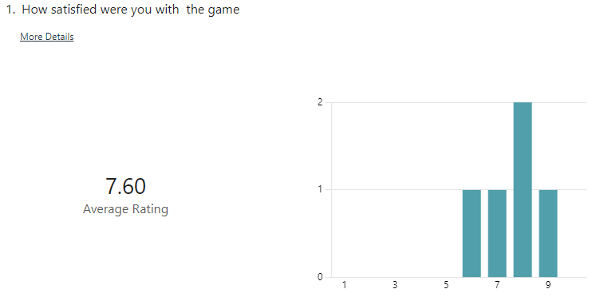

Stakeholders were generally satisfied with the game with an average score of 7.6 out of 10.

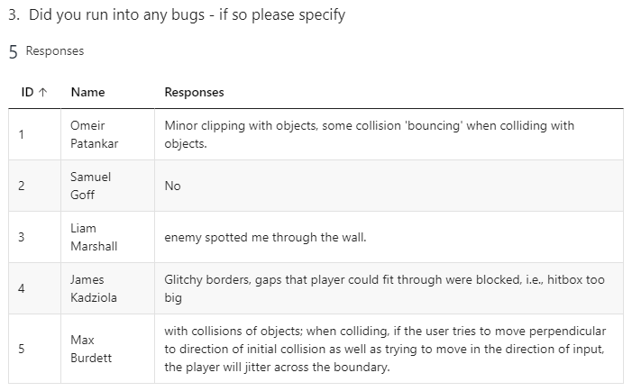

Here are some of the issues found via the stakeholder testing. A common bug was the player bouncing off of objects when colliding. There were also issues with players being seen through walls and sometimes collisions not working as intended.

Most of the game issues seemed to stem from the collisions and the hitboxes however these were some smaller issues which while noticeable, didn’t hinder the game experience.



All stakeholders wanted to see further development

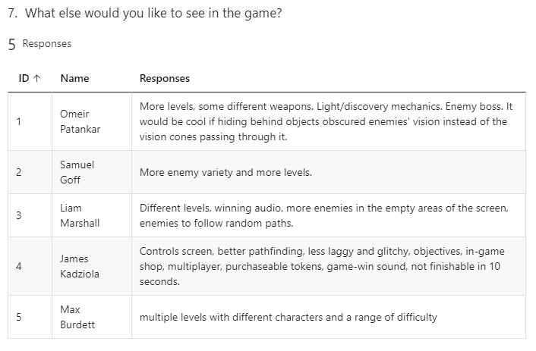

All stakeholders wanted to see more levels in the game, which I had actually planned to do originally but had to let go due to time restraints. I had designed the code in such a way to facilitate the development of further levels with my level parameters, lists and the way everything had been designed so if given more development time the game would see more levels added.

## Final post-development test

I will carry out the tests which I outlined at the end of my design section but also will carry out more tests that are relevant to my success criteria. The test outcomes will be marked either green, yellow or red depending on how I believe that they fit the original outcomes that I set out in the design section. Any new sections are marked as blue (tests which I didn’t outline during the design section). This will also test all of the usability features and needs of the program.

### Player

|  |  |  |  |  |
| --- | --- | --- | --- | --- |
| Method | Data | Expected Outcome | Actual outcome | Justification |
| Player_rotation() | Mouse movement | Player sprite rotates to face the mouse | Player rotates to face the mouse, this works while the player is moving, attacking and stationary | This is to test that the rotation function works at intended. Tests that the mouse location is being fetched. |
| User_input() | Directional Input (‘W’ / ‘A’ / ‘S’ / ‘D’) | Objects and background in the opposite direction of the key being pressed | Background, Objects, Enemies, Enemy routes and walls all move in accordance with the player. | Tests that the player moves when the movement keys are pressed. |
| User_input() | Input ‘CTRL’ | Player moves at 0.5x speed so objects move at 0.5x speed | Player moves at 0.6 of the speed. This is different to what I outlined in the design because the new speed worked better after some testing | This is to test that the player slows down as intended. This input data is the key used to slow down. |
| User_input() | Input any keys (excluding WASD, CTRL and mouseleftclick) | Nothing happens | Nothing happens | This is a test to make sure that the keys which aren’t being used in any part of the program, don’t have an effect on the game. |
| User_input() | Player moving diagonally | Player should move at the same speed as when they move horizontally/ vertically | Player moves at the same speed horizontally as they do vertically or horizontally | This input is tested as moving diagonally may cause the player to move faster as they are moving in 2 directions at once. |
| User_input() | Mouse click in game | Player should perform the attacking animation | Player performs the attacking animation and creates a rect based on the direction they’re facing – to get collisions when attacking enemies | This input is tested to check that the mouse input is being detected, and that the animation is playing as intended. No other data should activate this animation. This also tests that the rect is made for attacks. |
| Collisions_check() | Player walks into object | Player should not be able to walk through the object | Player cant walkthrough objects or walls, however (as outlined by my stakeholders) there is an issue with the screen jittering when a player is walking into object at a diagonal. | This data is tested to check that the collisions are working with the stationary objects. |
| Collisions_check() | Player walks into the level exit area | New level should be loaded | The game ends when the player walks into this object. This is due to time restraints which I have outlined. | This data is tested to check that the collisions are working with the level exits and that they are loading the new levels. |
| Collisions_check() | Player walks into an enemy vision cone and stays inside for 60 ticks | Game over | Game over but this was changed to 20 ticks for balancing reasons | This data is tested to check that the timer for vision cones works and collisions with the cones works. |
| Collisions_check() | Player walks into an enemy vision cone but exits before the 60 tick timer | Game should continue as normal | Game continues as normal (but is a 20 second tick) | This data is tested to check that the timer for vision cones works and collisions with the cones works. |
| Collisions_check() | Player attacking rect collides with an enemy rect | Enemy should be deleted, play a death sound | Enemy dies and is removed from the enemy list and the sprite groups, plays an impact sound and a death sound | This checks that the attack works when the player hits an enemy. This process shouldn’t be happening if there is no collision happening |
| Animate() | Left click once while in game | Plays the attacking animation for one run through | Plays the attacking animation for one run through | Checks that the animation plays in full but only once. |
| Animate() | Left click held down while in game | Plays the animation indefinitely until the left click stops being pressed | Plays the animation until the player lets go of the left click | Checks that the animation will keep playing provided that the player wants to keep attacking |
| Animate() | WASD held | Plays the legs walking animation in the correct direction of movement + play the torso animation in the direction of the mouse | Plays the legs walking animation in the correct direction of movement + play the torso animation in the direction of the mouse | Checks that both the animations are not only working but are also being played in their correct respective directions (as the players upper body is animated independently to the legs) |
| Attack() | Left click held in one for the 4 compass direction | Sets the attacking rect to the respective direction that the player is facing | Sets the attacking rect to the respective direction that the player is facing (4 individual directions) | Checks that the attack is hitting the correct area where the player is aiming the attack |
| Update() | Program ran | Calls all methods in the player class | Calls all methods in the player class |  |
| Update() | Mouse click -> attack_animate variable is set to true | Plays attacking animation once | I implemented the animations in a different way to how I planned it in the design section. | This data is tested to check that the animations for attacking are played when the mouse is clicked. Checks if this function is actually receiving an update when the mouse is clicked |

### Enemy

|  |  |  |  |  |
| --- | --- | --- | --- | --- |
| Method | Data | Expected Outcome | Actual Outcome | Justification |
| Move() | Route destinations | Enemy walks to each coordinate in order | Enemy walks to the location coordinates which are passed in as parameters | This data is not inputted in runtime but is passed as a parameter into the method. Is used to test that the enemies are following the correct route no matter what route is inputted. |
| Rotation() | Run program | Enemy rotates to face its destination | The enemy rotates instantly to its destination that its walking to | This input data is just running the program because this method should automatically run this process from start until the game ends. Tests that the enemy is rotating and doing it correctly. |
| Draw_cone() | Cone image and rotation | Cone is drawn at the correct location | Cone is drawn at the correct location, with the correct amount of rotation | Tests that the image of the cone is actually being drawn and being drawn at the right location. |
| Draw_cone() | Cone mask and rect | Cone has correct mask and rect drawn and rotated at the correct places | Cone has a mask which correctly collides with the players mask. Cone has a rect which is rotated correctly | Checks that the rect and mask for the cone is correct so that collisions are pixel perfect and only return true when they actually should. |
| Animate() | Movement animations | While enemies are moving the animation for moving plays and at the correct locations | The enemies play the correct animations and at the correct angle of rotation | To test if the animations are working as intended |

### Level

|  |  |  |  |  |
| --- | --- | --- | --- | --- |
| Method | Data | Expected Outcome | Actual Outcome | Justification |
| Update_level() | Level change (player enters a level exit) | Background changes, new objects loaded, new enemies loaded, old level deloaded | This method was never added. A lot of the parameters are in place to facilitate this method but I didn’t have the time to add more levels | This data is tested to check if the level actually changes upon entering a new level. |
| Game_over()  This was changed to reset() in the final version | Game_over == True | Game over screen is loaded, all other processes are stopped | Game over screen is drawn | This data is tested to check if the game over sequence occurs when the variable is set to true. This change would occur in the player class. |
| Game_over()  This was changed to reset() in the final version | Game over new game button pressed | Resets all objects and the background to their original starting position, enemies are all deleted and then readded | All objects and background and enemies are set to their original positions. Enemies routes are reset and all dead enemies are respawned | It is important that the new game button resets everything in the game and no attributes are kept from the previous life in the game. |
| Game_over()  This was changed to reset() in the final version | Game over exit button pressed | Closes the window and ends the program | Closes the window and ends the program |  |
| Camera() | Player moves | All objects on screen move opposite to the directional input | Objects on screen don’t move / move in wrong direction / at inconsistent speed | This test data is chosen as it is the only time in which the objects on screen should move. If they move due to any other data then there is an error. |
| Reset() | New game started | All objects and background are reset to original positions | Upon reset all objects are reset to their starting positions | Tests that the game is properly reset to its original state upon a new game |
| Reset() | New game started (some enemies dead) | All enemies set to their original positions with their original routes | All enemies back alive, all enemies are at their original starting position, all enemies have their original routes – regardless of whether they were dead or not | Tests that the enemies are all properly reset to their original states upon a new game and that enemy deaths don’t affect this method |

### Object

|  |  |  |  |  |
| --- | --- | --- | --- | --- |
| Method | Data | Expected Outcome | Actual Outcome | Justification |
| __init__() | Image passed as parameter | Draws image that is passed into the method. Has rect of that image. | Correct image is drawn and has the correctly sized rect | Testing that any image can be used to make an object and get the area of that object. |
| __init__() | Position passed as a parameter | Image is drawn at the correct location | All images are drawn at the correct locations | Testing that images are drawn at the right location of whatever is passed into the method. |

### Menu

|  |  |  |  |  |
| --- | --- | --- | --- | --- |
| Method | Data | Expected Outcome | Actual Outcome | Justification |
| Button() | Button is clicked | Menu is closed -> game is loaded | Menu is closed and the game is loaded | This tests that the button detects a click and that it actually loads the game after. |
| Button() | Screen clicked not on button | Menu stays open, game cant begin | Menu stays open | Tests that only when the mouse is on the button that the button detects a click. |
| Button() | Cursor hover over button | Button changes colour | Button changes colour | Tests that the button responds to colliding with the mouse |

### Wall

|  |  |  |  |  |
| --- | --- | --- | --- | --- |
| Method | Data | Expected Outcome | Actual Outcome | Justification |
| __init__() | Vertical wall passed in | Creates a vertical wall of the desired length, with the top left starting at the coordinate | Vertical wall creates with correct length and position | Tests that parameters are being taken properly and that the vertical walls are working as intended |
| __init__() | Horizontal wall passed in | Creates a horizontal wall of the desired length, with the top left starting at the coordinate | Horizontal walls are all in the correct places and of the correct length | Tests that parameters are being taken properly and that the horizontal walls are working as intended |
| Collisions |  |  |  | Collisions aren’t handled in this class so they aren’t tested here, collisions are tested in the player class |

### Points

|  |  |  |  |  |
| --- | --- | --- | --- | --- |
| Method | Data | Expected Outcome | Actual Outcome | Justification |
| __init__() | Class instantiated | Sets the image, position and scale factor for the points | Sets all of the correct attributes, position is set to a random location on the screen |  |
| Update() | Player kills an enemy (this class is instantiated and update method is called) | Image increases in size each frame until it reaches a certain size and the instance is killed | Image increases in size until it reaches 1.7x its original size and then disappears. Image is drawn each frame | Tests that the points actually show on screen and that the image increases in size. Also tests that the object is removed from memory when it is killed |

## Has this met success criteria?

Here is the success criteria which I outlined within the analysis section. I have objectively tested this success criteria in the tests above.

## Success Criteria

* Player will be able to move through levels using the WASD and arrow keys, having responsive movements.
* Each Level will have enemies with working cones of vision and ability to interact with the player.
* There will be collision physics between objects and the player
* There will be multiple levels for the player to interact with
* Player will be able to kill enemies.
* The game will have a menu and settings screens.
* When a new game is started, I will reset all objects in the game.

**Player will be able to move through levels using the WASD and arrow keys, having responsive movements.**

As I outlined in my test, this criteria has been met. When the player uses the movement keys, the player doesn’t move on the screen but they do move around the map, as the player is fixed to the centre of the screen. All objects and enemies are instead moved in the opposite direction of the player which makes it look like the player is walking around the map.

Diagonal movement is the same speed as horizontal and vertical movement (when it normally otherwise wouldn’t be)

The player moves in 8 directions (north, north east, east, south east, south, south west, west and north west) depending on the keys held. This movement has animations which are separate for the legs and torso and are handled independently.

I believe I met and exceeded this point in my success criteria.

**Each Level will have enemies with working cones of vision and ability to interact with the player.**

The first level is comprised of 7 enemies, which all have their own individual positions and routes they take when walking around the map. Each enemy has a vision cone which rotates and moves correctly with the enemy. The routes are passed into the enemies as a parameter during their instantiation.

Enemies interact with the player in one of two ways:

1. When the player walks into a vision cone (collisions are taken here using masks to get pixel perfect collisions), they receive a game over
2. When the player attacks an enemy, that specific enemy dies and is removed from the game

Enemies have animations for walking, sound effects for dying, customizable speeds, customizable positions, customizable routes to allow for new enemies to be easily added to the game.

However, as noticed by my shareholders, the enemies can spot players through objects as the cones only check for collisions with the player and so they ignore any other objects that might be in the way.

I believe I met and exceeded this point in my success criteria however if I were to continue development further I may add a check for if there is any objects blocking the enemies view of the player.

**There will be collision physics between objects and the player.**

All objects and walls in the game have a rect, which when colliding with the player will offset the player so that they cannot walk through it. The collisions check for if any part of the two rects are touching and if they are, it checks which side of the rect the collision is happening so that the player can be correctly offset.

One issue which both I and the stakeholders found in testing was that the screen would jitter when walking into a wall or object at a diagonal, I know why this happened but couldn’t find a solution so will further development I would like to fix this issue.

I believe I met this point in my success criteria.

**There will be multiple levels for the player to interact with.**

In the final product of the game, there is only one level. I had designed the program to facilitate more levels by having a parameter for every object to signify which level it was on, having a lists that stored only the objects of the current level and having a method in pseudocode to update the lists and levels when a new level was loaded.

The reason I didn’t end up adding more levels is due to time restraints, adding more levels wouldn’t be complicated as I have all of the resources to create them , but it would take time to make the background, add all of the objects and the enemies and make the level appealing.

I did not meet this point in my success criteria but if development were to continue, I would add more levels.

**Player will be able to kill enemies.**

As outlined in one of the other success criteria, the player is able to kill enemies. The player performs an attack which when colliding with an enemy will kill that specific enemy. When an enemy dies, it is removed from all of the sprite groups it is found in and from the enemies list (list of currently active enemies) but is not removed from the enemies library.

Player attack has animation and sound effects. Enemy death has sound effects too.

I believe I met this point in my success criteria.

**The game will have a menu and settings screens.**

The game has a menu for when the game starts up. This menu screen has its own background, its own music and has a button to start a new game. The game also has a game over screen and a win screen for both respective conditions, each having both a ‘new game’ button and an ‘exit’ button.

Unfortunately I never added a settings screen, this is because I hadn’t implemented any settings that would be changeable in game e.g. the colourblind filter which I had proposed in analysis.

I believe I met this success criteria to an extent. I would like to implement settings to the game in further development but again I was limited in time and a settings screen was low on priority in the order of features.

**When a new game is started, I will reset all objects in the game.**

This applies to when a new game is started after death or after a win. There is a ‘new game’ button which resets the position of the background, resets the position of all objects on the screen and fully resets all of the enemies (whether they are dead or not).

Enemies are reset by all being deleted and then being re-instantiated as all of the enemies are stored in a list which holds the parameters for creating all of the enemies. This was far more difficult and complex than I had anticipated but after thorough testing, the reset() method is fully working.

I believe I met this point in my success criteria.

## Addressing unmet criteria

The main unmet criteria was the lack of levels. As I have already explained, I have all of the components to develop new levels so adding new levels would simply be a case of designing the new levels, creating new instances of enemies and objects with the correct parameters and then coding the method for updating the level (which I have pseudocode for).

I also didn’t implement a settings menu, in further development I would create this menu in a similar way to the game over and win screens. Settings would include features like player speed, enemy speed, text size, screen resolution and other easily scalable variables.

I would also fix the jittering issue with the collisions, I know that it is happening because of how the player is being offset when colliding with surfaces but am currently unsure as to how I would fix this so this would require a lot of iterative testing.

## Usability features

One of the main usability features of the program are the menus. While quite simple, they allow the player to start the game when they want rather than just starting instantly. Makes the game look more polished. The game over an the win screens allow players to exit the game using a button actually within the program rather than closing it using the task bar or other method. These in menu buttons make the game much easier to navigate and control as a player. This is a success.

The game is also relatively easy to pick up and understand. The controls are limited and simple, consisting mainly of WASD and the mouse clicks so are easy to remember and understand, even for people who aren’t familiar with video games. The gameplay is also simple to understand, kill enemies and don’t get caught, so can be enjoyed by casual gamers and also by more skilled players (which I found was my main demographic in my analysis questionnaire). This is a success.

The game explicitly tells the player how many points they have by writing it to the screen in English. The enemy vision cones are clearly and easily visible so users shouldn’t have problems understanding how it works. This is a success but it could be made more obvious to users that the vision cones should be avoided.

The player can easily recover from errors or mistakes as death has little punishment and is very quick to get back to the gameplay. This means players can easily learn from their mistakes and improve at the game. This is a success.

I never added the ability to scale the font size or for a colourblind mode which I outlined in my analysis. These would have made the game more accessible and usable for people with visual impairments and helped with their satisfaction of the game. This is a usability issue.

While the controls are simple, they are not explained to the user within the program. This may lead users to be confused as to how to get started with the program, or be unaware of certain features like the sprinting when holding shift/ctrl. This is a usability issue.

## Improving Usability

To increase usability, I would add a settings menu which I had planned to do in analysis. This setting menu would allow for more of the UI to be used. This settings menu would also allow for customization of certain features like text size scaling which could be achieved by using a variable for the text size which is altered in game.

I would also add a way for the controls to be visible within the game, this would either be in the form of a controls screen or via a form of tutorial level to teach the user the controls and how to play the game.

Could also make the game more flexible in the players approach, in analysis I outlined potential different ways to win the game e.g. winning without killing. This would give users more freedom to play how they want rather than limiting them to a linear fixed playstyle. This would occur in further development.

## Maintenance

With maintenance, most of this would just involve fixing any bugs which may be found after the product is released. Future development would first focus on meeting all of the unmet success criteria and the unmet usability features, then I would move onto adding all of the other features which I outlined within the analysis.

The only real limitations of maintenance would be time as it would require me to keep up to date with the current state of the program, what current bugs are issues and would need to spend time to fix these issues.

For future development, I would use git – a version control software to help with managing the code with development and keeping track of changes. This would also help with collaboration if I decided to work on the program with other developers for future development. I have designed the program in a way using strict naming conventions and other standards that will make future development easier for me and for any others working on the code.

## Conclusion

I am happy to conclude the process with this state of the game. While I didn’t meet all of my success criteria, I have prepared the program for future development to meet these criteria. I didn’t add a lot of the features I proposed in analysis, but I achieved almost all of what I essentially wanted to and plan to further develop the program for my own personal programming practice.

# References

Rabbid76. 2023. *Stack Overflow.* 12 5. https://stackoverflow.com/questions/4183208/how-do-i-rotate-an-image-around-its-center-using-pygame.

Subversions, Tiny. 2010. “Akihabara Tutorial 4: Camera with Dead Zone.” *Youtube.* 11 June. https://www.youtube.com/watch?v=ylHXo98G1hM.

Wikipedia, Various Authors. 2012. *Wikipedia - Dishonoured.* 9 10. https://en.wikipedia.org/wiki/Dishonored.

Wikipedia, Varoius Authors. 2012. *Wikipedia - Hotline Miami.* 23 10. https://en.wikipedia.org/wiki/Hotline_Miami.